

**Helwan University**

**Faculty of Computers and Artificial Intelligence**

**Computer Science Department**

[Crime Detection & Recognition]

A graduation project dissertation by:

Aya Emad Talaat Harb [202000186]

Fayrouz Goumaa Mansour Mohamed [202000649]

Ahmed Mustafa Mohamed Zen [202000088]

Ahmed Khaled Abd El Fatah [202000032]

Mohamed Osama Faid Abdo [202000727]

Submitted in partial fulfilment of the requirements for the degree of Bachelor of Science in Computers & Artificial Intelligence at the **Computer Science** Department, the Faculty of Computers & Artificial Intelligence, Helwan University

Supervised by:

Dr. Salwa Osama

June 2024  
  


**جـامـعـة حـلـوان**

**كـليـة الحـاسـبـات والـذكـاء الإصـطـنـاعي**

**قـسـم عـلـوم الحـاسـب**

[Crime Detection & Recognition]

رسالة مشروع تخرج مقدمة من:

آيه عماد طلعت حرب [202000186]

فيروز جمعه منصور محمد [202000649]

احمد مصطفي محمد زين الدين [202000088]

احمد خالد عبدالفتاح [202000032]

محمد اسامه فايد عبده [202000727]

رسالة مقدمة ضمن متطلبات الحصول على درجة البكالوريوس في الحاسبات والذكاء الإصطناعي، بقسم علوم الحاسب، كلية الحاسبات والذكاء الإصطناعي، جامعة حلوان

تحت إشراف:

د.سلوى أسامه

يونيو / حزيران 2024

Acknowledgment  
**عَلَّمَ الإنْسَانَ مَا لَمْ یَعْلَم**  
 We extend our heartfelt appreciation to **Dr. Salwa Osama** for her invaluable guidance and unwavering support throughout our project. As our supervisor, **Dr. Salwa** played a pivotal role in shaping the direction of our work and providing insightful feedback at every step. **Dr. Salwa’s** expertise, deep understanding of the subject matter, and dedication to our success were instrumental in the completion of this project. Her consistent encouragement, patience, and willingness to share her knowledge greatly enriched our learning experience and propelled us toward achieving our goals. We are immensely grateful for the time and effort **Dr. Salwa** devoted to mentoring us. Her guidance not only helped us navigate through complex challenges but also fostered an environment of intellectual curiosity and collaboration.   
We would also like to extend our sincere gratitude to our loving **family** for their unwavering support not only during this project but throughout our entire university journey. Their encouragement, understanding, and belief in our abilities have been a constant source of motivation.

Table of Contents

List of figures 7

List of Tables 8

Abbreviations 9

Abstract 10

Chapter1 1. Introduction: 10

3. Scope and Objectives: 14

4. Problems: 17

6. Conclusion: 18

chapter2 Related Work (Literature Review) 20

2.1. Related Work 20

2.2.Background 24

2.2.1.Data Science and Analytics 24

2.2.2.Deep Learning 24

2.2.3.Artificial Intelligence 25

2.2.4.Computer Vision 25

2.2.5. What is CNN? 25

2.2.6. What is YOLO? 29

2.2.7. What is LSTM? 31

2.3 Literature Survey 32

2.3.1 Overview of the Application Area 32

2.3.2.Reviewing Main Modules in the Selected Scope 33

Chapter3 The Proposed Solution 36

3.1 Solution Methodology: 37

3.1.1 Crime Detection Models: 38

3.1.2 Low Light Model: 41

3.1.4 Face Detection and Recognition: 44

3.1.5 Plate DETECTION and Recognition: 47

3.2.1Bloke Diagram 54

3.2.2.Use Case 54

3.2.3.Activity Diagram 56

3.2.4.Sequence Diagram 56

Chapter4 Implementation, Experimental Setup, & Results 58

4.1 Implementation 59

4.1.1 Used Programs 59

4.2 Experimental 93

4.2.2.5 Exploratory Data Analysis (EDA) Descriptive statistics 99

4.2.2 Experiments for low light 111

4.2.5 Experiments for plate detection and recognition CNN & SEGMENTATION 116

4.4 Evaluation 119

5.1 Discussion 122

5.1.1advantage of the proposed system 122

5.1.2Comparison with Existing Technique 122

5.1.3. Limitations and Future Work: 122

5.4 References 125

5.4.1 References 125

# List of figures

Figure 1: illustrate how does CV work. ………………………………………………………………28

Figure 2 :An overview of CNN architecture. 29

Figure 3:Example of convolution 30

Figure 4 :Example of padding 30

Figure 5 :An Example of stride 31

Figure 6 :An Example of max pooling 31

Figure 7 : Residual blocks in YOLO 32

Figure 8 : Bounding box regression in YOLO 33

Figure 9 : IOU in YOLO 33

Figure 10: illustrate LSTM 35

Figure 12 :The CNN-LSTM Architecture Workflow Overview 42

Figure 14:The Retinexformer Architecture . 46

Figure 16 :Flowchart of Latent Diffusion Model (LDM) 48

Figure 18 : Example of How face recognition model steps work. 49

Figure 19 : Illustrate the HOG steps. 50

Figure 20: Illustrate face encoding. 50

Figure 23 : Workflow and steps of the proposed system 53

Figure 24: Architecture of yolov8………………………………………………………………………..47 Figure 25 : Implications of OCR ……………………………………………….. ………………………....47 Figure 26 : Pipeline of yolov8 54

Figure 27: Block Diagram 59

Figure 28: Use Case Diagram 59

Figure 29: Activity diagram 61

Figure 30:Sequence Diagram 62

Figure 31 : Illustrate LBP work 118

Figure 31 : Illustrate MTCNN Architecture 120

# List of Tables

Table 1 : comparison of features extractors 109

Table 2: Comparison between LBP , MTCNN and Dlib  117

Table: Comparison between cnn and yolov8 118

**Key Words**

Convolutional neural network, Convolutional vision transformer, Crime Detection , OCR,MTCNN , Plate Recognition , Face Recognition ,Computer Vision, Upscaling , LSTM.

Abbreviations

**1.CNN: Convolutional neural network**

**2.LSTM : long short-term memory**

**3.YOLO You Only Look Once**

**4.CV : Computer Vision**

**5.LDM : Latent Diffusion Model**

**6. OCR : Optical Character Recognition**

**7.HOG : Histogram of Oriented Gradients**

**8. Multi-Task Cascaded Convolutional Neural Networks**

# Abstract

In modern cities, law enforcement faces numerous challenges that make it difficult to ensure public safety effectively. The complexities of urban environments, coupled with the limitations of traditional surveillance systems, often impede the efforts of law enforcement officers, especially during nighttime and in densely populated areas. The Crime Detection Project aims to address these challenges by leveraging advanced technologies to enhance crime detection, prevention, and response mechanisms.

**Recognizing Actions**: One of the core components of the Crime Detection Project is the development of sophisticated tools that can identify suspicious activities in real-time. These tools use advanced algorithms and machine learning to analyse behaviour patterns, enabling officers to intervene before crimes escalate. By predicting and identifying potential threats early, the system helps in preventing criminal activities and ensuring public safety.

**Handling Poor Camera Quality**: Traditional surveillance systems often suffer from poor camera quality, which hampers their effectiveness. To overcome this, the project incorporates high-definition cameras and image enhancement technologies. These technologies significantly improve image clarity, making it easier to identify suspects and gather critical evidence. Enhanced image quality is crucial for accurate facial recognition, vehicle identification, and overall situational awareness.

**Managing Crimes in Darkness**: Darkness poses a significant challenge for surveillance systems. The Crime Detection Project employs advanced imaging technologies such as infrared and thermal cameras to improve visibility in low-light conditions. These technologies allow for effective monitoring and surveillance during nighttime, ensuring that criminal activities are detected and addressed promptly, regardless of lighting conditions.

**Recognizing Faces**: Accurate facial recognition is essential for identifying suspects and ensuring public safety. The project integrates sophisticated facial recognition systems that can accurately identify individuals even in crowded or fast-moving environments. These systems use deep learning algorithms to match faces with existing databases, aiding in the quick identification and apprehension of suspects.

**Detecting Plate Numbers**: Vehicle-related crimes are a major concern in urban areas. The project uses advanced license plate recognition technology to accurately read and track vehicle plates. This technology is effective even under challenging conditions such as high speeds, poor lighting, and obstructed views. By identifying vehicles involved in criminal activities, the system enhances vehicular surveillance and aids in the swift response to crimes.

Chapter1  
1. Introduction:  
  
In law enforcement, officers have to deal with a lot of different challenges that each pose a unique threat to public safety. Imagine a busy city that is alive during the day but mysterious and dark at night. In these dark hours, conventional surveillance systems often fail, leaving officers to navigate through murky shadows and uncertainty. Their ability to protect the public is limited by the veil of mystery. But the Crime Detection Project is a beacon of hope.

Conventional surveillance systems, once the cornerstone of their nighttime vigilance, frequently fail to penetrate the shadows that envelop the city after sunset. Forced to navigate through a maze of murky uncertainty, the officers find their ability to safeguard the public severely hindered by the very conditions they are tasked with overcoming.

Imagine the scene – a stolen car weaving through the chaotic traffic, its license plates a fleeting whisper of identity in a sea of anonymity. Or a suspected criminal lost in the throngs of a bustling crowd, their face obscured by the darkness and the density of the masses. In these moments, the dedicated law enforcement professionals are often left feeling powerless, their efforts to maintain order and protect the innocent seemingly futile in the face of such overwhelming adversity.

But just when the night's shadows seem most impenetrable, a beacon of hope has emerged in the form of the Crime Detection Project – a groundbreaking initiative that stands as a testament to the unwavering dedication and relentless ingenuity of those committed to keeping their communities safe.

This innovative endeavour, born from the collective experiences and insights of law enforcement professionals, is poised to revolutionize the way crime is fought and order is restored. At the heart of the project lies a fundamental recognition: that equipping these officers with the most advanced surveillance technologies available is not just a luxury, but a necessity.

One such innovation is the Plate Detection system, which grants officers the ability to track the movements of vehicles in real-time, even as they dart through the bustling traffic. By harnessing the power of this cutting-edge tool, law enforcement can disrupt criminal networks, cutting off the lifeblood of their operations and restoring a sense of security to the streets – a critical step in the ongoing battle against the forces of chaos and lawlessness.

Another game-changing technology introduced by the Crime Detection Project is the Face Detection system, an advanced facial recognition platform that transforms the human face into a key that can unlock the very mysteries of criminal activity. In the crowded and chaotic environments that characterize the modern city, officers can now quickly identify and apprehend suspects, providing a heightened sense of safety and security to the community they serve.

But the impact of this groundbreaking initiative extends far beyond the immediate benefits to law enforcement. It represents a paradigm shift in the way crime is fought and communities are safeguarded, empowering officers with the tools they need to respond with unparalleled precision and efficiency.

By disrupting criminal networks and restoring a sense of order and stability, the Crime Detection Project is poised to change the very fabric of law enforcement, paving the way for a safer and more secure future. It stands as a shining example of how human resilience and ingenuity can overcome even the most daunting challenges, demonstrating the transformative power of collaboration, innovation, and a steadfast commitment to the well-being of the people.

Moreover, the Crime Detection Project is designed with scalability in mind. As it continues to evolve, its technologies can be upscaled to accommodate larger urban environments and more complex scenarios. This adaptability ensures that as cities grow and crime patterns shift, the project can expand its reach and enhance its capabilities, providing a robust framework for future advancements in law enforcement technology.

As the Crime Detection Project continues to evolve and expand, it remains a beacon of hope, a testament to the unwavering spirit of those who refuse to be daunted by the darkness and are determined to illuminate the path towards a safer, more secure future for all. In the face of the night's most formidable obstacles, these dedicated professionals stand ready to meet the challenge, armed with cutting-edge technologies, scalable solutions, and the unbreakable determination that will enable them to turn the tide against the forces of crime and lawlessness.  
  
  
2. Motivation:

**Addressing Modern Challenges**:

In today's rapidly changing urban landscapes, crime has become increasingly sophisticated and multifarious. Traditional surveillance systems and conventional methods of crime detection often fall short in the face of these complexities, especially under the cover of darkness. The motivation to develop the Crime Detection Project stems from a recognition that law enforcement agencies require advanced tools and innovative solutions to effectively combat the myriad of threats that jeopardize public safety.

**Enhancing Officer Capabilities:**

Law enforcement officers are the frontline defenders of our communities, and their ability to respond swiftly and accurately to criminal activities is paramount. The Crime Detection Project aims to empower these dedicated professionals with state-of-the-art technologies, such as the Plate Detection and Face Detection systems, to enhance their operational capabilities. By providing real-time tracking of vehicles and advanced facial recognition, officers can act with greater precision and confidence, ultimately leading to more successful interventions and a safer public space.

**Bridging Technological Gaps:**

The Crime Detection Project is driven by the desire to bridge the technological gaps that often hinder effective crime prevention and resolution. Conventional surveillance systems, while valuable, often lack the robustness and adaptability required to address the nuanced challenges of modern urban environments. By integrating scalable, advanced technologies into the law enforcement toolkit, the project seeks to create a comprehensive and adaptive framework that can evolve alongside emerging threats and changing urban dynamics.

**Promoting Collaboration and Innovation**:

A core motivation behind the Crime Detection Project is to foster collaboration and innovation within the law enforcement community. The project is a testament to the collective insights and experiences of officers who understand the intricacies of crime-fighting firsthand. By promoting a culture of continuous improvement and technological adoption, the initiative aims to inspire other law enforcement agencies to embrace innovative solutions and share best practices, leading to a more unified and effective approach to public safety.

**Ensuring Community Trust and Safety:**

At the heart of the Crime Detection Project is a profound commitment to ensuring the safety and well-being of the community. The initiative seeks to restore and reinforce public trust in law enforcement by demonstrating a proactive and technologically advanced approach to crime prevention. By disrupting criminal networks and enhancing the efficiency of law enforcement operations, the project aims to create a palpable sense of security and stability within the community, allowing residents to live without fear and with greater confidence in their protectors.

**Vision for a Safer Future:**

Ultimately, the motivation behind the Crime Detection Project is anchored in a visionary pursuit of a safer future. The project embodies the belief that through relentless dedication, innovation, and collaboration, it is possible to overcome even the most formidable challenges posed by crime and lawlessness. It represents a commitment to illuminating the darkest corners of our cities and transforming them into havens of safety and order. This vision drives the continuous evolution and expansion of the project, ensuring that it remains a dynamic force for good in the ongoing battle to safeguard our communities.

## 3. Scope and Objectives:

**Enhancing Crime Detection and Prevention:**

The primary purpose of the Crime Detection Project is to significantly improve the ability of law enforcement agencies to detect and prevent criminal activities. By deploying state-of-the-art technologies such as Plate Detection and Face Detection systems, the project aims to provide officers with real-time, actionable intelligence. This enables quicker identification of suspects, more efficient tracking of vehicles involved in criminal activities, and a greater overall capability to preempt and thwart criminal operations before they escalate.

**Empowering Law Enforcement with Advanced Tools:**

Equipping law enforcement professionals with the most advanced tools available is a fundamental purpose of the Crime Detection Project. These tools are designed to enhance the situational awareness and operational efficiency of officers, allowing them to respond to incidents with heightened precision and confidence. The project seeks to bridge the gap between traditional surveillance methods and modern technological advancements, ensuring that officers are well-prepared to face the challenges of contemporary urban crime.

**Promoting Community Safety and Trust:**

A crucial purpose of the Crime Detection Project is to foster a sense of safety and trust within the community. By leveraging cutting-edge technologies to enhance law enforcement capabilities, the project aims to create an environment where residents feel secure and protected. This not only helps to reduce crime rates but also strengthens the relationship between law enforcement agencies and the communities they serve, promoting mutual trust and cooperation.

**Facilitating Scalability and Adaptability:**

The Crime Detection Project is designed with scalability and adaptability at its core. Its purpose includes the ability to scale its technologies to meet the needs of larger urban environments and more complex crime scenarios. This ensures that as cities grow and evolve, the project can expand its reach and capabilities, accordingly, maintaining its effectiveness in diverse and changing urban landscapes.

**Driving Innovation in Law Enforcement**:

Innovation is a driving force behind the Crime Detection Project. Its purpose is to serve as a catalyst for ongoing technological advancements within the field of law enforcement. By continuously integrating new and emerging technologies, the project aims to stay ahead of criminal tactics and ensure that law enforcement agencies are equipped with the most effective tools available. This commitment to innovation is essential for adapting to the ever-evolving nature of crime and maintaining public safety.

**Enhancing Operational Efficiency:**

Improving the operational efficiency of law enforcement agencies is another key purpose of the Crime Detection Project. By providing real-time data and advanced analytical capabilities, the project helps streamline law enforcement operations. This leads to faster response times, more accurate decision-making, and a more effective allocation of resources, ultimately enhancing the overall efficiency of crime-fighting efforts.

**Supporting Evidence-Based Policing**:

The Crime Detection Project aims to support evidence-based policing by providing law enforcement agencies with reliable and precise data. Advanced surveillance technologies generate valuable insights that can be used to inform policing strategies, optimize patrol routes, and allocate resources more effectively. This data-driven approach helps to ensure that law enforcement efforts are focused on areas where they are needed most, maximizing their impact on public safety.

**Creating a Sustainable Security Framework**:

Sustainability is an integral aspect of the Crime Detection Project’s purpose. The project is designed to create a long-term, sustainable framework for public safety that can adapt to future challenges. By fostering a culture of continuous improvement and innovation, the project aims to build a resilient law enforcement infrastructure capable of withstanding the test of time and evolving threats.

4. Problems:In modern urban environments, law enforcement faces several critical challenges that hinder their ability to maintain public safety effectively. Addressing these challenges is essential for developing advanced surveillance technologies that can significantly improve crime detection and prevention.

One of the major problems is how to recognize criminal actions in real time. Conventional systems often fail to accurately interpret and identify suspicious activities due to limited analytical capabilities. This makes it difficult for officers to respond proactively and prevent crimes before they occur.

Poor camera quality is another significant issue that impacts the effectiveness of surveillance systems. Many existing cameras produce grainy or low-resolution images, especially in low-light conditions or during inclement weather. This poor-quality footage makes it challenging to identify suspects and gather reliable evidence, thus hampering investigative efforts.

Darkness creates substantial blind spots in surveillance coverage, allowing criminals to operate with reduced risk of detection. Conventional cameras often struggle to capture clear images in low-light conditions, limiting their utility during nighttime operations. Enhancing visibility in these conditions is crucial for ensuring continuous and effective monitoring.

Accurate facial recognition is vital for identifying suspects in crowded or fast-moving environments. Traditional systems often lack the precision needed to distinguish faces accurately, especially when dealing with obstructions, disguises, or varying angles. This limitation can lead to missed opportunities in identifying and apprehending criminals.

Reading license plates accurately is essential for tracking and intercepting vehicles involved in criminal activities. Poor image resolution, fast-moving vehicles, and dirty or damaged plates can make it difficult for traditional systems to capture and read plate numbers effectively. Reliable plate detection is necessary for enhancing vehicular surveillance and crime response.

Resource constraints, including limited personnel, budgetary restrictions, and outdated equipment, pose significant challenges for law enforcement agencies. These constraints can lead to operational inefficiencies, such as delayed response times and inadequate investigative capabilities. Additionally, surveillance systems must be fast and scalable to handle large amounts of data in real time, ensuring quick and efficient crime detection and response.

A user-friendly interface is crucial for ensuring that law enforcement officers can effectively utilize advanced surveillance technologies. Complex and unintuitive systems can lead to errors and inefficiencies, reducing the overall effectiveness of crime detection efforts. Developing interfaces that are easy to use, understand, and navigate is essential for maximizing the utility of these advanced tools.  
  
5. Work Methodology:

* Collecting Crime Data videos (like Fighting, Fire, Smoking, Gun, Knife)
* Collecting Plates and Faces Data Videos
* Process data to Detect and Recognize Crimes using Computer vision
* Detect and recognize the Crimes
* Knowing The Action Behavior & Crimes tools
* Detect and recognise the car plate
* Detect and recognise the face
* Save and send the results to the Competent authorities
* Display the results to the Users to Know the Action that happened

## 6. Conclusion:

The Crime Detection Project represents a transformative initiative aimed at addressing the myriad challenges faced by modern law enforcement in urban environments. By integrating advanced technologies such as Plate Detection and Face Detection systems, this project significantly enhances the capabilities of officers to detect, prevent, and respond to criminal activities with unprecedented precision and efficiency. These innovations tackle critical issues like poor camera quality, darkness-induced blind spots, and the need for accurate facial and vehicle recognition, thereby ensuring more effective surveillance and crime prevention.

The project's commitment to scalability and user-friendly interfaces ensures that it can evolve alongside emerging threats and expanding urban landscapes, providing a sustainable and adaptable framework for public safety. By fostering collaboration and continuous innovation, the Crime Detection Project not only empowers law enforcement agencies but also restores and reinforces community trust and safety. Ultimately, this initiative is a beacon of hope, illuminating the path towards a safer, more secure future through the relentless dedication and ingenuity of those committed to protecting their communities.

chapter2  
  
 Related Work (Literature Review)  
  
In this chapter, we will explore the related works that have contributed to our understanding of the problem at hand and are closely related and like our work. These papers serve as valuable references and have guided our approach throughout the project. Additionally, we will provide a background on the technologies used in our work.

## 2.1. Related Work

With the widespread use of surveillance cameras and the emerging need for automatically abnormal event detection, several methods have been proposed to solve various types of anomaly detection in video datasets Supervised learning methods aim to separate data classes, whereas unsupervised techniques explain and understand data characteristics. Between the two, supervised anomaly detection techniques outperform unsupervised anomaly detection techniques using labelled data In supervised anomaly detection, the separating boundary is learnt from training data, and then test data are classified into either normal or abnormal classes using the learned model.  
The paper titled **" Learning Spatiotemporal Features with 3D Convolutional Networks "[1]** In 2015, Tran el presented a model for learning spatiotemporal features with 3D convolutional networks. This model is called C3D, and in this model, each segmented video goes through a three convolution layer 3D ConvNet to classify different actions. After four years, Sultani et al. used this model with multiple instance learning (MIL) in their paper to find abnormal events. However, deep neural network architecture has recently been successfully used in various computer vision tasks, including anomaly detection problems. Mainly, supervised deep learning for anomaly detection includes two parts: a feature extraction network followed by a classifier network. This paper implements Convolutional Neural Networks (CNN) to extract essential features from each input video data frame. By taking advantage of the Recurrent Neural Network (RNN) structure, the system can investigate a series of frames to find any abnormal events. Convolutional Neural Networks CNNs are the most popular choice of neural network for the image processing goals. Extracting complex hidden features from high dimensional data with a complex structure is the main advantage of CNNs, making them suitable feature extractors for sequential and image datasets The extracted deep features were utilized in different applications like image quality assessment, skin lesions classification, and person re-identification . Although CNNs are widely used in various deep learning tasks like text classification and NLP, they are mainly used in computer vision, such as for image and video detection and classification. Various kinds of CNNs have been built in the recent decade like AlexNet, ResNets, VGG, Inceptions and their variants. Several works were also done by combining these convolutional neural networks with a softmax layer, and morphological analysis in the anomaly detection area.

**Recurrent Neural Networks.** On the other hand, RNNs is one of the well-known choices for capturing features in analysing time series data. However, they fail in extracting context as time steps increases. Long short-term memory (LSTM) networks were introduced to overcome this limitation by improving the long-term dependency in RNNs . Due to the sequential nature of the surveillance camera feeds, LSTM networks have become more popular for anomaly detection applications . Therefore, several researchers worked on anomaly, Application detection problems using the LSTM structure. Using regularity scores from reconstruction errors in an LSTM-based network is one approach of using LSTM to solve anomaly detection problems. Furthermore, Srivastava et al. proposed a model using auto-encoders, the encoder LSTM, and Decoder LSTM in an unsupervised learning approach **" Unsupervised Learning of Video Representations using LSTMs "[2]**. However, the only RNNs methods could not achieve high accuracy results. They mainly predict the subsequent frames in a video time-series and, by calculating the differ- ence between the ground truth and predicted value, decide whether the video segment is abnormal or not. Therefore, as the abnormal events do not follow a particular algorithm, it is difficult to say an uncommon event happened based on the prediction of the next frame.

The paper titled **" Face Detection Based on Multi-Block LBP Representation "[3]** presents a face detection method that leverages a Multi-Block Local Binary Pattern (MB-LBP) representation and an Adaboost classifier. The MB-LBP descriptor is used to capture both local and global facial features, providing a comprehensive representation of the face. The Adaboost algorithm is then employed to train a robust classifier using the MB-LBP features. The proposed approach utilizes a sliding window technique to locate the presence and positions of faces within input images. The authors evaluate the method on challenging benchmark datasets and report state-of-the-art face detection performance, demonstrating the effectiveness of the MB-LBP representation and Adaboost classifier for this task.

The paper titled **" FACIAL RECOGNITION AND ATTENDANCE SYSTEM USING DLIB AND FACE RECOGNITION LIBRARIES "[4]** presents a facial recognition and attendance system that leverages the DLIB and Face Recognition libraries. The DLIB library is used for face detection, while the Face Recognition library is utilized for facial feature extraction and recognition. The system captures images using a webcam and performs real-time face detection and recognition to mark attendance. It maintains a database of registered user images and their corresponding identities. When a person's face is detected, the system compares the detected face features against the database to identify the individual and mark their attendance. The authors evaluate the system's performance on various test cases and demonstrate its effectiveness in accurately recognizing faces and recording attendance. The use of the DLIB and Face Recognition libraries provides a robust and reliable facial recognition solution that can be easily integrated into attendance tracking applications**.**

The paper titled **" Face Recognition System Based on Haar Cascade Classifier" [5]** describes a face recognition system that is based on the Haar Cascade Classifier. The Haar Cascade Classifier, a machine learning-based approach, is used for face detection. The system captures images using a webcam and first applies the Haar Cascade Classifier to detect the presence of faces in the input frames. Once a face is detected, the system extracts facial features using the eigenfaces method. These facial features are then used to train a k-Nearest Neighbors (k-NN) classifier for face recognition. The trained k-NN model is employed to identify and recognize individuals in subsequent input images. The authors evaluate the performance of their system on a custom dataset and report high accuracy in correctly identifying faces. The use of the Haar Cascade Classifier for face detection and the k-NN algorithm for face recognition enables a robust and efficient facial recognition solution.

Recent research on ALPR systems has explored various techniques for vehicle character recognition. A notable approach is template matching, used in studies such as in paper titled **"Automatic license plate recognition using extracted features" [6],** where gray scaling, dilation, normalization, and the Sobel operator were employed for data detection, and OCR was performed by template matching with cross-correlation. Another study in paper titled **" License number plate recognition using template matching and bounding box method** **"[7]** applied a similar method using template matching and bounding box techniques for OCR-based car number plate recognition.

Machine learning also plays a significant role, as seen in paper titled **" Automatic license plate recognition,” Recent Trends in Signal and Image Processing"[8]**, which recommended using the bounding box technique for data extraction and template matching for character recognition. In India, specific ALPR systems have been developed. One such system in paper titled **"Anonymous vehicle detection for secure campuses: A framework for license plate recognition using deep learning "[9]** utilized Faster R-CNN, Top-hat and Black-hat transforms, Gaussian smoothing filter, and Tesseract OCR.

In the context of Intelligent Transportation Systems (ITS), **"one study Automatic license plate recognition using extracted features"[9]** discussed future ITS services and proposed a novel architecture. Another **"**Automatic car number plate recognition**"[10]** designed an ALPR system using a modified ACO algorithm for edge detection, CCA and Kohonen neural network for segmentation, and SVM for character recognition. An OCR system based on FPGA was proposed in **"An efficient FPGA implementation of opti cal character recognition for license plate recognition** **"**[11], achieving 97.62% accuracy using a feed-forward neural network.

## 2.2.Background

### 2.2.1.Data Science and Analytics

Data science plays a pivotal role in crime detection by enabling the analysis of large datasets to identify patterns, trends, and anomalies associated with criminal activities. Techniques such as data mining, statistical analysis, and machine learning are commonly used to process and interpret crime data.

### 2.2.2.Deep Learning

Deep learning is a subset of machine learning that uses multi-layered neural networks, called deep neural networks, to simulate the complex decision-making power of the human brain. Some form of deep learning powers most of the artificial intelligence (AI) in our lives today.

### 2.2.3.Artificial Intelligence

Artificial intelligence encompasses a range of technologies that allow machines to mimic human intelligence. AI techniques, such as natural language processing (NLP) and computer vision, are employed in crime detection to analyse textual data (e.g., social media posts) and visual data (e.g., CCTV footage), respectively.

### 2.2.4.Computer Vision

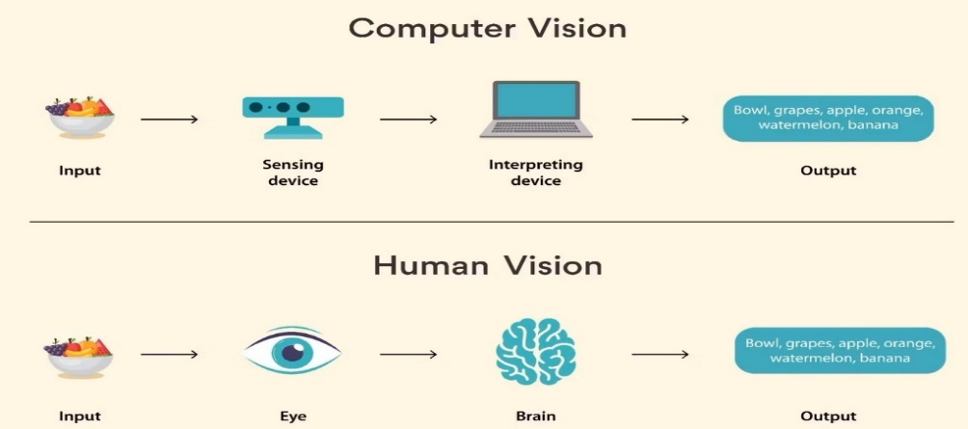Computer vision is a field of artificial intelligence (AI) that uses machine learning and neural networks to teach computers and systems to derive meaningful information from digital images, videos and other visual inputs—and to make recommendations or take actions when they see defects or issues.

Figure 1: illustrate how does CV work.

### 2.2.5. What is CNN?

A Convolutional Neural Network (CNN) is a type of deep learning model specifically designed to process data with a grid pattern, such as images.

The architecture of CNN consists of three main types of layers: convolutional layers, pooling layers, and fully connected layers. Convolutional layers perform feature extraction by applying a set of learnable filters, known as kernels, to the input data. These filters scan the input data in a localized manner, capturing relevant features at different spatial locations. Pooling layers reduce the spatial dimensions of the extracted features while retaining the most salient information. Finally, fully connected layers connect the extracted features to the desired output, such as class labels in classification tasks.

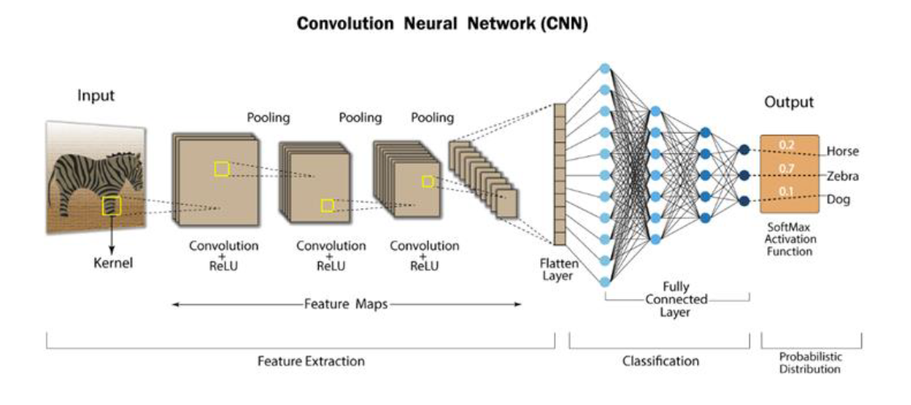

Figure 2 :An overview of CNN architecture.

#### 2.2.5.1. Convolution

Convolution is a crucial operation performed within the convolution layer of a convolutional neural network (CNN). It is a specialized type of linear operation used for feature extraction. In convolution, a small array of numbers, known as a **kernel** or filter, is applied across the input tensor.

During the convolution process, the kernel is systematically moved across the input tensor, performing element-wise multiplication between the kernel values and the corresponding input values within its receptive field. These products are then summed to produce a single value, which represents a feature in the output tensor, also known as a feature map.

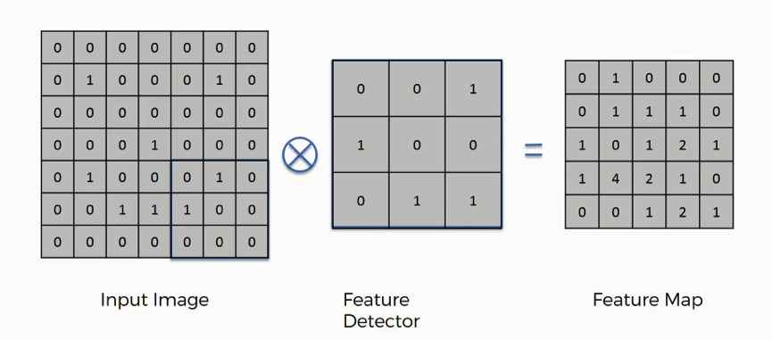

Figure 3:Example of convolution

#### 2.2.5.2 Padding

Padding is a technique used in convolutional neural networks (CNNs) to address the issue of reduced dimensions in the output feature map. In the convolution operation, the center of each kernel cannot overlap the outermost elements of the input tensor, leading to a decrease in the height and width of the feature map compared to the input.

To overcome this limitation, padding is employed, typically in the form of zero padding. It involves adding rows and columns of zeros around the borders of the input tensor. By introducing this additional padding, the center of a kernel can be positioned on the outermost elements, ensuring that the convolution operation can be performed while maintaining the same in-plane dimensions.

Modern CNN architectures commonly adopt zero padding to preserve the in-plane dimensions throughout the network. Without padding, each subsequent feature map would progressively shrink in size after each convolution operation.

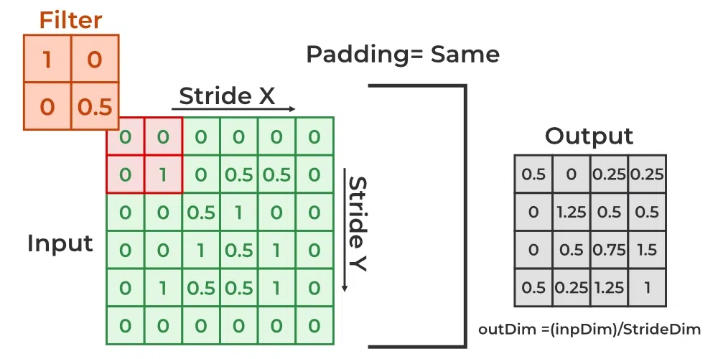

Figure 4 :Example of padding

#### 2.2.5.3.Stride

Stride determines how the filter convolves over the input matrix, how many pixels shift. When stride is set to 1, the filter moves across one pixel at a time, and when the stride is set to 2, the filter moves across two pixels at a time. The smaller the stride value, the smaller the output, and vice versa .

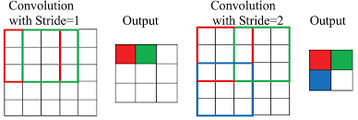

Figure 5 :An Example of stride

#### 2.2.5.4. Pooling Layer

A pooling layer is a component commonly found in convolutional neural networks (CNNs) that performs down sampling operations on the input feature maps. The primary purpose of the pooling layer is to introduce translation invariance to small shifts and distortions in the data while reducing the spatial dimensions of the feature maps. This reduction in dimensionality helps to decrease the number of learnable parameters in subsequent layers. Unlike convolutional and fully connected layers, pooling layers do not have any learnable parameters. Instead, they utilize hyperparameters such as filter size, stride, and padding to control their operations, like convolutional layers.

#### 2.2.5.5.Max Pooling

Max pooling is the most widely used type of pooling operation. It works by dividing the input feature maps into non-overlapping patches or regions and selecting the maximum value within each patch while discarding the other values. A common configuration is to use a max pooling filter with a size of 2x2 and a stride of 2. This means that the pooling operation down sample the in-plane dimensions of the feature maps by a factor of 2. It is important to note that the depth dimension of the feature maps remains unchanged.

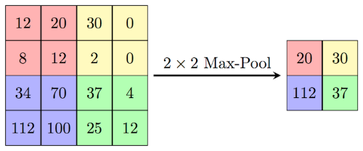

Figure 6 :An Example of max pooling

### 2.2.6. What is YOLO?

You only look once(YOLO) is a state-of-the-art, real-time object detection system. It is so fast, that it has become the standard way of detection of objects in the field of computer vision. the algorithm works based on four approaches: Residual blocks, Bounding box regression, Intersection Over Unions or IOU for short and Non-Maximum Suppression.

#### 2.2.6.1.Residual blocks

This first step starts by dividing the original image into NxN grid cells of equal shape, where N in our case is 13 shown on the image on the left. Each cell in the grid is responsible for localizing and predicting the class of the object that it covers, along with the probability/confidence value.

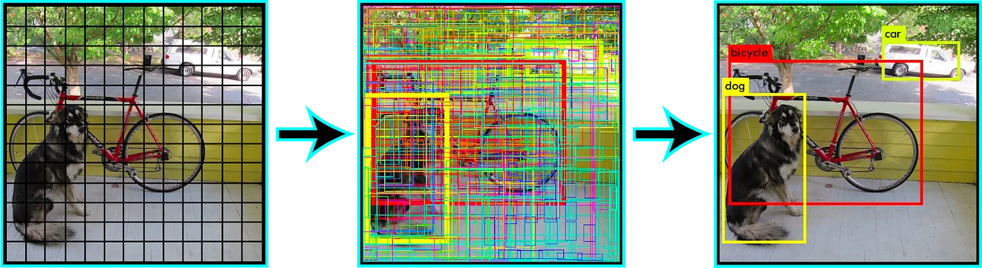

Figure 7 : Residual blocks in YOLO

#### 2.2.6.2 Bounding box regression

Bounding box regression is a technique used in object detection tasks to predict the coordinates of a bounding box that tightly encloses an object of interest within an image.

YOLO determines the attributes of these bounding boxes using a single regression module in the following format, where Y is the final vector representation for each bounding box.

**Y = [pc, bx, by, bh, bw, c1, c2]**  
This is especially important during the training phase of the model.

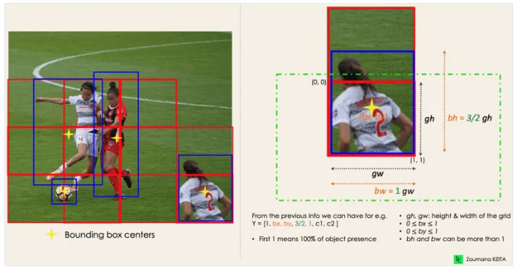

Figure 8 : Bounding box regression in YOLO

#### 2.2.6.2 Intersection Over Union (IOU):

Intersection over Union, commonly referred to as IOU, is a metric used to evaluate the overlap between two bounding boxes or regions of interest. It quantifies the similarity or agreement between the predicted bounding box and the ground truth bounding box. IOU is calculated as the ratio of the intersection area to the union area of the two bounding boxes. It is often used as a criterion for evaluating the performance of object detection algorithms, where a higher IOU indicates better detection accuracy

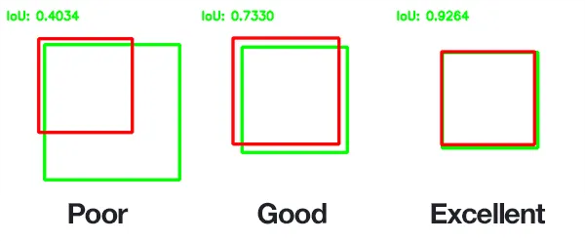

Figure 9 : IOU in YOLO

2.2.6.3 Why yolov8?• **State-of-the-Art Performance:** The summaries mention the system uses pre-trained text recognition and potentially object detection models. YOLOv8 is advertised as a state-of-the-art computer vision model, suggesting it might offer higher accuracy in detecting and recognizing license plates compared to older YOLO versions.

• **Efficiency:** Real-time processing of video frames is crucial for license plate recognition. YOLOv8 claims to be faster than previous YOLO versions, especially on smaller devices. This efficiency could be advantageous for running the system on resource-constrained hardware.

• **Ease of Use:** The summaries mention using a pre-trained model with a Python package and potentially a command-line interface. YOLOv8 is known for its user-friendly implementation with well-structured code and easy integration into Python projects.

• **Development and Community:** YOLOv8 is under active development, suggesting ongoing improvements and potential for future enhancements. Additionally, a growing community around YOLOv8 could provide support and resources for implementing and troubleshooting the model.

2.2.7. What is LSTM?Long Short-Term Memory (LSTM) is a type of artificial recurrent neural network (RNN) architecture used in the field of deep learning. Unlike standard feedforward neural networks, LSTMs have feedback connections, allowing them to exploit temporal dependencies across sequences of data. LSTM is designed to handle the issue of vanishing or exploding gradients, which can occur when training traditional RNNs on sequences of data. This makes them well-suited for tasks involving sequential data, such as natural language processing (NLP), speech recognition, and time series forecasting

LSTM networks introduce memory cells, which have the ability to retain information over long sequences. Each memory cell has three main components: an input gate, a forget gate, and an output gate. These gates help regulate the flow of information in and out of the memory cell.

The input gate determines how much of the new input should be stored in the memory cell. It takes the current input and the previous hidden state as inputs, and outputs a value between 0 and 1 for each element of the memory cell.

The forget gate decides which information to discard from the memory cell. It takes the current input and the previous hidden state as inputs, and outputs a value between 0 and 1 for each element of the memory cell. A value of 0 means the information is ignored, while a value of 1 means it is retained.

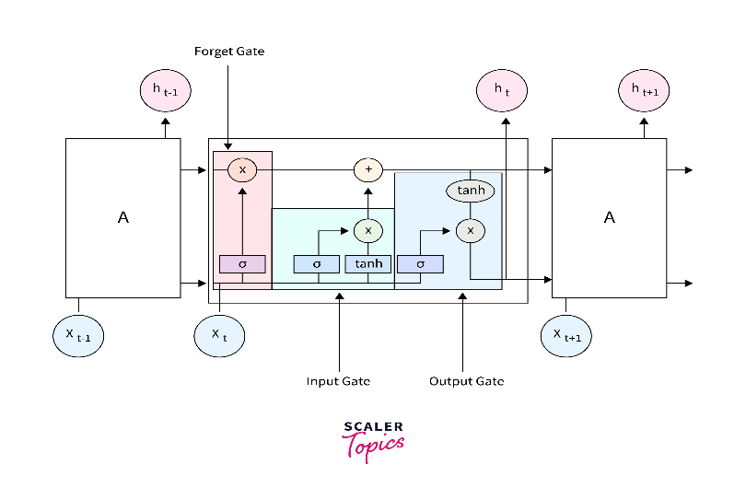 The output gate controls how much of the memory cell’s content should be used to compute the hidden state. It takes the current input and the previous hidden state as inputs, and outputs a value between 0 and 1 for each element of the memory cell.

Figure 10: illustrate LSTM

## 2.3 Literature Survey

### 2.3.1 Overview of the Application Area

Crime detection is a critical aspect of maintaining public safety and security. It involves identifying and preventing criminal activities through various means such as surveillance, law enforcement operations, and data analysis. The primary goal of crime detection is to reduce crime rates, apprehend offenders, and ensure a safe environment for communities. In recent years, the application of advanced technologies in crime detection has gained significant traction. By leveraging modern computational methods, law enforcement agencies can enhance their capabilities to predict, detect, and respond to criminal activities more effectively.

### 2.3.2.Reviewing Main Modules in the Selected Scope

#### 2.3.2.1.Action Recognition

Action recognition involves analysing video footage to detect and interpret human actions. This technology can be used in crime detection to identify suspicious behaviours such as Fighting.

* **Approaches and Methodologies**:
  + **Deep Learning Models**: Convolutional Neural Networks (CNNs) and Long- Short-Term-Memory (LSTM) are widely used to recognize actions in videos.
  + **Advantages**: High accuracy in recognizing complex actions, adaptable to different scenarios.
  + **Disadvantages**: Requires large amounts of labelled data, computationally intensive.
* **Tool Detection**

Tool detection focuses on identifying objects, especially potential weapons or tools used in crimes, within video footage or images.

* **Approaches and Methodologies**:
  + **Object Detection Algorithms**: Techniques like YOLO (You Only Look Once) we use version 8 of YOLO, YOLO’s efficiency in detecting various objects in complex scenes ‎.
  + **Advantages**: Real-time detection capabilities, good and acceptable accuracy.
  + **Disadvantages**: Not the best accuracy.
  + **Comparative Study**: YOLO provides faster detection compared to SSD but may have slightly lower accuracy in detecting small objects.

#### 2.3.2.2.Low-Light Model

Low-light models are designed to enhance the visibility and detection accuracy of surveillance footage captured in poor lighting conditions.

* **Approaches and Methodologies**:
  + **Image Enhancement Techniques**: Methods like histogram equalization, Retinex theory, and deep learning-based enhancement. Lore et al. (2017) proposed a deep learning approach using a stacked sparse denoising autoencoder for low-light image enhancement.
  + **Advantages**: Improves visibility and detection accuracy in low-light conditions, useful for night-time surveillance.
  + **Disadvantages**: Can introduce noise, computationally intensive.
  + **Comparative Study**: Deep learning-based enhancement methods outperform traditional techniques in terms of clarity and detail retention but require significant computational resources.

#### 2.3.2.3.Upscaling

Upscaling technology is used to improve the resolution of surveillance footage, making it easier to identify details such as faces and license plates.

* **Approaches and Methodologies**:
  + **Super-Resolution Techniques**: Methods like bicubic interpolation, CNN-based super-resolution (e.g., SRCNN). Dong et al. (2014) introduced SRCNN[12], a deep learning model for image super-resolution.
  + **Advantages**: Enhances image details, useful for improving the quality of low-resolution footage.
  + **Disadvantages**: May introduce artifacts, requires significant processing power.
  + **Comparative Study**: CNN-based super-resolution techniques provide better detail enhancement compared to traditional methods but at the cost of higher computational requirements.

#### 2.3.2.4.Plate Detection

Plate detection technology reads and analyses vehicle license plates using image recognition algorithms. This is crucial in identifying vehicles involved in criminal activities, tracking stolen cars, and enforcing traffic laws.

* **Approaches and Methodologies**:
  + **Optical Character Recognition (OCR)**: Combined with image processing techniques to detect and read license plates.
  + **Advantages**: High accuracy in controlled environments, effective in various lighting conditions.
  + **Disadvantages**: Performance issues with dirty or damaged plates, sensitivity to angle and motion blur.
  + **Comparative Study**: OCR-based methods outperform simple image processing techniques in terms of accuracy and adaptability but require better preprocessing steps to handle challenging conditions.

#### 2.3.2.5.Face Detection

Face detection technology identifies and verifies individuals based on facial features. This is used in surveillance systems to recognize known offenders, missing persons, or unauthorized individuals in restricted areas.

* **Approaches and Methodologies**:
  + **Deep Learning Models**: Techniques like CNNs, particularly models like FaceNet and RetinaFace, have shown high accuracy in face detection. Schroff et al. (2015) introduced FaceNet, achieving significant improvements in face recognition accuracy ‎[13].
  + **Advantages**: High accuracy and robustness, effective in various lighting and angle conditions.
  + **Disadvantages**: Privacy concerns, potential for biases in training data.
  + **Comparative Study**: Deep learning models provide superior performance compared to traditional methods like Haar Cascades but at the cost of requiring extensive computational resources.

2.3.2.6.User Interface A user-friendly interface is essential for efficiently managing and analysing surveillance data. This section outlines how to implement a user interface using Django to handle the functionalities described in the previous sections.

* + **Approaches and Methodologies:**
    - Web Framework: Django is a high-level Python web framework that encourages rapid development and clean, pragmatic design. It can be used to build a comprehensive interface for action recognition, tool detection, low-light enhancement, upscaling, plate detection, and face detection.
  + **Advantages:** Easy to integrate various functionalities, scalable, supports rapid development, and provides a clean and maintainable codebase.
  + **Disadvantages:** Requires knowledge of web development, may involve additional overhead in terms of server management and deployment and it’s slow in execute.

Chapter3  
 The Proposed Solution  
  
In this chapter, we will get acquainted with the details of building our system (CrimeGuard). Additionally, will provide a detailed SDD. We will discuss the low-level design, the architectural design, and the detailed design enhanced with UML model diagrams (Block Diagram, Flowchart Diagrams, Activity Diagrams, Use Case Diagram, Sequence Diagrams, and Entity Relationship Diagrams).

3.1 Solution Methodology:  
The proposed system is designed to enhance public safety by integrating advanced image processing and machine learning techniques. The system is divided into two main phases: crime and tool detection with image enhancement, and face and license plate detection and recognition.  
  
By dividing the system into two phases, we leverage specialized models and techniques for crime detection and enhancement of low-light images, followed by robust face and license plate detection and recognition. This comprehensive approach ensures accurate, real-time monitoring and identification, significantly enhancing public safety and security measures. The architecture the system is shown in Figure below:  
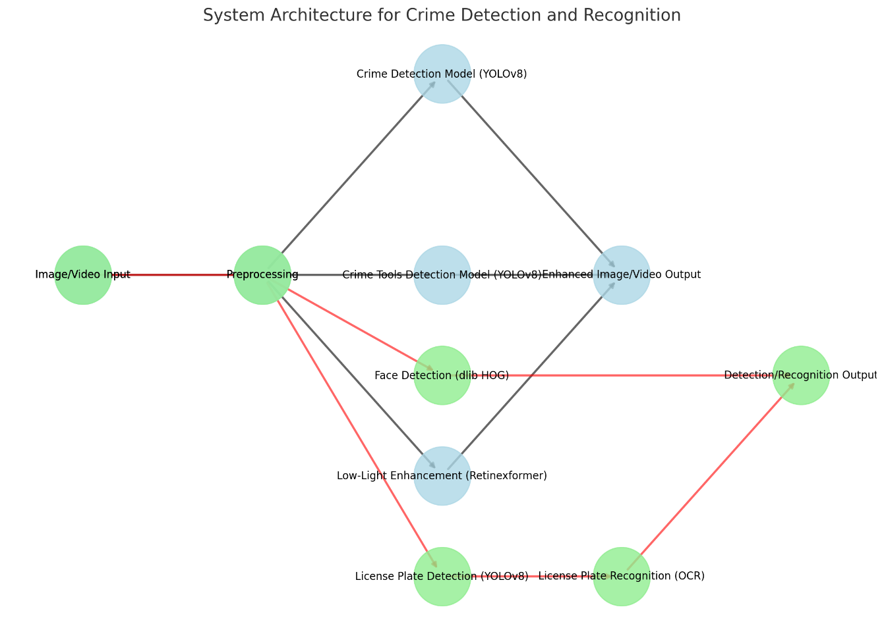  
 Figure 11 :The system Architecture   
  
  
Phase 1: Crime Detection, Tool Detection, and Image Enhancement

1. Image/Video Input: Capture input from cameras.
2. Preprocessing: Enhance image quality, remove noise, and extract regions of interest (ROI).
3. Crime Detection Model (YOLOv8): Detect criminal activities such as fighting, fire, smoking, presence of guns, and knives.
4. Crime Tools Detection Model (YOLOv8): Identify crime tools like guns and knives.
5. Low-Light Enhancement (Retinexformer ): Improve visibility in low-light images.
6. Enhanced Image/Video Output: Output enhanced images/videos with detected crimes and tools.

#### Phase 2: Face Detection and Recognition, and License Plate Detection and Recognition

1. Image/Video Input: Capture input from cameras.
2. Preprocessing: Enhance image quality and prepare data for further processing.
3. Face Detection (MTCNN): Detect faces in the input images/videos.
4. Face Recognition (dlib HOG): Recognize and match detected faces with stored identities.
5. License Plate Detection (YOLOv8): Detect vehicle license plates.
6. License Plate Recognition (OCR): Extract and recognize characters from detected license plates.
7. Detection/Recognition Output: Output the recognized faces and license plates.

3.1.1 Crime Detection Models:  
3.1.1.1 Behaviour Detection Using CNN-LSTM:  
Behaviour Detection Using CNN-LSTM involves identifying and categorizing human actions or activities in videos. Both Convolutional Neural Networks (CNNs) and Long Short-Term Memory (LSTM) networks are commonly used in action recognition systems due to their complementary strengths. As shown in Figure below:  
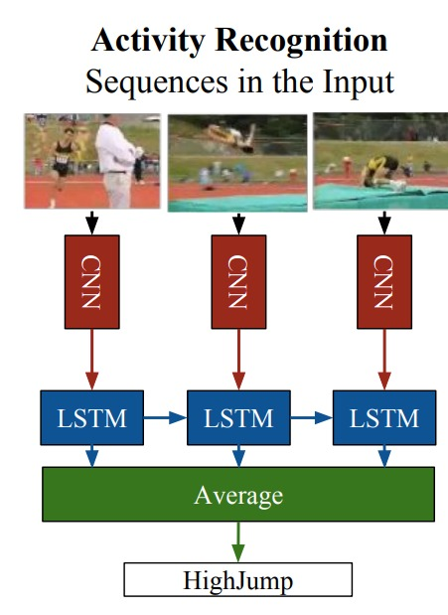

Figure 12 :The CNN-LSTM Architecture   
  
Workflow Overview

1. Input (Video Sequences):
   * Captures activities over time.
2. 3D Convolutional Neural Network (3D CNN):
   * Purpose: Extracts spatial and temporal features.
   * Operation: Uses 3D filters to process motion and spatial details.
3. Long Short-Term Memory (LSTM) Networks:
   * Purpose: Learns temporal dependencies in sequences.
   * Operation: Processes 3D CNN features to understand action progression.
4. Dense (Fully Connected) Layer:
   * Purpose: Consolidates LSTM features for final decision.
   * Operation: Produces probability scores for classification.
5. Output (Classification):
   * Purpose: Provides final activity classification.
   * Operation: Classifies activity as "fight" or "not fight" based on score.
6. Averaging Layer (if used):
   * Purpose: Aggregates predictions from multiple sequences.
   * Operation: Enhances stability and accuracy by averaging LSTM outputs.

#### Example Workflow

1. Preprocessing: Resize and normalize video frames.
2. Feature Extraction (3D CNN): Extract spatio-temporal features.
3. Temporal Analysis (LSTM): Analyze temporal dynamics.
4. Prediction (Dense Layer): Predict fight probability.
5. Classification: Classify activity based on probability score.

#### Benefits

1. Spatial and Temporal Analysis: Captures complex activities.
2. Sequence Learning: Understands action sequences.
3. End-to-End Training: Optimizes performance and accuracy.  
     
   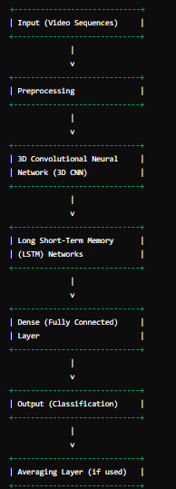  
    Figure 13 :Flowchart of CNN-LSTM Architecture

3.1.1.2 Crime Tools Detection using YOLOv8:  
  
Crime tools detection is a crucial application in the field of computer vision and artificial intelligence. Leveraging state-of-the-art object detection algorithms can significantly enhance security measures by automatically identifying potentially dangerous tools or weapons in various settings such as airports, public events, or surveillance footage. YOLOv8 (You Only Look Once version 8) is one such advanced real-time object detection model that can be employed for this purpose. This documentation provides an overview of how to use YOLOv8 for detecting crime tools, detailing the architecture and implementation process.

**HOW IT WORK?**

The basic idea behind YOLO is to divide the input image into a grid of cells and, for each cell, predict the probability of the presence of an object and the bounding box coordinates of the object. The process of YOLO can be broken down into several steps:

1. Input image is passed through a CNN to extract features from the image.

2. The features are then passed through a series of fully connected layers, which predict ‌class probabilities and bounding box coordinates.

3. The image is divided into a grid of cells, and each cell is responsible for predicting a set of bounding boxes and class probabilities.

4. The output of the network is a set of bounding boxes and class probabilities for each cell.

5. The bounding boxes are then filtered using a post-processing algorithm called non-max suppression to remove overlapping boxes and choose the box with the highest probability.  
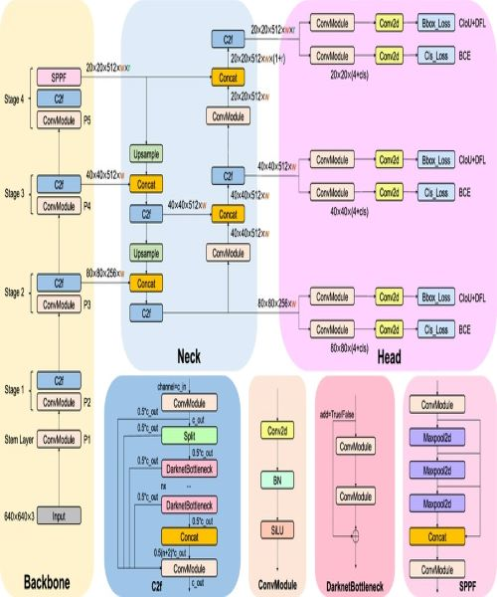

3.1.2 Low Light Model:  
  
Improving the quality of low-light images has been a challenge for deep learning algorithms. Existing methods, often inspired by Retinex theory, struggle to handle noise and require complex training procedures. Additionally, they rely heavily on convolutional neural networks, which can miss important relationships between distant parts of the image.

To overcome these limitations, researchers have introduced Retinexformer, a novel deep learning framework specifically designed for low-light image enhancement. Retinexformer tackles this problem in two stages: first, it estimates the lighting conditions to brighten the image, and then it restores details to create a high-quality result. A key innovation is the Illumination-Guided Transformer (IGT), which plays a crucial role in capturing long-range connections within the image, even in areas with varying light levels.

Extensive testing demonstrates that Retinexformer outperforms current state-of-the-art methods, achieving superior image quality. This approach is not only effective for general image enhancement, but also proves valuable for real-world tasks like low-light object detection. The public release of the code and models allows others to explore the potential of Retinexformer and its impact on various low-light image processing applications.  
  
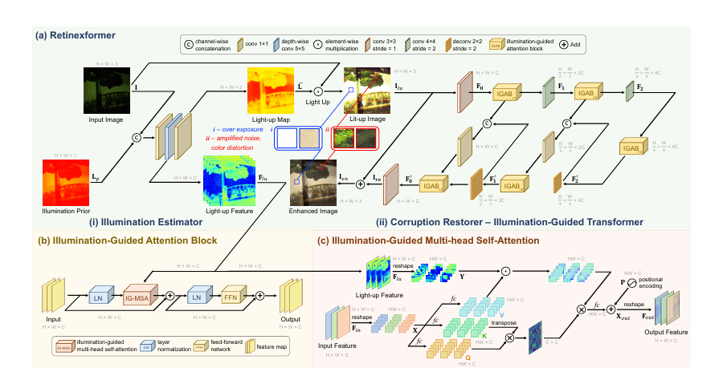

Figure 14:The Retinexformer Architecture  
  
Retinexformer tackles low-light image enhancement in a clever two-stage process. First, it estimates how the lighting affects the image. A dedicated illumination estimator creates a map revealing areas with overexposure or color problems. This map is then used to create a brightened and color-corrected version of the image.

Next, Retinexformer employs a powerful tool called the Illumination-Guided Transformer (IGT) for detail restoration. IGT relies on building blocks named Illumination-Guided Attention Blocks (IGAB). These blocks analyze the image while considering the illumination information. Essentially, they pay more attention to features in regions that need the most correction based on the lighting issues. This is achieved through a multi-step process within each IGAB: normalization, illumination-guided self-attention, and feeding the processed data through a network to generate the final output. The self-attention mechanism itself leverages illumination data to focus on crucial details in different image areas.

By combining illumination correction with detail restoration guided by illumination information, Retinexformer achieves impressive results. The final image is not only brighter and free of overexposure but also boasts reduced noise and minimal color distortion.  
  
3.1.3.UpScaling Using Latent Diffusion Model (LDM):  
  
Creating high-quality images with diffusion models (DMs) has traditionally been a computationally expensive task. These models, while powerful, require significant resources to train and use because they work directly on every pixel of an image.

Researchers have proposed a new approach called Latent Diffusion Models (LDMs) to address this challenge. LDMs work in a more efficient way by operating in the "latent space" of a pre-trained autoencoder. This compressed space reduces complexity while retaining the image's crucial details. Additionally, LDMs incorporate innovative "cross-attention layers" that allow them to be guided by textual descriptions or bounding boxes. This enables them to generate high-resolution images using efficient convolutional operations.

The benefits of LDMs are compelling. They achieve state-of-the-art results in various tasks like image inpainting and text-to-image synthesis, while also performing competitively across other image generation applications. Most importantly, they achieve this level of performance with significantly reduced computational requirements compared to traditional diffusion models. This paves the way for more practical and accessible applications of diffusion models in image generation.  
  
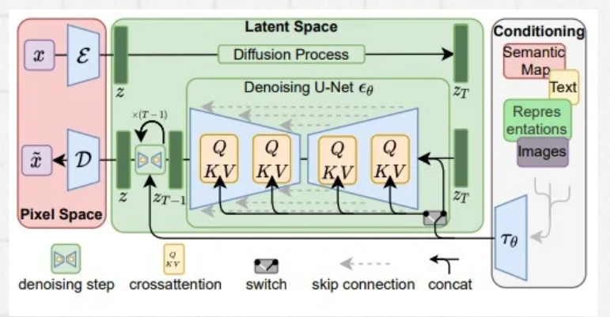  
 Figure 15 :The Latent Diffusion Model (LDM) Architecture  
  
The flowchart shown in Figure depicts the workflow of the image generation process, which involves encoding an input image, applying a diffusion process with noise injection, denoising the latent representation with conditional guidance, and finally decoding the denoised representation to generate the output image.

1. **Start:** The process begins with an input image.
2. **Encode:** The input image is fed into an encoder, which analyzes it and creates a compressed version of it called a latent representation. This latent representation captures the essence of the image while being more efficient to work with.
3. **Diffusion Process:** The latent representation enters the diffusion process. Here, noise is gradually added across multiple steps, essentially transforming the clear image representation into a noisy mess.
4. **Denoising with Conditional Guidance:** A special network called a Denoising U-Net tackles the noisy mess. This U-Net works step-by-step, removing noise from the increasingly clean versions of the latent representation. Crucially, the U-Net incorporates cross-attention modules at each step. These modules can receive various types of information, such as text descriptions or additional images. By paying attention to this conditioning information, the U-Net can remove noise while also incorporating the desired elements guided by this external data.
5. **Skip Connection:** A skip connection is included to help preserve information across layers, facilitating gradient flow during training.
6. **Decode:** Finally, the denoised latent representation is fed into a decoder. This decoder undoes the work of the encoder, transforming the compressed version back into a complete image.
7. **End:** The process outputs the generated image.

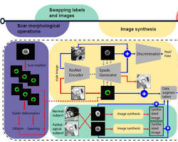

Figure 16 :Flowchart of Latent Diffusion Model (LDM)

3.1.4 Face Detection and Recognition:  
We used advanced facial recognition technology to assist law enforcement in identifying suspects and solving criminal cases. By leveraging the latest advancements in computer vision and machine learning, our system can accurately match faces from various image and video sources against a database of known criminal profiles. We Recognize and detect faces with the world's simplest face recognition library. The library is built on top of the dlib library, which includes deep learning models for face encoding and matching. This library provides simple, yet powerful tools for face detection, facial feature extraction, and face recognition.  
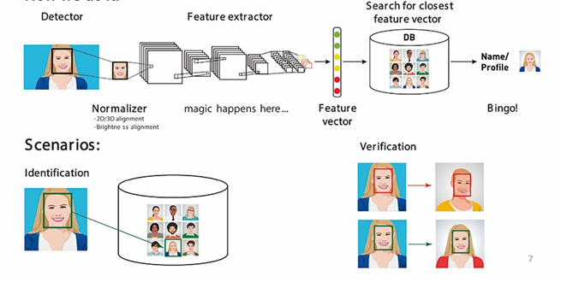**A Face Recognition pipeline can be divided into four major stages:**

1-Face Detection

2- Face Alignment

3- Face encoding

4- Face comparing

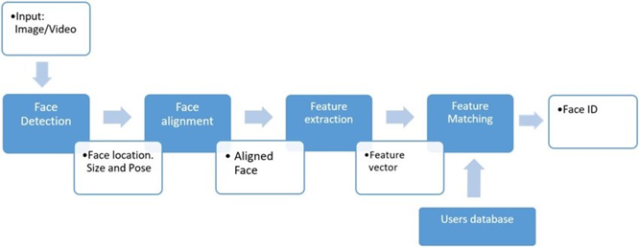 Figure 17: Explain face recognition process

Figure 18 : Example of How face recognition model steps work.

#### 3.1.4.1.Face detection (using dlib HOG)

This is based on the **HOG** (Histogram of Oriented Gradients) feature descriptor with a **linear SVM** machine learning algorithm to perform face detection. HOG is a simple and powerful feature descriptor.

The basic idea of HOG is

* dividing the image into small connected cells.
* Computes histogram for each cell.
* Bring all histograms together to form feature vector . it forms one histogram from all small histograms which is unique for each face.

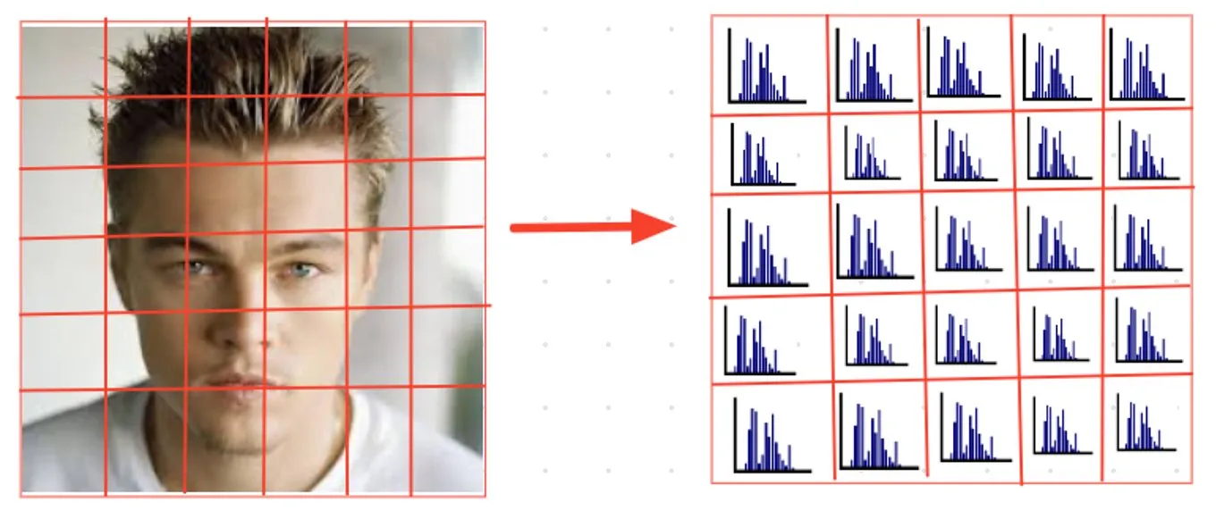 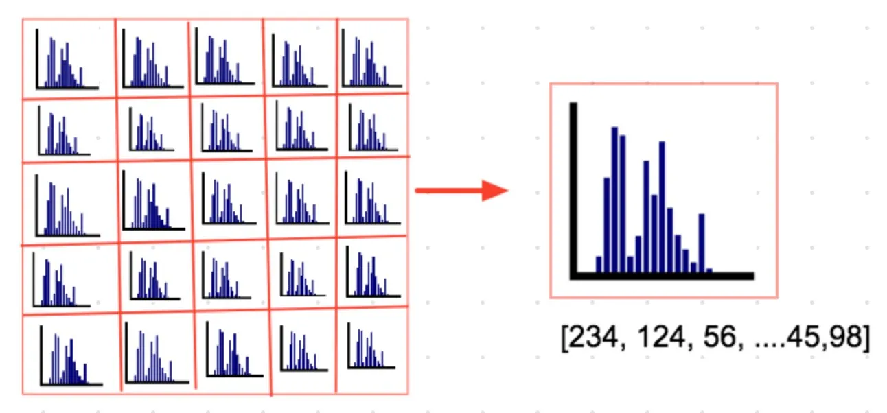

Figure 19 : Illustrate the HOG steps.

#### 3.1.4..2Face Alignment

Face alignment corrects variations in head pose and facial expression by aligning each face to a standard

position

#### 3.1.4.3Face encoding

It is basically a way to represent the face using a set of 128 computer-generated measurements. Two different pictures of the same person would have similar encoding and two different people would have totally different encoding.

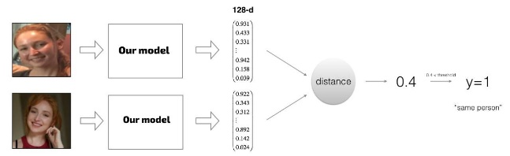

Figure 20: Illustrate face encoding.

#### 3.1.4.4Face Comparing

When performing a face comparing, the system calculates a similarity score between the target face and each face in the database. This score represents how closely the two faces resemble each other based on the extracted facial features.

To determine if a face in the database is a match for the target, the system compares the similarity score against a predefined threshold value. If the similarity score meets or exceeds the threshold, the system considers that face to be a match.

#### 3.1.4.5Gender Detection

#### 3.1.4.5.1Methodology

We present a gender detection model based on the VGGNet architecture, which leverages the depth and powerful feature extraction capabilities of this deep neural network.

Inputs: The VGGNet accepts 224224-pixel images as input. To maintain a consistent input size for the ImageNet competition, the model’s developers chopped out the central 224224 patches in each image.

Convolutional Layers: VGG’s convolutional layers use the smallest feasible receptive field, or 33, to record left-to-right and up-to-down movement. Additionally, 11 convolution filters are used to transform the input linearly. The next component is a ReLU unit, a significant advancement from AlexNet that shortens training time. Rectified linear unit activation function, or ReLU, is a piecewise linear function that, if the input is positive, outputs the input; otherwise, the output is zero. The convolution stride is fixed at 1 pixel to keep the spatial resolution preserved after convolution (stride is the number of pixel shifts over the input matrix).

**Hidden Layers:** The VGG network’s hidden layers all make use of ReLU. Local Response Normalization (LRN) is typically not used with VGG as it increases memory usage and training time. Furthermore, it doesn’t increase overall accuracy.

**Fully Connected Layers:** The VGGNet contains three layers with full connectivity. The first two levels each have 4096 channels, while the third layer has 1000 channels with one channel for each class.

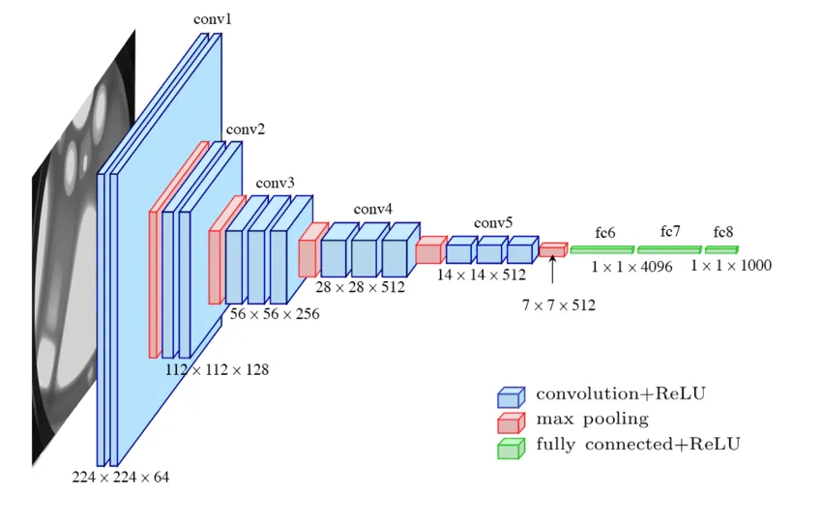

Figure 21 : Illustrate VGG-Net Architecture

3.1.5 Plate DETECTION and Recognition:  
  
This system tackles the task of identifying and reading vehicle license plates in two steps. First, it employs a YOLOv8 object detection model to pinpoint the location of the license plate within an image. Then, it utilizes Optical Character Recognition (OCR) technology to decipher the individual characters on the identified plate. The researchers tested their system on a large dataset of license plate images (License Plate Recognition Image Dataset) and achieved an impressive accuracy rate of 98.1%. This promising approach has the potential to be applied in real-world situations, such as security applications, traffic management, and access control systems for restricted areas. Facing challenges as shown in Figure   
  
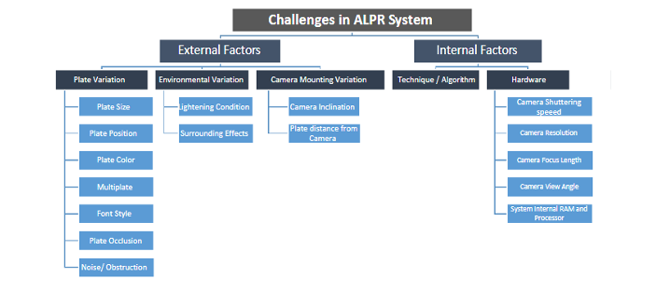  
 Figure 22:. Categories of distinct automatic license N.P. recognition system challenges  
  
Advantages of NP recognition systems include:

* Enhanced monitoring and surveillance
* Both still and video recording capabilities
* Improved security
* Reduced need for manual surveillance

3.1.5.1 System Design  
  
 the system for number plate detection using OCR and YOLOv8 is designed to ensure high accuracy and real-time processing. Key components include:

1. Image Acquisition: High-resolution cameras capture images or video frames of vehicles at strategic locations.
2. Preprocessing: Techniques are applied to enhance image quality, adjust lighting, and reduce noise.
3. YOLOv8-Based Detection: The YOLOv8 model detects and localizes number plates within the images, providing high accuracy and real-time processing.
4. Region of Interest (ROI) Extraction: Detected number plate areas are isolated for further processing.
5. Optical Character Recognition (OCR): OCR is used to segment, recognize, and convert characters on the number plates into text.
6. Post-Processing: Refinement of OCR results, error correction, and output formatting.
7. Integration and Storage: Recognized data is integrated with existing databases and systems for applications like vehicle tracking and toll collection, with secure storage.
8. User Interface and Reporting: A user-friendly interface is provided for monitoring and managing data, generating real-time reports and alerts.  
   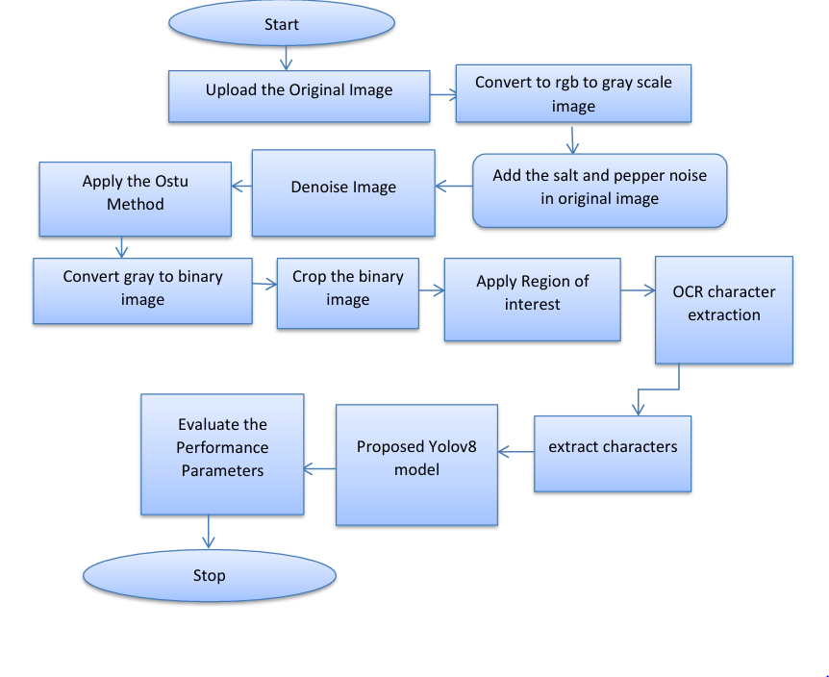

Figure 23 : Workflow and steps of the proposed system

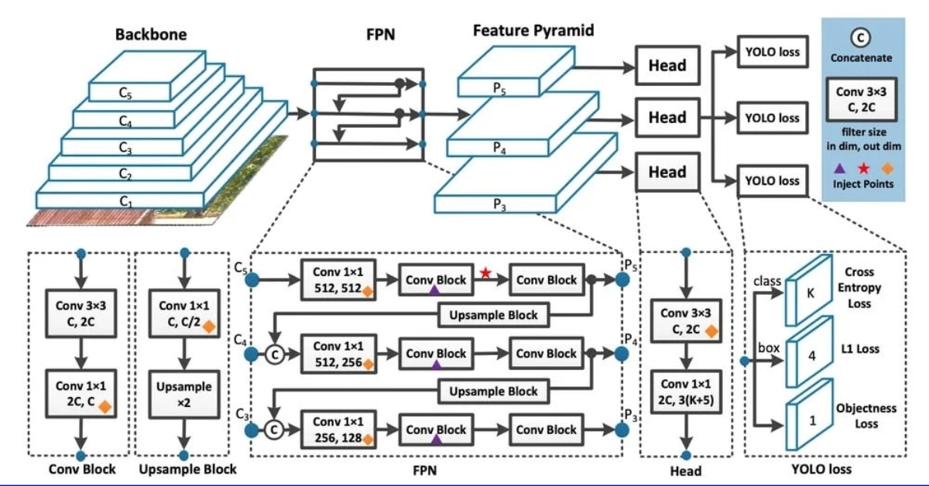3.1.5.2 Methods:  
  
Vehicle number plate recognition system (VNPRS), the proposed Yolov8 method, defined different steps: • Pre-processing is applied using grayscale, resize, crop, noise removal, smooth images, and segmentation methods. • A novel Yolov8 model was implemented for segmentation and detection purposes. • Valuable features of vehicle license NPSR are attained in feature and distance evaluation equations. The research model workflow Yolov8 approach is defined in Figure  
  
**1.The Plates Detector (yolov8)**  
The YOLOv8 architecture is comprised of several key components ,including a backbone network, neck, and head. The backbone network is responsible for extracting feature maps from the input image, while the neck fuses information from different scales to improve detection performance.

Figure 24: Architecture of yolov8  
**2.The plates Number Reader (ocr)**  
The aim of this study is to evaluate the impact of using Optical Character Recognition(OCR) technology on improving the efficiency of vehicle license plate control and traffic safety in Tirana. To reach these conclusions, the study employs a mixed- methods approach, combining qualitative and quantitative data analysis to provide a comprehensive assessment of the effects of implementing OCR technology. The use of OCR technology was chosen for this system due to its demonstrated accuracy and efficiency in the automatic identification of text in images.   
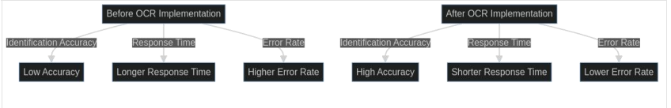  
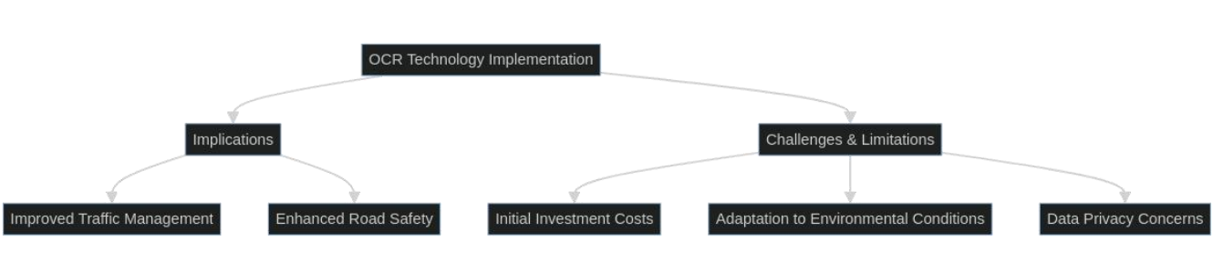  
  
 Figure 25 : Implications of OCR Technology

3.1.5.3pipeline   
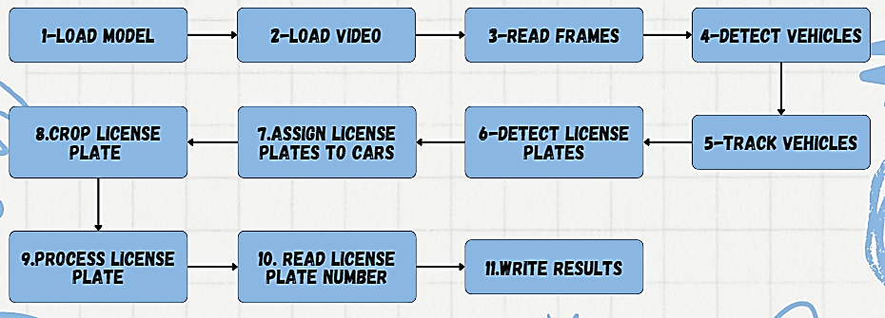  
 Figure 26 : Pipeline of yolov8  
3.1.6 User Interface for Surveillance Systems Using Django

A well-designed user interface (UI) is essential for efficiently managing and analysing surveillance data. The UI acts as the intermediary between the user and the underlying surveillance models, providing a seamless and intuitive experience. Using Django, a high-level Python web framework, for developing the UI is particularly advantageous due to its scalability, ease of integration, and rapid development capabilities. This section will discuss why Django is an ideal choice for handling large models in surveillance systems, including a comparison with other frameworks and a step-by-step sequence of implementation.

#### 3.1.6.1 Why Django is Ideal for Big Models:

* **Scalability:** Django's architecture is designed to handle high traffic and large amounts of data, making it suitable for applications that require processing and displaying results from big models.
* **Integration:** Django's built-in support for various databases, REST APIs, and other web technologies makes it easy to integrate complex surveillance models into the UI.
* **Security:** Django comes with robust security features, which are crucial for applications handling sensitive surveillance data.
* **Community and Support:** Being one of the most popular web frameworks, Django has a large community and extensive documentation, ensuring that developers can find support and resources easily.

#### 3.1.6.2 Comparison with Other Frameworks:

* **Flask vs. Django:**
  + Flask is a micro-framework that provides greater flexibility but requires more setup and configuration for larger applications. Django, on the other hand, follows the "batteries-included" philosophy, offering a wide range of built-in features.
  + For large-scale surveillance systems, Django's comprehensive features and scalability are more suitable compared to Flask's minimalist approach.
* **FastAPI vs. Django:**
  + FastAPI is known for its performance and ease of building APIs, making it a good choice for microservices and real-time applications.
  + However, Django provides a more holistic framework with integrated admin panels, ORM, and template engines, making it better suited for building complete web applications that include complex UIs and extensive database interactions.

#### 3.1.6.3 Implementation Sequence:

**1. Set Up Django Project:**

* **Install Django:** Start by installing Django through the package manager.
* **Start a New Project:** Use Django's command-line tools to create a new project.
* **Create an App:** Within the project, create a new app dedicated to the surveillance system functionalities.

**2. Create Models and Views:**

* **Define Models:** Set up models to store surveillance data, including video files, metadata, and results from the surveillance models.
* **Develop Views:** Create views to handle user requests. These views will process data, call the surveillance models, and prepare the data for display.

**3. Design Templates:**

* **Create HTML Templates:** Develop HTML templates for the user interface. These templates will be used to upload videos, display processed results, and manage data.
* **Integrate Templates with Views:** Link the templates with Django views to ensure that user actions are processed correctly and results are displayed in real-time.

**4. Integrate Functionalities:**

* **Form Handling:** Use Django forms to manage video and image uploads. This includes validation and saving the files to the server.
* **Model Integration:** Connect the uploaded data to the surveillance models (e.g., action recognition, tool detection). Process the data using these models.
* **Result Display:** Display the results of the processed videos in a user-friendly manner, allowing users to analyze and interpret the data.

**5. Implement Advanced Features:**

* **API Development:** Use Django REST framework to create APIs. These APIs will allow the front-end to interact with the back-end services and models.
* **Real-time Processing:** Implement real-time data processing and notifications using WebSockets and Django Channels. This will enable immediate alerts for critical detections.
* **Database Optimization:** Optimize database interactions and queries to handle large volumes of surveillance data efficiently. This ensures the system remains responsive under load.

**6. How It Works:**

1. **Video Upload:**
   * Users can upload surveillance videos through a simple form in the UI.
   * The uploaded videos are stored in a designated directory on the server.
2. **Processing Pipeline:**
   * Once a video is uploaded, it is processed through various models for action recognition, tool detection, low-light enhancement, upscaling, plate detection, and face detection.
   * Each model performs its specific task and generates results which are stored in the database.
3. **Results Display:**
   * The results of the processed videos are displayed on a dedicated page where users can view details like detected actions, identified tools, enhanced images, and recognized faces and plates.
   * The UI allows users to filter and sort the results for easier analysis.
4. **Real-time Notifications:**
   * For critical detections (e.g., identification of a weapon), real-time notifications can be sent to security personnel through integrated channels.
5. **Historical Data Access:**
   * Users can access historical surveillance data and processed results through the UI.
   * Advanced search and filter options are available to quickly retrieve specific records.
6. **Administrative Interface:**
   * Django's built-in admin panel provides an interface for managing users, models, and other configurations.

Administrators can monitor system performance, manage database records, and configure model parameters.  
3.2 System Analysis & Design

### 3.2.1Bloke Diagram

The block diagram is a fundamental diagram utilized in software design and various other domains, including engineering (such as hardware) and process flow diagrams.

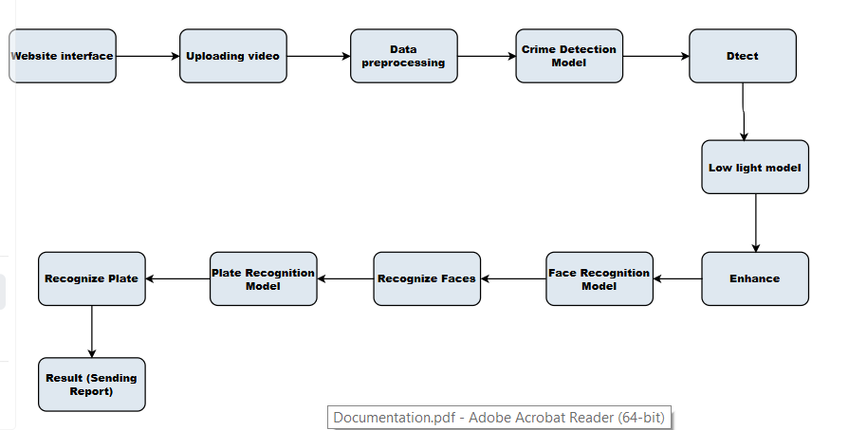

Figure 27: Block Diagram

### 3.2.2.Use Case

A use case is a concise description of how users will perform tasks on a website. It focuses on the user's perspective and outlines the system's behavior in response to user requests.

#### 3.2.3.1Use Case Diagram

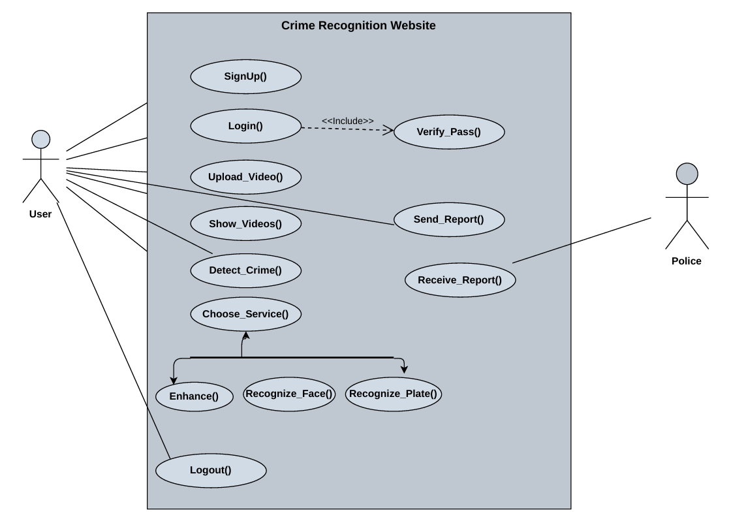

Figure 28: Use Case Diagram

#### 3.2.2.2. Use Case Scenarios

**1- User Signup:**

* A user visits the Crime Recognition Website.
* The user clicks on the "SignUp()" button to create a new account.
* The user provides the necessary information, such as username, email, and password.
* The website verifies the user's password through the "Verify_Pass()" function.
* Upon successful registration, the user can now log in to the website.

**2-User Login:**

* The user clicks on the "Login()" button on the website.
* The user enters their username and password.
* The website verifies the user's credentials through the "Verify_Pass()" function.
* If the login is successful, the user is granted access to the website's features.

**3-Reporting a Crime:**

* The user identifies a crime or suspicious activity.
* The user clicks on the "Upload_Video()" button to upload a video recording of the incident.
* The website processes the video and attempts to detect the crime using the "Detect_Crime()" function.
* If a crime is detected, the user can choose to "Send_Report()" to the police.
* The police can then receive the report through the "Receive_Report()" function.

**4-Choose Service:**

* The user clicks on the "Choose_Service()" button to choose any service.
* The user can choose to "Enhance()" the image, "Recognize_Face()" to identify individuals, or "Recognize_Plate()" to identify vehicle license plates.
* The website processes the image and provides the relevant information to the user.

### 3.2.3.Activity Diagram

Activity diagrams are vital in UML for illustrating a system's dynamic aspects.

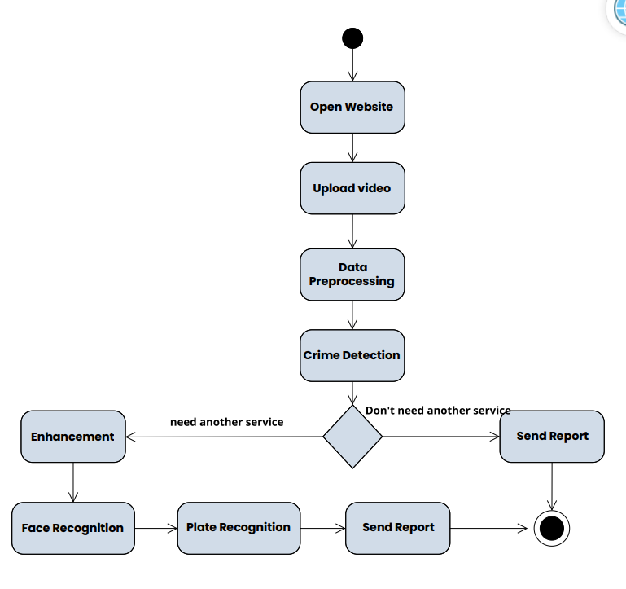

Figure 29: Activity diagram

### 3.2.4.Sequence Diagram

Sequence diagrams are interactive diagrams that provide a detailed overview of how processes are executed within a system. They focus on capturing the interactions between objects as they cooperate to accomplish tasks. With a time focused perspective, sequence diagrams visually present the sequence of interactions by using the vertical axis to depict the timing of message exchanges.

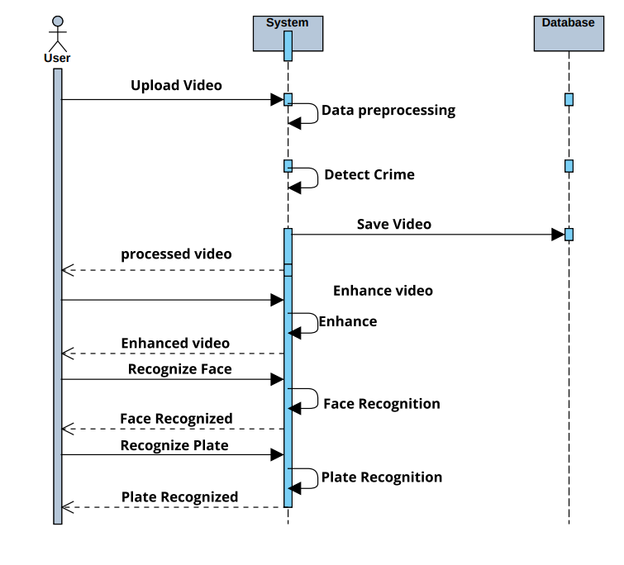

Figure 30:Sequence Diagram

Chapter4  
  
 Implementation, Experimental Setup, & Results  
  
In this chapter, we will delve into the details of our implementation setup, including the program used, The implementation code and setup. Additionally, we will outline the experimental setup and experiments used to evaluate the performance of our system. Furthermore, we will present the results obtained from our experiments and provide a comprehensive evaluation of these results.

4.1 ImplementationThe system implementation comprises several key models, each responsible for specific tasks within the overall activity recognition and monitoring framework. Below is an ordered and detailed scope of the implementation system:  
• **Preprocessing:**

* Input video sequences are preprocessed to resize and normalize frames.

• **Crime Detection:**

* Preprocessed frames are analyzed using CNN-LSTM for detecting criminal activities.

• **Tool Detection:**

* YOLO v8 is applied to frames to detect tools or objects related to crimes.

• **Low-Light Enhancement:**

* Frames captured in low-light conditions are enhanced using the Retinexformer model.

• **Image Upscaling:**

* Enhanced images are upscaled using the Latent Diffusion Model to improve resolution.

• **Face Detection:**

* Faces are detected in frames using dlib HOG.

• **Face Recognition:**

* Detected faces are recognized using VGGNet.

• **Plate Detection and Recognition:**

* YOLO v8 detects license plates, and OCR recognizes the characters on the plates.

4.1.1 Used Programs

     
   
   
4.1.2 Implementation Setup  
4.1.2.1. Dataset Used  
1. Face Detection and Recognize   
Labelled Faces in the Wild , The data set contains more than 13,000 images of faces collected from the web. Each face has been labelled with the name of the person pictured. 1680 of the people pictured have two or more distinct photos in the data set .[14 ]  
  
  
2. Plates Detection and Recognize  
used data set: License Plate Recognition Image Dataset.  
License Plate Recognition Image Dataset [15] is a robust, well-annotated collection that significantly contributes to the development and evaluation of ALPR systems.

This dataset contains 24242 images with Grayscale: Apply to 10% of images

Hue: Between -15° and +15°

Saturation: Between -15% and +15%

Brightness: Between -15% and +15%

Exposure: Between -15% and +15%

Blur: Up to 0.5px

Cutout: 5 boxes with 2% size each

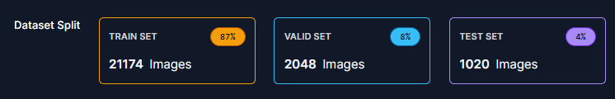

3.Crime and Tool Detection  
we didn’t see a dataset that contained our categories so we had to collect our categories so we had collect our data (Tool Detection)  
 8GB Size -16216 image train set-569 Valid set  
4.1.3 Implementation Code  
4.1.3.1 Crime and Tools Detection   
4.1.3.1.1 Preprocessing for the Video

**1-Imports:**

import tensorflow as tf

import tensorflow as tf

import cv2

import numpy as np

import random

* tensorflow is used for image processing.
* cv2 (OpenCV) is used for video processing.
* numpy is used for array manipulations.
* random is used for generating random numbers.
* 2-Function: format_frames:

def format_frames(frame, output_size):

  frame = tf.image.convert_image_dtype(frame, tf.float32)

  frame = tf.image.resize_with_pad(frame, *output_size)

  return frame

Purpose: Pads and resizes a single video frame to a specified size.

Arguments:

* frame: The image/frame from the video.
* output_size: Desired size of the output frame (width, height).

Steps:

* Converts the frame to a float32 tensor.
* Resizes and pads the frame to the specified output size.
* Returns the processed frame.
* Function: frames_from_video_file:

def frames_from_video_file(video_path, n_frames, output_size = (224,224), frame_step = 15):

  # Read each video frame by frame

  result = []

  src = cv2.VideoCapture(str(video_path))

  video_length = src.get(cv2.CAP_PROP_FRAME_COUNT)

  need_length = 1 + (n_frames - 1) * frame_step

  if need_length > video_length:

    start = 0

  else:

    max_start = video_length - need_length

    start = random.randint(0, max_start + 1)

  src.set(cv2.CAP_PROP_POS_FRAMES, start)

  # ret is a boolean indicating whether read was successful, frame is the image itself

  ret, frame = src.read()

  result.append(format_frames(frame, output_size))

  for _ in range(n_frames - 1):

    for _ in range(frame_step):

      ret, frame = src.read()

    if ret:

      frame = format_frames(frame, output_size)

      result.append(frame)

    else:

      result.append(np.zeros_like(result[0]))

  src.release()

  result = np.array(result)[..., [2, 1, 0]]

  return result

* Purpose: Extracts and formats a specific number of frames from a video.
* Arguments:
* video_path: Path to the video file.
* n_frames: Number of frames to extract.
* output_size: Size to which each frame is resized (default is 224x224).
* frame_step: Number of frames to skip between each extracted frame.
* Steps:
* Initializes a list to store frames.
* Opens the video file.
* Calculates the number of frames needed.
* Determines the starting frame position randomly, ensuring enough frames can be captured.
* Sets the starting frame and reads the first frame.
* Formats the first frame and adds it to the list.
* Iteratively reads and formats the specified number of frames, skipping frame_step frames between each.
* If reading a frame fails, appends a zero frame.
* Releases the video capture object.
* Converts the list of frames to a NumPy array and adjusts color channels from BGR to RGB.
* Returns the array of frames.

##### 4.1.3.1.2 Fighting and Tools Detection

1-Imports:

import tensorflow as tf

import cv2

from  full_project.action  import frames_from_video_file

from full_project.lowlight import is_low_light

from full_project.upscaling import diffusion ,upscale_image

import os

import gc

from ultralytics import YOLO

from django.contrib.auth.models import User

from django.conf import settings

from myapp.models import Video

from myapp.utils import generate_thumbnail

import torch

import os

from full_project.video import image_enhancement

import torch

* tensorflow: Used for loading the action detection model and processing video frames.
* cv2: OpenCV library for video processing.
* numpy: For handling arrays.
* from full_project.action import frames_from_video_file: Imports a function to extract frames from video.
* from full_project.lowlight import is_low_light: Imports a function to check if a frame is low light.
* from full_project.upscaling import diffusion, upscale_image: Imports functions for image upscaling.
* os: For handling file paths.
* from ultralytics import YOLO: Imports the YOLO model for object detection.
* from django.contrib.auth.models import User: Django model for user management.
* from django.conf import settings: Django settings configuration.
* from myapp.models import Video: Imports the Video model from a Django app named myapp.
* from myapp.utils import generate_thumbnail: Imports a utility function to generate video thumbnails.
* Function: fight_detection:

def fight_detction(path):

    model = tf.keras.models.load_model("E:\\workstation\\project\\project\\enhancement_Retinex\\action")

    # video_path = "E:\workstation\project\project\\test7.mp4"

    sample_video =frames_from_video_file(path, n_frames =20)

    sample_video = sample_video.reshape((1,20,224,224,3))

    act_score = model.predict(sample_video)

    print(act_score)

    if act_score >=0.5:

        print("fight")

        return "fight"

    else:

        print("No fight")

        return 'No fighting'

* **Purpose**: Detects fights in a video.
* **Arguments**: path (path to the video file).

**Steps**:

* Loads a pre-trained TensorFlow model.
* Prints the video path.
* Extracts and formats 20 frames from the video.
* Reshapes the frames for model input.
* Predicts the action score.
* Prints and returns whether a fight is detected based on the score.
* Function: Crime:

def Crime(path,user,Enhancement,plate_detection):

    # Load the YOLOv8 model

    model = YOLO("E:\\workstation\\project\\project\\crime_detection\\full_project\\yolo\\best.pt")

    pipeline =diffusion()

    cap = cv2.VideoCapture(path)

    names = model.names

    input_video_name = os.path.basename(path)

    output_video_name = f"{user.username}_{input_video_name.split('.')[0]}_output.mp4"

    output_video_path = os.path.join(settings.MEDIA_ROOT,"result",output_video_name)

    os.makedirs(os.path.dirname(output_video_path),exist_ok=True)

    fourcc = cv2.VideoWriter_fourcc(*'mp4v')

    out = cv2.VideoWriter(output_video_path, fourcc, 30.0, (600, 600))

    crimes = []

    names = model.names

    plates = []

    while True:

       success, frame = cap.read()

        if success:

            frame =cv2.resize(frame,(600,600))

            print(is_low_light(frame))

            if is_low_light(frame):

                frame = image_enhancement(frame ,"E:\\workstation\\project\\project\\crime_detection\\full_project\\weight\\best_psnr_21.66_95000.pth")

                torch.cuda.empty_cache()

                gc.collect()

            if Enhancement:

                print("Enhancement")

                frame = upscale_image(frame , pipeline=pipeline)

                torch.cuda.empty_cache()

                gc.collect()

            results = model.track(source=frame,conf=0.8, persist=True)

            torch.cuda.empty_cache()

            gc.collect()

            if plate_detection:

                print("plate")

                from plate_detection.main import plate_detector

                plate_num = plate_detector(frame)

                torch.cuda.empty_cache()

                gc.collect()

                if plate_num :

                    plates.append(plate_num)

            annotated_frame = results[0].plot()

            for m in results[0].boxes:

                cls = m.cls

                crimes.append(names[int(cls)])

            out.write(annotated_frame)

            if cv2.waitKey(1) & 0xFF == ord("q"):

                break

        else:

            break

    cap.release()

    out.release()

    Crimes = set(crimes)

    print("The Crime path of the uploaded video:", output_video_name)

    print(plates)

    return Crimes ,output_video_path

* **Purpose**: Detects crimes in a video and saves an annotated output video.
* **Arguments**: path (path to the video file), user (Django user object).
* Steps:
* Loads a pre-trained YOLO model for object detection.
* Initializes an image diffusion pipeline.
* Imports an image enhancement function.
* Opens the video file.
* Sets up video and output file paths.
* Creates a Video object in the database and generates a thumbnail.
* Initializes a VideoWriter object to save the output video.
* Initializes an empty list to store detected crimes.
* Processes each frame of the video:
* Resizes the frame.
* Enhances low-light frames.
* (Optionally) Upscales the frame.
* Runs YOLO model to detect objects.
* Annotates and writes the frame to the output video.
* Saves the last annotated frame as an image.
* Releases video capture and writer objects.
* Returns the set of detected crimes and the output video path.

#### 4.1.3.2 Lowlight

import cv2

def is_low_light(image, threshold=100):

    # Convert image to grayscale

    img_gray = cv2.cvtColor(image, cv2.COLOR_BGR2GRAY)

    # Calculate average pixel intensity

    avg_intensity = cv2.mean(img_gray)[0]

    # Check if average intensity falls below the threshold

    return avg_intensity < threshold

**Purpose**

* The purpose of the is_low_light function is to determine if an image is in low light conditions by analyzing its average pixel intensity.

**Arguments**

* image: The input image on which the low-light check is to be performed. This should be a colour image in BGR format.
* threshold: An optional parameter (default value is 100) that specifies the intensity threshold below which the image is considered low light.

Steps

* Convert Image to Grayscale
* Calculate Average Pixel Intensity
* Check if Average Intensity Falls Below the Threshold

4.1.3.2 .1 Action

import tensorflow as tf

import tensorflow as tf

import cv2

import numpy as np

import random

* Import TensorFlow:
* To use TensorFlow’s image processing functions.
* Import OpenCV:
* To handle video capture and frame extraction.
* Import NumPy:
* For array manipulation and numerical operations.
* Import Random:
* To randomly select starting frames in the video.
* Define format_frames Function

def format_frames(frame, output_size):

  frame = tf.image.convert_image_dtype(frame, tf.float32)

  frame = tf.image.resize_with_pad(frame, *output_size)

  return frame

**Purpose**

* The purpose of the format_frames function is to format a single video frame by converting its data type and resizing it with padding to a specified output size.
* Arguments
* frame: A single video frame to be formatted.
* output_size: A tuple specifying the desired output size of the frame.

**Steps**

* Convert Image Data Type:
* Convert the image data type to float32, which is often required for further image processing tasks.
* Resize with Padding:
* Resize the image to the specified output size while maintaining the aspect ratio by adding padding if necessary.
* Return Formatted Frame:
* Return the formatted frame.
* Define frames_from_video_file Function

def frames_from_video_file(video_path, n_frames, output_size = (224,224), frame_step = 15):

  # Read each video frame by frame

  result = []

  src = cv2.VideoCapture(str(video_path))

  video_length = src.get(cv2.CAP_PROP_FRAME_COUNT)

  need_length = 1 + (n_frames - 1) * frame_step

  if need_length > video_length:

    start = 0

  else:

    max_start = video_length - need_length

    start = random.randint(0, max_start + 1)

  src.set(cv2.CAP_PROP_POS_FRAMES, start)

  ret, frame = src.read()

  result.append(format_frames(frame, output_size))

  for _ in range(n_frames - 1):

    for _ in range(frame_step):

      ret, frame = src.read()

    if ret:

      frame = format_frames(frame, output_size)

      result.append(frame)

    else:

      result.append(np.zeros_like(result[0]))

  src.release()

  result = np.array(result)[..., [2, 1, 0]]

  return result

**Purpose**

* The purpose of the frames_from_video_file function is to extract a specified number of frames from a video file, format them to a specified size, and return them as a NumPy array.

**Arguments**

* video_path: The path to the video file from which frames are to be extracted.
* n_frames: The number of frames to extract from the video.
* output_size: An optional tuple specifying the desired output size of the frames (default is 224x224).
* frame_step: An optional parameter specifying the step between frames to be extracted (default is 15).

**Steps**

* Initialize Result List:
* Initialize an empty list to store the formatted frames.
* Open Video File:
* Open the video file for reading.
* Get Video Length:
* Retrieve the total number of frames in the video.
* Calculate Needed Length:
* Calculate the total number of frames needed, accounting for the frame step.
* Determine Start Position:
* Determine a random starting position in the video if it is long enough; otherwise, start from the beginning.
* Set Start Position:
* Set the starting frame position in the video.
* Read and Format First Frame:
* Read the first frame from the video, format it, and append it to the result list.
* Read and Format Subsequent Frames:
* Iteratively read and format subsequent frames, skipping a specified number of frames between reads. If reading fails, append a zero array of the same shape as the first frame.
* Release Video Capture:
* Release the video capture object.
* Convert to NumPy Array and Change Channel Order:
* Convert the result list to a NumPy array and change the color channel order from BGR to RGB.
* Return Result:
* Return the formatted frames as a NumPy array.

#### 4.1.3.3 UpScaling

from PIL import Image

from io import BytesIO

from diffusers import LDMSuperResolutionPipeline

import torch

import cv2

import numpy as np

**Purpose**

* The purpose of these import statements is to include the necessary libraries for image processing, handling byte streams, running the super-resolution pipeline, and working with arrays.

**Arguments**

* There are no arguments in this part as it consists only of import statements.

**Steps**

* Import PIL Image and BytesIO:
* For handling image conversions and byte streams.
* Import LDMSuperResolutionPipeline from diffusers:
* For loading and using the super-resolution model.
* Import torch:
* For checking the availability of CUDA and running the pipeline on the appropriate device.
* Import OpenCV (cv2):
* For handling image reading and conversions.
* Import NumPy (np):
* For array manipulation and numerical operations.
* Define diffusion Function

def diffusion():

    device = "cuda" if torch.cuda.is_available() else "cpu"

    model_id = "CompVis/ldm-super-resolution-4x-openimages"

    # load model and scheduler

    pipeline = LDMSuperResolutionPipeline.from_pretrained(model_id)

    pipeline = pipeline.to(device)

    return  pipeline

**Purpose**

* The purpose of the diffusion function is to load and initialize the super-resolution model, preparing it for use.

**Arguments**

* There are no arguments for this function.

**Steps**

* Check Device Availability:
* Determine if CUDA (GPU) is available; if not, use CPU.
* Specify Model ID:
* Set the model ID to load the specific pre-trained super-resolution model.
* Load Model:
* Load the super-resolution pipeline model from the specified model ID.
* Move Model to Device:
* Move the loaded model to the specified device (GPU or CPU).
* Return Pipeline:
* Return the initialized pipeline
* Define upscale_image Function

def upscale_image(input_image, pipeline):

    # Convert the input CV2 image to PIL Image

    pil_image = Image.fromarray(cv2.cvtColor(input_image, cv2.COLOR_BGR2RGB))

    # Resize the image to 128x128

    pil_image = pil_image.resize((128, 128))

    # Run the pipeline on the low-resolution image

    upscaled_image = pipeline(pil_image, num_inference_steps=100, eta=1).images[0]

    # Convert the output PIL Image back to CV2 image

    cv2_upscaled_image = cv2.cvtColor(np.array(upscaled_image), cv2.COLOR_RGB2BGR)

    return cv2_upscaled_image

**Purpose**

* The purpose of the upscale_image function is to upscale a low-resolution image using the provided super-resolution pipeline and convert it back to an OpenCV-compatible format.

**Arguments**

* input_image: The low-resolution image to be upscaled, in OpenCV format.
* pipeline: The super-resolution pipeline initialized by the diffusion function.

**Steps**

* Convert to PIL Image:
* Convert the input image from OpenCV format (BGR) to a PIL Image (RGB).
* Resize Image:
* Resize the PIL image to 128x128 pixels.
* Run Super-Resolution Pipeline:
* Use the pipeline to upscale the low-resolution image, specifying the number of inference steps and the eta parameter.
* Convert Back to OpenCV Image:
* Convert the output PIL Image back to OpenCV format (BGR).
* Return Upscaled Image:
* Return the upscaled image in OpenCV format.

#### 4.1.3.3.1 Frame Extraction:

* This code extracts frames from a video file at specific intervals and saves processed frames to a new output video file .The script uses the OpenCV library to read the video file and extract the frames

def process_video(input_path, output_folder):

# Open the input video

video_capture = cv2.VideoCapture(input_path)

# Get the video properties

frame_width = int(video_capture.get(cv2.CAP_PROP_FRAME_WIDTH))

frame_height = int(video_capture.get(cv2.CAP_PROP_FRAME_HEIGHT))

fps = int(video_capture.get(cv2.CAP_PROP_FPS))

# Create VideoWriter object to save the output video

output_path = os.path.join(output_folder, 'processed_video.mp4')

video_writer = cv2.VideoWriter(output_path, cv2.VideoWriter_fourcc(*'mp4v'), fps, (frame_width, frame_height))

while True:

ret, frame = video_capture.read()

if not ret:

break

# Process the frame using the Face_info module

out = f_Face_info.get_face_info(frame)

res_img = f_Face_info.bounding_box(out, frame)

video_writer.write(res_img)

video_capture.release()

video_writer.release()

input_video = r'D:\Face_information model\data test\video\GeoVision VD8700 Face Recognition.mp4'

output_folder = r'C:\Users\DELL\Downloads\Face_information_model\results'

os.makedirs(output_folder, exist_ok=True)

Purpose: This function processes a video, performing face detection and potentially additional operations, and saves the resulting video with bounding boxes and labels.

Arguments:

* + input_path: The path to the input video file.
  + output_folder: The path to the folder where the processed video will be saved.

Steps:

1. Open Video: Opens the input video using cv2.VideoCapture(input_path).
2. Get Video Properties: Retrieves the video's frame width, height, and frame rate (FPS) using video_capture.get().
3. Create Video Writer: Creates a cv2.VideoWriter object to save the processed video in the specified output_folder.
4. Process Frames: Enters a loop that iterates through each frame of the video:
   1. Read Frame: Reads a frame from the video using video_capture.read().
   2. Face Detection and Labeling: Calls the f_Face_info.get_face_info() function to detect faces in the frame, and then calls f_Face_info.bounding_box() to draw bounding boxes and add labels (if available) to the detected faces.
   3. Write Frame: Writes the processed frame with bounding boxes and labels to the output video using video_writer.write().
   4. Release Resources: Releases the video capture and video writer objects using video_capture.release() and video_writer.release().

4.1.3.4 Face Detection and Recognition4.1.3.4.1 Frame Extraction:

This code extracts frames from a video file at specific intervals and saves processed frames to a new output video file .The script uses the OpenCV library to read the video file and extract the frames.

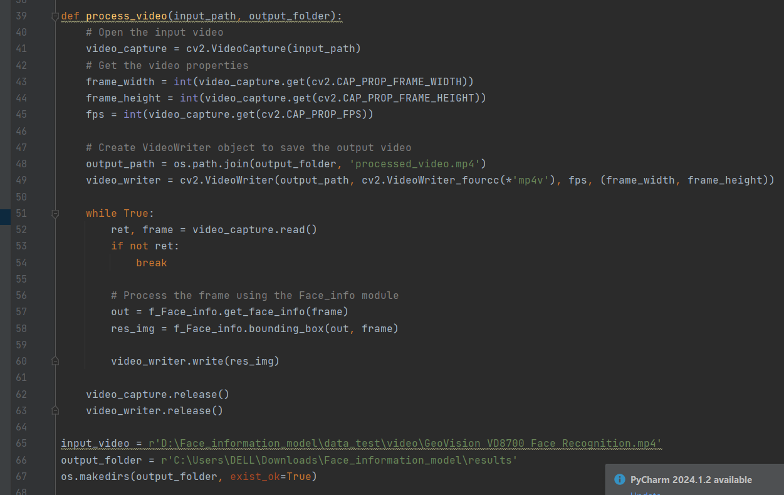

##### 4.1.3.4.2Face Detection

This function takes in an image path as input and returns an image with a bounding box and write it’s data like name and gender .

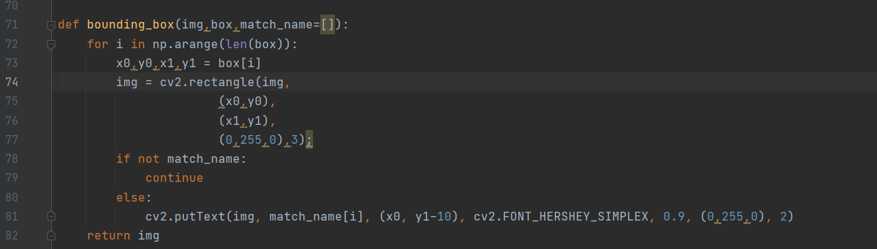

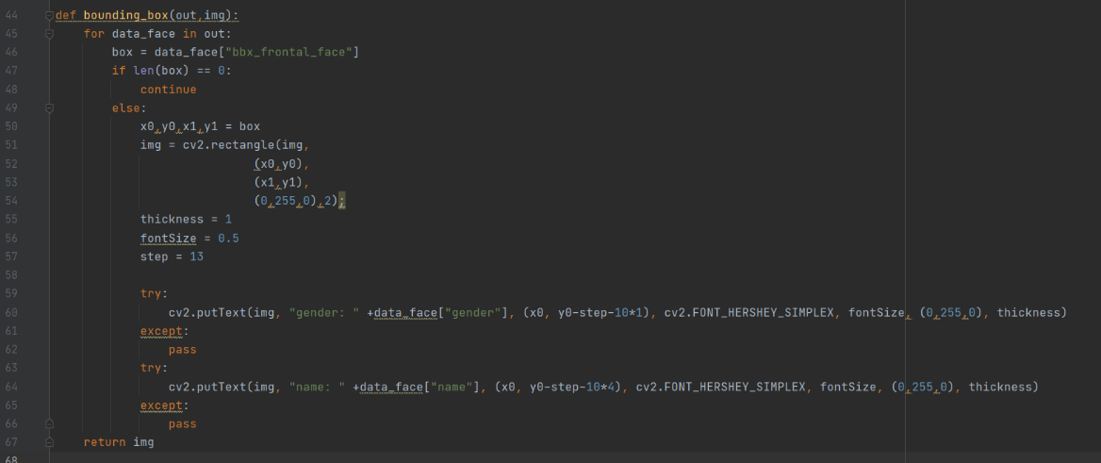

##### 4.1.3.4.2 Face comparing

the compare_faces() function takes the facial features of detected faces and compares them to the facial features of known people in a database, in order to identify the detected faces. it goes through each detected face's facial features in the face_encodings list.

For each detected face, it calculates the distance between its facial features and the facial features of each person in the database (db_features).

It finds the person in the database whose facial features are closest (have the smallest distance) to the detected face.  
If the distance between the detected face and the closest person in the database is less than or equal to 0.6, it adds the name of that person from the db_names list to the match_name list.

If the distance is greater than 0.6, it adds the word "unknown" to the match_name list, because the detected face doesn't match anyone in the database.  
Finally, it returns the match_name list, which contains the names (or "unknown") for each detected.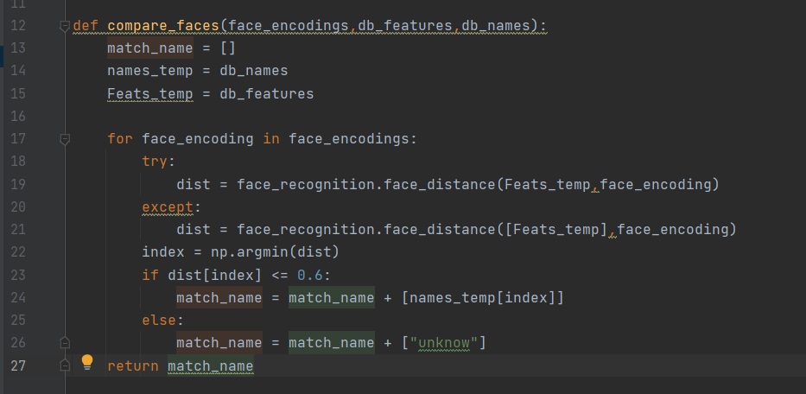

##### 4.1.3.4.3 Predict gender

This method takes a face image as input and predicts the gender of the person in the image. It first preprocesses the input face image using the transform_face_array2gender_face method. Then, it makes a prediction on the preprocessed image. The prediction is a probability distribution over the two classes: "Woman" and "Man". The method then determines the predicted gender by taking the class with the highest probability.  
  
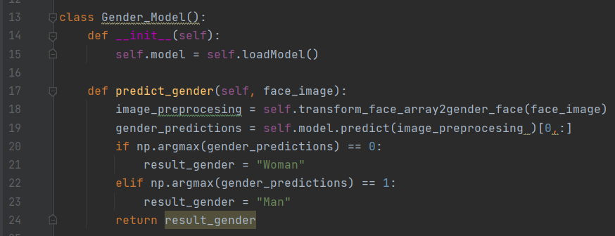  
  
  
4.1.3.5 Plate Detection and Recognition4.1.3.5.1 Load models  
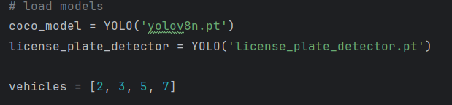By integrating these two models, the system achieves a comprehensive and accurate approach to vehicle and license plate detection, leveraging the strengths of YOLOv8's object detection capabilities, and select the detecting vehicles .   
4.1.3.5.2 Sort Tracker   
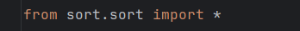  
It is designed for online tracking applications where only past and current frames are available and the method produces object identities on the fly. While this minimalistic tracker doesn't handle occlusion or re-entering objects its purpose is to serve as a baseline and testbed for the development of future trackers.  
  
4.1.3.5.3 process_frame   
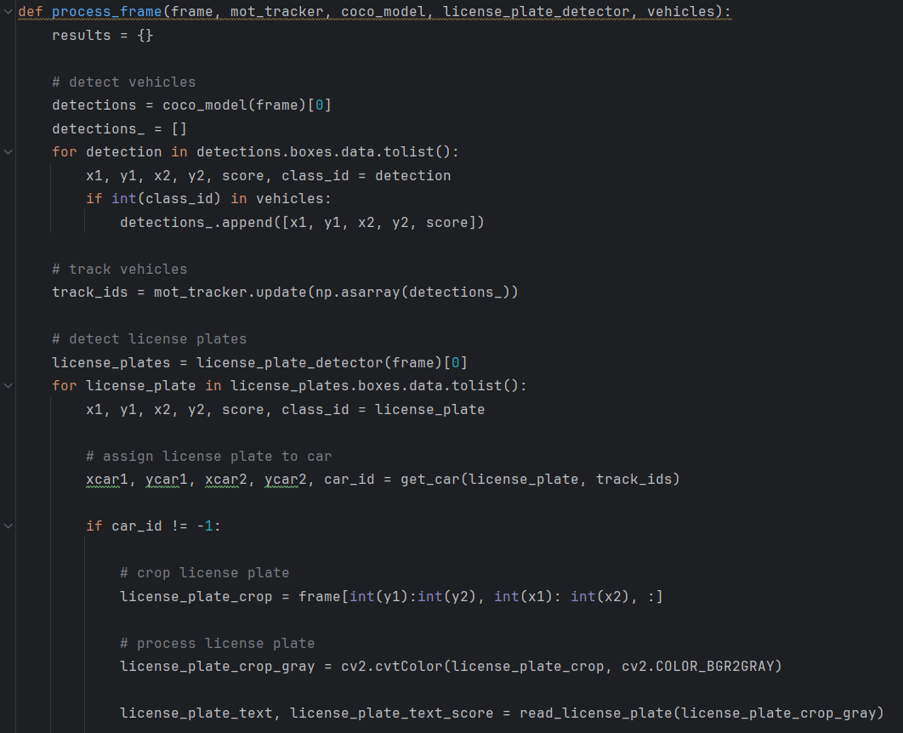  
  
**Inputs:**

* frame: The current frame of the video as a NumPy array.
* mot_tracker: A pre-configured object tracker (likely using Multiple Object Tracking algorithms).
* coco_model: A pre-trained object detection model (possibly based on COCO dataset) that can detect vehicles.
* license_plate_detector: A pre-trained object detection model for license plates.
* vehicles: A list or set containing valid vehicle class IDs (e.g., car, motorcycle).

**Outputs:**

* results: A dictionary containing information about identified vehicles and their license plates (if read successfully).

**Steps:**

1. **Vehicle Detection:**

* The function uses coco_model to detect objects in the frame.
* It iterates through the detected objects and keeps only those with class IDs corresponding to vehicles based on the vehicles list.
* It stores the bounding boxes and confidence scores of these vehicle detections in a list (detections_).

1. **Vehicle Tracking:**

* The detections_ list is converted to a NumPy array.
* The mot_tracker object is used to update the tracked vehicles based on the current detections. This likely involves associating detections with existing tracks or creating new tracks if no matching track is found.
* track_ids stores the updated track IDs for each detected vehicle.

1. **License Plate Detection:**

* The license_plate_detector is used to detect license plates in the frame.
* It iterates through the detected license plates and extracts information like bounding boxes, confidence scores, and class IDs.

1. **License Plate Association and Processing:**

* A function get_car(license_plate, track_ids) is called to try to associate the detected license plate with a specific vehicle track. This function's specific implementation is not provided but likely uses spatial relationships or other logic to match the license plate to the corresponding vehicle.
* If a successful association is made (car_id != -1), the function proceeds to process the license plate:
* The license plate region is cropped from the frame based on the bounding box information.
* The cropped region is converted to grayscale for further processing.
* A function read_license_plate(license_plate_crop_gray) (not provided) is used to attempt to read the text from the license plate image. This likely involves image processing and Optical Character Recognition (OCR) techniques.
* If the license plate text is successfully read (license_plate_text is not None), the results dictionary is populated with information about the vehicle (bounding box) and the license plate (bounding box, text, confidence scores for both detection and text recognition).
* Return Results:
  + The function returns the results dictionary, which contains vehicle and license plate information for successfully processed detections.

##### A computer screen shot of a program Description automatically generated4.1.3.5.4 get_car

• **Unpack License Plate Data:**

* The function unpacks the first argument (license_plate) to access individual elements like bounding box coordinates (x1, y1, x2, y2) and potentially score and class ID.

• **Iterate Over Tracked Vehicles:**

* It iterates through each entry (vehicle_track_ids[j]) in the vehicle_track_ids list. Each entry likely represents a tracked vehicle.

• **Check for Overlap:**

* For each tracked vehicle, it compares the bounding box coordinates of the license plate with those of the tracked vehicle.
* It checks if the license plate bounding box falls entirely within the tracked vehicle's bounding box using a simple conditional statement:

Python

if x1 > xcar1 and y1 > ycar1 and x2 < xcar2 and y2 < ycar2:

Use code with caution.

content_copy

• **Association and Return:**

* If an overlap is found, it sets foundIt to True and stores the index (car_indx) of the matching tracked vehicle.
* If a match is found, it returns the entire tracked vehicle information from vehicle_track_ids[car_indx]. This likely includes the bounding box, track ID, and potentially additional data associated with the vehicle.

• **No Association:**

* If no overlap is found after iterating through all tracked vehicles, the function remains with foundIt set to False.

• **Return No Association:**

* In case no matching tracked vehicle is found, the function returns a list of -1 values, potentially signifying that no association was made.

4.1.3.5.4 OCR

1.import   
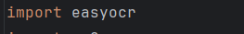  
  
2.license_complies_format   
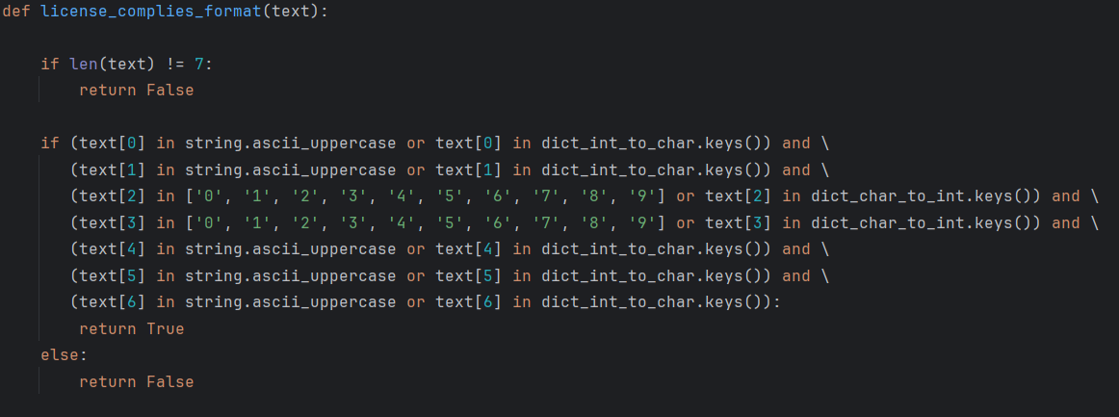  
   
Input:

* + text: The text string extracted from the detected license plate image (presumably after license plate text recognition).
  + Output:
  + True if the text conforms to the expected license plate format, False otherwise.
  + Steps:
  + Length Check:
  + The function first checks if the length of the text string (len(text)) **is exactly 7** characters.  
     License plates typically follow a specific format with a set number of characters.

1. **Character Validation:**
   * If the length check passes, the function proceeds to validate each character position:
   * It checks if the first two characters (text[0] and text[1]) are either uppercase letters (string.ascii_uppercase) or exist in a dictionary named dict_int_to_char. This suggests the format might allow for alphanumeric characters at the beginning, potentially including custom characters mapped in the dictionary.
   * It checks if the third and fourth characters (text[2] and text[3]) are either digits (0 to 9) or exist in another dictionary named dict_char_to_int. This suggests the middle section might contain numeric characters, possibly including custom alphanumeric representations mapped in the dictionary.
   * Finally, it checks if the last three characters (text[4], text[5], and text[6]) are again uppercase letters or entries in the dict_int_to_char dictionary, following the same logic as the first two characters.
2. **Return based on Validation:**
   * If all character positions comply with the format checks, the function returns True, indicating the text adheres to the expected license plate format.
   * If any character position fails the validation, the function returns False.

3. read_license_plate  
  
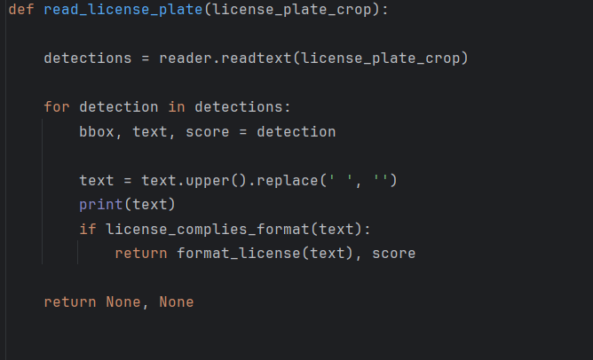  
  
**Input:** Grayscale image of a cropped license plate (license_plate_crop).

**Output:**

* Formatted license plate text (uppercase, no spaces) and confidence score (if successful).
* None, None if no text is recognized or doesn't match the format.

**Steps:**

1. **Text Recognition:** Uses a pre-trained OCR engine (reader) to extract text from the image.
2. **Iterate Over Recognitions:** Analyzes each recognized text string.
3. **Preprocessing and Format Check:**
   * Converts text to uppercase and removes spaces.
   * Checks if the text adheres to the expected license plate format using license_complies_format.
4. **Return on Success (if format check passes):**
   * Formats the text further using format_license (not provided).
   * Returns formatted text and confidence score.
5. **Return on Failure:**
   * If no text matches the format or no text is recognized, returns None, None.

4. write_csv  
  
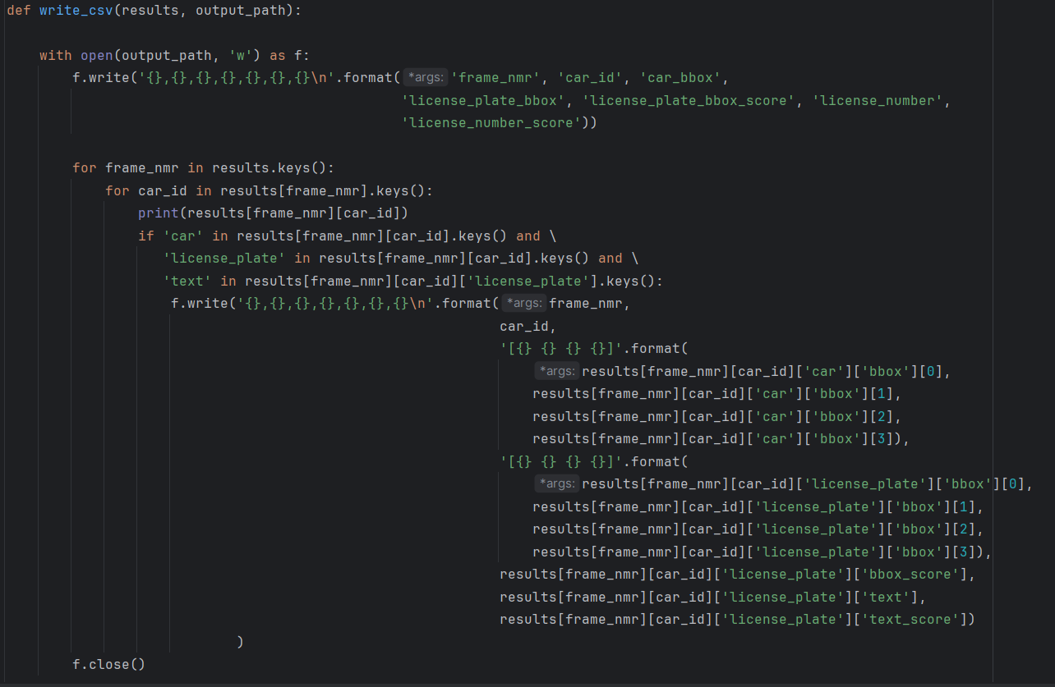  
This function aims to write the processing results from the video frames to a CSV (Comma-Separated Values) file.  
4.1.3.6 Software   
4.1.3.6.1 signup_view

def signup_view(request):

    form = UserSignUpForm()

    if request.method == 'POST':

        form = UserSignUpForm(request.POST)

        if form.is_valid():

            user = form.save()

            login(request, user)

            return redirect('video_upload')

    return render(request, 'signup.html', {'form': form})

* + **Purpose**: To handle user registration by displaying a signup form, validating the form input, creating a new user account, logging the user in, and redirecting to the video upload page.
  + request: The HTTP request object.
  + **Steps**:
  + Instantiate the UserSignUpForm.
  + If the request method is POST, populate the form with the request data.
  + Validate the form. If valid, save the new user and log them in.
  + Redirect the user to the video upload page.
  + If the request method is GET, render the signup page with the empty form.

##### 4.1.3.6.2 login_view

def login_view(request):

    if request.method == 'POST':

        form = AuthenticationForm(request, data=request.POST)

        if form.is_valid():

            user = form.get_user()

            login(request, user)

            if user.is_staff:

                return redirect('admin_dashboard')

            else:

                return redirect('user_profile')

    else:

        form = AuthenticationForm()

    return render(request, 'login.html', {'form': form})

* + **Purpose**: To handle user login by displaying a login form, validating the form input, logging the user in, and redirecting to the appropriate dashboard based on user role.
  + request: The HTTP request object.
  + **Steps**:
  + If the request method is POST, instantiate the AuthenticationForm with the request data.
  + Validate the form. If valid, log the user in.
  + Redirect staff users to the admin dashboard and regular users to the user profile page.
  + If the request method is GET, render the login page with the empty form.

##### 4.1.3.6.3 logout_view

def logout_view(request):

    if request.method == 'POST':

        logout(request)

        return redirect('login')

* + **Purpose**: To handle user logout by logging the user out and redirecting to the login page.
  + **Arguments**:
  + request: The HTTP request object.
  + **Steps**:
  + If the request method is POST, log the user out.
  + Redirect the user to the login page.

##### 4.1.3.6.4 video_upload

@login_required(login_url='login')

def video_upload(request):

    if request.method == 'POST':

        form = VideoForm(request.POST, request.FILES)

        if form.is_valid():

            # Construct the full path of the uploaded video file before it's moved

            upload_directory = os.path.join(settings.BASE_DIR, 'media', 'videos')

            os.makedirs(upload_directory, exist_ok=True)

            original_video_path = os.path.join(upload_directory, request.FILES['video'].name)

            timestamp = timezone.now().strftime("%Y%m%d%H%M%S")

            original_video_name = f"{slugify(request.FILES['video'].name.split('.')[0])}_{timestamp}.mp4"

            original_video_path = os.path.join(upload_directory, original_video_name)

            # Save the uploaded file to the original path

            with open(original_video_path, 'wb+') as destination:

                for chunk in request.FILES['video'].chunks():

                    destination.write(chunk)

            # Now that the file is moved, print the original path

            print("Original path of the uploaded video:", original_video_path)

            # Proceed with other operations

            video = form.save(commit=False)

            video.user = request.user

            video.video_name = request.FILES['video'].name

            video.video_path = original_video_path

            Construct the final path of the uploaded video file in the media directory

            final_video_path = os.path.join('videos', request.FILES['video'].name)

            video.video = final_video_path

            video.upload_time = timezone.now()

            video.save()

            Crime(video.video_path)

            crimes,crime_path = Crime(video.video_path,request.user)

            torch.cuda.empty_cache()

            fight = fight_detction(video.video_path)

            torch.cuda.empty_cache()

            crimes.add(fight)

            output_video_name = f"{video.video_name.split('.')[0]}_{uuid.uuid4().hex}.mp4"

            output_video_path = os.path.join(settings.MEDIA_ROOT, 'result', output_video_name)

            clip = VideoFileClip(output_video_path)

            clip.write_videofile(output_video_path, codec='libx264')

            thumbnail = generate_thumbnail(final_video_path)

            video.thumbnail.save(thumbnail.name, thumbnail, save=True)

            print(final_video_path)

            from Face_information_model.Face_info import face_video

            torch.cuda.empty_cache()

            Face_output_video_path = os.path.join(settings.MEDIA_ROOT, 'Face', output_video_name)

            print(Face_output_video_path)

            face_video(output_video_path,Face_output_video_path)

            video.video_name =output_video_name

            video.save()

            # Send notification email

            user_videos = Video.objects.filter(user=request.user)

            send_report_email(request.user, user_videos,'crimes')

            return redirect('user_profile')

    else:

        form = VideoForm()

    return render(request, 'video_upload.html', {'form': form, 'user': request.user})

* + **Purpose**: To handle video uploads by displaying a video upload form, saving the uploaded video, processing it for crime and fight detection, generating a thumbnail, and sending a report email.
  + **Arguments**:
  + request: The HTTP request object.
  + **Steps**:
  + If the request method is POST, instantiate the VideoForm with the request data and files.
  + Validate the form. If valid, save the video file to the specified directory.
  + Save the video instance with the user, video path, and upload time.
  + Process the video for crime and fight detection.
  + Generate a thumbnail for the video.
  + Save the video instance with the processed video name.
  + Send a report email to the user.
  + Redirect the user to their profile page.
  + If the request method is GET, render the video upload page with the empty form.

##### 4.1.3.6.5 user_profile

@login_required(login_url='login')

def user_profile(request):     videos = Video.objects.filter(user=request.user)

    for video in videos:

       video.upload_time = video.upload_time + timedelta(hours=2)

        result_video_name = f"{request.user.username}_{video.video_name.split('.')[0]}_output.mp4"

        video.result_video_path = os.path.join(settings.MEDIA_URL, 'results', result_video_name)

    return render(request, 'user_profile.html', {'videos': videos, 'user': request.user})

* + **Purpose**: To display the user's profile with their uploaded videos, adjusting upload times and video paths as necessary.
  + **Arguments**:
  + request: The HTTP request object.
  + **Steps**:
  + Retrieve all videos uploaded by the current user.
  + Adjust the upload time and set the result video path for each video.
  + Render the user profile page with the user's videos and user information.

##### 4.1.3.6.6 delete_video

@login_required(login_url='login')

def delete_video(request, pk):

    video = get_object_or_404(Video, pk=pk)

    if video.user == request.user:

        video.delete()

    return HttpResponseRedirect(reverse('user_profile'))

* + **Purpose**: To allow users to delete their uploaded videos.
  + **Arguments**:
  + request: The HTTP request object.
  + pk: The primary key of the video to be deleted.
  + **Steps**:
  + Retrieve the video instance by primary key.
  + If the video belongs to the current user, delete it.
  + Redirect the user to their profile page.

##### 4.1.3.6.7 admin_dashboard

@staff_member_required

def admin_dashboard(request):

    # Get the count of users registered per month for all time

    user_counts_per_month = User.objects.annotate(month=TruncMonth('date_joined')).values('month', 'month__month', 'month__year').annotate(count=Count('id')).order_by('month__year', 'month__month')

    # Get the count of users registered per year for all time

    user_counts_per_year = User.objects.annotate(year=TruncYear('date_joined')).values('year', 'year__year').annotate(count=Count('id')).order_by('year__year')

    # Get the total number of users

    total_users = User.objects.count()

    context = {

        'user': request.user,

        'user_counts_per_month': user_counts_per_month,

        'user_counts_per_year': user_counts_per_year,

        'total_users': total_users,

    }

    return render(request, 'admin_dashboard.html', context)

* + **Purpose**: To display an admin dashboard with user statistics including counts of users registered per month and per year.
  + **Arguments**:
  + request: The HTTP request object.
  + **Steps**:
  + Retrieve user registration counts per month and per year.
  + Retrieve the total number of users.
  + Render the admin dashboard with the user statistics.

##### 4.1.3.6.8 generate_report

@staff_member_required

def generate_report(request):

    # Retrieve the necessary data for the report

    users = User.objects.all()

    user_profiles = UserProfile.objects.all()

    # Get the count of users registered per month for all time

    user_counts_per_month = User.objects.annotate(month=TruncMonth('date_joined')).values('month', 'month__month', 'month__year').annotate(count=Count('id')).order_by('month__year', 'month__month')

    # Get the count of users registered per year for all time

    user_counts_per_year = User.objects.annotate(year=TruncYear('date_joined')).values('year', 'year__year').annotate(count=Count('id')).order_by('year__year')

    # Create the PDF report

    buffer = BytesIO()

    doc = SimpleDocTemplate(buffer, pagesize=letter)

    elements = []

    # Add the user data to the report

    data = [['Username', 'Address', 'Phone', 'Age']]

    for user, user_profile in zip(users, user_profiles):

        data.append([user.username, user_profile.address, user_profile.phone, user_profile.age])

    user_table = Table(data)

    user_table_style = TableStyle([

        ('BACKGROUND', (0,0), (-1,0), colors.grey),

        ('TEXTCOLOR', (0,0), (-1,0), colors.whitesmoke),

        ('ALIGN', (0,0), (-1,-1), 'CENTER'),

        ('FONTNAME', (0,0), (-1,0), 'Helvetica-Bold'),

        ('FONTSIZE', (0,0), (-1,0), 14),

        ('BOTTOMPADDING', (0,0), (-1,0), 12),

        ('BACKGROUND', (0,1), (-1,-1), colors.beige),

        ('GRID', (0,0), (-1,-1), 1, colors.black),

    ])

    user_table.setStyle(user_table_style)

    elements.append(user_table)

    # Add a space

    elements.append(Spacer(1, 12))

    # Add the user registration statistics charts

    styles = getSampleStyleSheet()

    # User registration per month and per year charts

    drawing = Drawing(550, 150)

    chart1 = VerticalBarChart()

    chart1.x = 25

    chart1.y = 25

    chart1.height = 100

    chart1.width = 225

    chart1.data = [[count['count'] for count in user_counts_per_month]]

    chart1.categoryAxis.labels.angle = 45

    chart1.categoryAxis.labels.dx = -10

    chart1.categoryAxis.labels.dy = -10

    chart1.categoryAxis.categoryNames = [f"{count['month__year']}-{count['month__month']}" for count in user_counts_per_month]

    chart1.valueAxis.valueMin = 0

    chart2 = VerticalBarChart()

    chart2.x = 275

    chart2.y = 25

    chart2.height = 100

    chart2.width = 225

    chart2.data = [[count['count'] for count in user_counts_per_year]]

    chart2.categoryAxis.labels.angle = 45

    chart2.categoryAxis.labels.dx = -10

    chart2.categoryAxis.labels.dy = -10

    chart2.categoryAxis.categoryNames = [str(count['year__year']) for count in user_counts_per_year]

    chart2.valueAxis.valueMin = 0

    drawing.add(chart1)

    drawing.add(chart2)

    elements.append(Paragraph('User Registration per Month and Year', styles['Heading2']))

    elements.append(drawing)

    elements.append(Spacer(1, 12))

    # Add a pie chart for user age distribution

    age_counts = UserProfile.objects.values('age').annotate(count=Count('age'))

    ages = [count['age'] for count in age_counts]

    counts = [count['count'] for count in age_counts]

    drawing = Drawing(350, 200)

    chart = Pie()

    chart.x = 25

    chart.y = 50

    chart.width = 300

    chart.height = 150

    chart.data = counts

    chart.labels = [str(age) for age in ages]

    chart.slices.strokeWidth = 0.5

    chart.slices.strokeColor = colors.grey

    drawing.add(chart)

    elements.append(Paragraph('User Age Distribution', styles['Heading2']))

    elements.append(drawing)

    elements.append(Spacer(1, 12))

    doc.build(elements)

    # Set the response headers for file download

    response = HttpResponse(buffer.getvalue(), content_type='application/pdf')

    response['Content-Disposition'] = 'attachment; filename="user_report.pdf"'

    return response

* + **Purpose**: To generate a PDF report containing user data and registration statistics, and provide it as a downloadable file.
  + **Arguments**:
  + request: The HTTP request object.
  + **Steps**:
  + Retrieve all user and user profile data.
  + Retrieve user registration counts per month and per year.
  + Create a PDF document with user data and charts for user registration statistics.
  + Add a pie chart for user age distribution.
  + Set response headers for file download and return the PDF file.
  + Backend Table

##### 4.1.3.6.9 Video Model

class Video(models.Model):

    user = models.ForeignKey(User, on_delete=models.CASCADE)

    video = models.FileField(upload_to='videos/')

    video_name = models.CharField(max_length=255, blank=True)

    video_path = models.CharField(max_length=255, blank=True)

    thumbnail = models.ImageField(upload_to='thumbnails/', null=True, blank=True)

    upload_time = models.DateTimeField(default=timezone.now)

    def save(self, *args, **kwargs):

        if not self.video_name:

            self.video_name = self.video.name

        super().save(*args, **kwargs)

* + **Purpose**: To represent video uploads by users, including metadata such as the user who uploaded the video, the video's name, path, thumbnail, and upload time.
  + Fields:
  + user: Foreign key linking to the User model, representing the user who uploaded the video.
  + video: FileField to store the uploaded video file.
  + video_name: CharField to store the name of the video.
  + video_path: CharField to store the path to the video file.
  + thumbnail: ImageField to store the thumbnail of the video.
  + upload_time: DateTimeField to store the time when the video was uploaded.
  + Methods:
  + save: Overrides the default save method to ensure video_name is set if it is not provided.
  + **Steps**:
  + Define fields for user, video, video name, video path, thumbnail, and upload time.
  + Override the save method to set video_name to the name of the uploaded video file if video_name is not already set.
  + Call the superclass's save method to save the instance.

##### 4.1.3.6.10 UserProfile Model

class UserProfile(models.Model):

    user = models.OneToOneField(User, on_delete=models.CASCADE)

    address = models.TextField()

    phone = models.CharField(max_length=20)

    age = models.IntegerField()

    def _str_(self):

        return self.user.username

* + **Purpose**: To store additional information about users that is not included in the default User model, such as address, phone number, and age.
  + Fields:
  + user: One-to-one relationship with the User model, ensuring each user has one profile.
  + address: TextField to store the user's address.
  + phone: CharField to store the user's phone number.
  + age: IntegerField to store the user's age.
  + Methods:
  + __str__: Returns the username of the associated user.
  + **Steps**:
  + Define fields for user, address, phone, and age.
  + Define the __str__ method to return the username of the associated user.

Backend Form

##### 4.1.3.6 .11 UserSignUpForm

class UserSignUpForm(UserCreationForm):

    address = forms.CharField(widget=forms.TextInput)

    phone = forms.CharField(widget=forms.TextInput)

    date_of_birth = forms.DateField(label='Date of Birth', widget=forms.DateInput(attrs={'type': 'date'}))

    password1 = forms.CharField(label='Password', widget=forms.PasswordInput(attrs={'maxlength': 30}))

    password2 = forms.CharField(label='Confirm Password', widget=forms.PasswordInput(attrs={'maxlength': 30}))

    class Meta(UserCreationForm.Meta):

        fields = UserCreationForm.Meta.fields + ('address', 'phone', 'date_of_birth')

    def save(self, commit=True):

        user = super().save(commit=False)

        if commit:

            user.save()

            today = date.today()

            date_of_birth = self.cleaned_data['date_of_birth']

            age = today.year - date_of_birth.year - ((today.month, today.day) < (date_of_birth.month, date_of_birth.day))

            UserProfile.objects.create(user=user, address=self.cleaned_data['address'], phone=self.cleaned_data['phone'], age=age)

        return user

* + **Purpose**: To extend the UserCreationForm to include additional fields (address, phone, date of birth) and to handle the creation of UserProfile when a new user is registered.
  + Fields:
  + address: CharField to capture the user's address.
  + phone: CharField to capture the user's phone number.
  + date_of_birth: DateField to capture the user's date of birth.
  + password1: CharField to capture the user's password.
  + password2: CharField to confirm the user's password.
  + Meta:
  + fields: Includes the default fields from UserCreationForm along with address, phone, and date_of_birth.
  + Methods:
  + save: Overrides the default save method to create a UserProfile with the additional information provided.
  + **Steps**:
  + Define additional fields for address, phone, and date of birth.
  + Set up the Meta class to extend the fields of UserCreationForm.
  + Override the save method:
  + Save the user instance without committing immediately.
  + Calculate the user's age based on the date of birth.
  + Create a UserProfile instance with the user's additional information.
  + Save the user instance if commit is True.

##### 4.1.3.6.12 VideoForm

class VideoForm(forms.ModelForm):

    class Meta:

        model = Video

        fields = ['video']

* + **Purpose**: To provide a form for uploading a video file, linked to the Video model.
  + Fields:
  + video: FileField to capture the video file being uploaded.
  + Meta:
  + model: Specifies that the form is linked to the Video model.
  + fields: Specifies that only the video field should be included in the form.
  + **Steps**:
  + Set up the Meta class to link the form to the Video model and specify the video field to be included.

4.2 Experimental4.2.2 Experiments for Action Recognition4.2.2 .1 Objectives and Scope   
The primary objective of the Crime Classification Project is to develop a comprehensive, real-time crime detection and classification system that can be effectively deployed in various settings. The system aims to enhance the capabilities of existing CCTV networks by integrating an intelligent layer capable of analyzing video feeds and identifying criminal activities with high accuracy.  
  
4.2.2 .2 Developing a Comprehensive Dataset:  
 A key objective is to curate a large and diverse dataset of video footage that includes various types of crimes as well as normal activities. This dataset will be used to train and validate the machine learning model. The dataset should encompass different environments, lighting conditions, and camera angles to ensure robustness.  
  
4.2.2 .2.1 Selection of Datasets:   
We have used many datasets ( UCF Crime Datasets, Shanghai Violence , …) but the most used it was UCF crime , we use it with many distributions like (norma and abnormal , Classification of Crimes for 5 or more Datasets, here the distribution of the most Used Datasets.  
1.The distribution of the data  
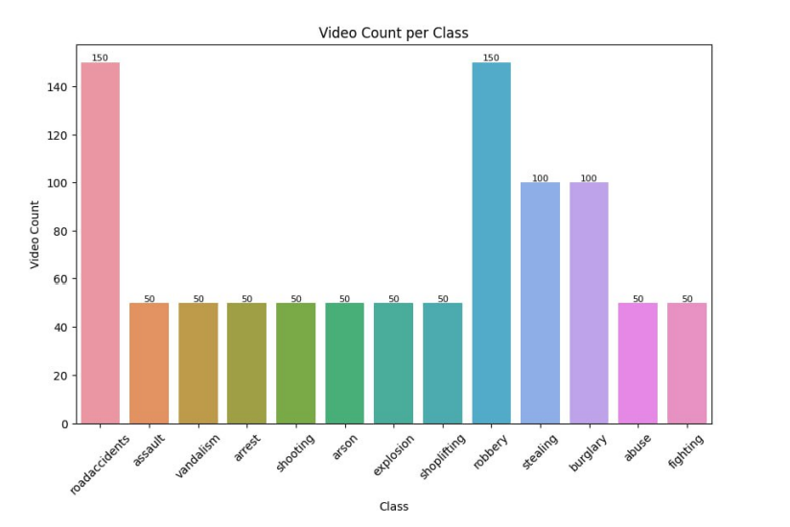  
We faced a problem In that part with the huge size of of the Datasets so we used many ways to solve that as used part of the datasets , or combine same classes of datasets , and used to split. It into 2:7 classes to use it to the train.  
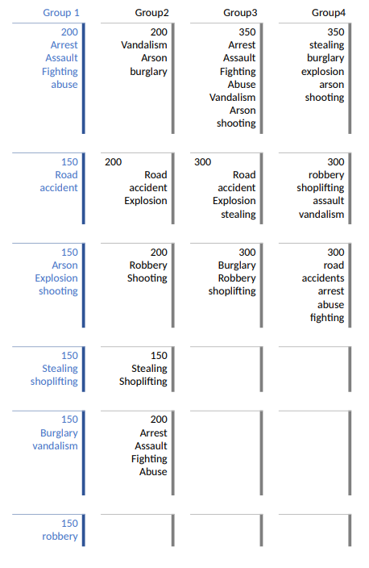  
  
4.2.2.3 Data cleaning and preprocessing steps  
  
**1. Frame Extraction:**

* Video footage is broken down into individual frames, enabling analysis of each frame for relevant information.
* Frames are extracted at a consistent rate to preserve the temporal sequence of events.

**2. Noise Reduction:**

* Techniques like Gaussian blur and median filtering are applied to minimize noise in the video frames.
* Noise reduction improves the clarity of the footage, aiding the model in detecting important features.

**3. Normalization:**

* Pixel values in the frames are scaled to a standard range, typically between 0 and 1.
* Normalization ensures the model receives data with consistent values, promoting training stability and performance.

**4. Data Augmentation:**

* Techniques like random cropping, flipping, rotation, and color adjustments are used to artificially create variations of existing frames.
* This process increases the diversity of the training data, preventing the model from overfitting and enhancing its ability to generalize to unseen data.

**5. Annotation and Labeling:**

* Each video is annotated with relevant labels that describe the type of activity taking place (e.g., robbery, assault, non-violent).
* This involves creating bounding boxes, temporal annotations, and class labels to provide necessary information for supervised learning models.

**6. Feature Extraction:**

* Advanced techniques like 3D Convolutional Networks (3D ConvNets), C3D, and I3D are employed to extract meaningful features from the video frames.
* These features capture both spatial information (object locations) and temporal information (object motion) from the videos, providing rich input data for classification models.

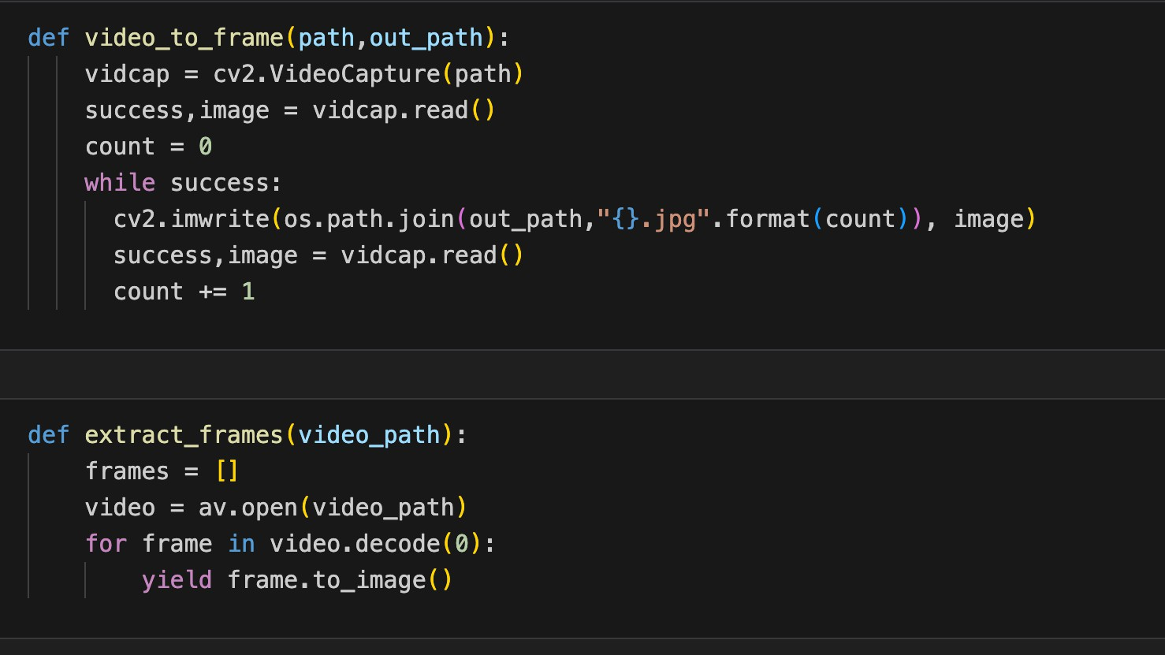

Function Used For Extracting Frames from the Videos

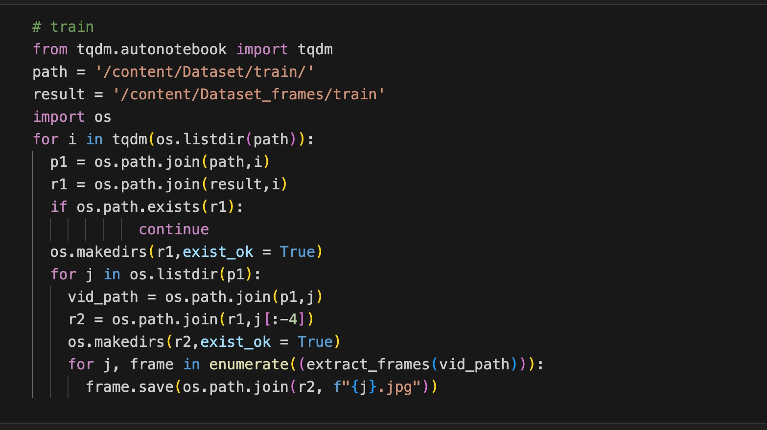

Code Used for The Training Part and Theres another One for the Validation part

#### 4.2.2.4 Splitting into Training, Validation:

The annotated and preprocessed data is split into training, validation, sets. This step ensures that the model is trained on a representative portion of the data, while the validation and test sets are used to evaluate its performance and generalization capabilities. So the mode can be better Training and Gain more Insights or Pattern from the Data

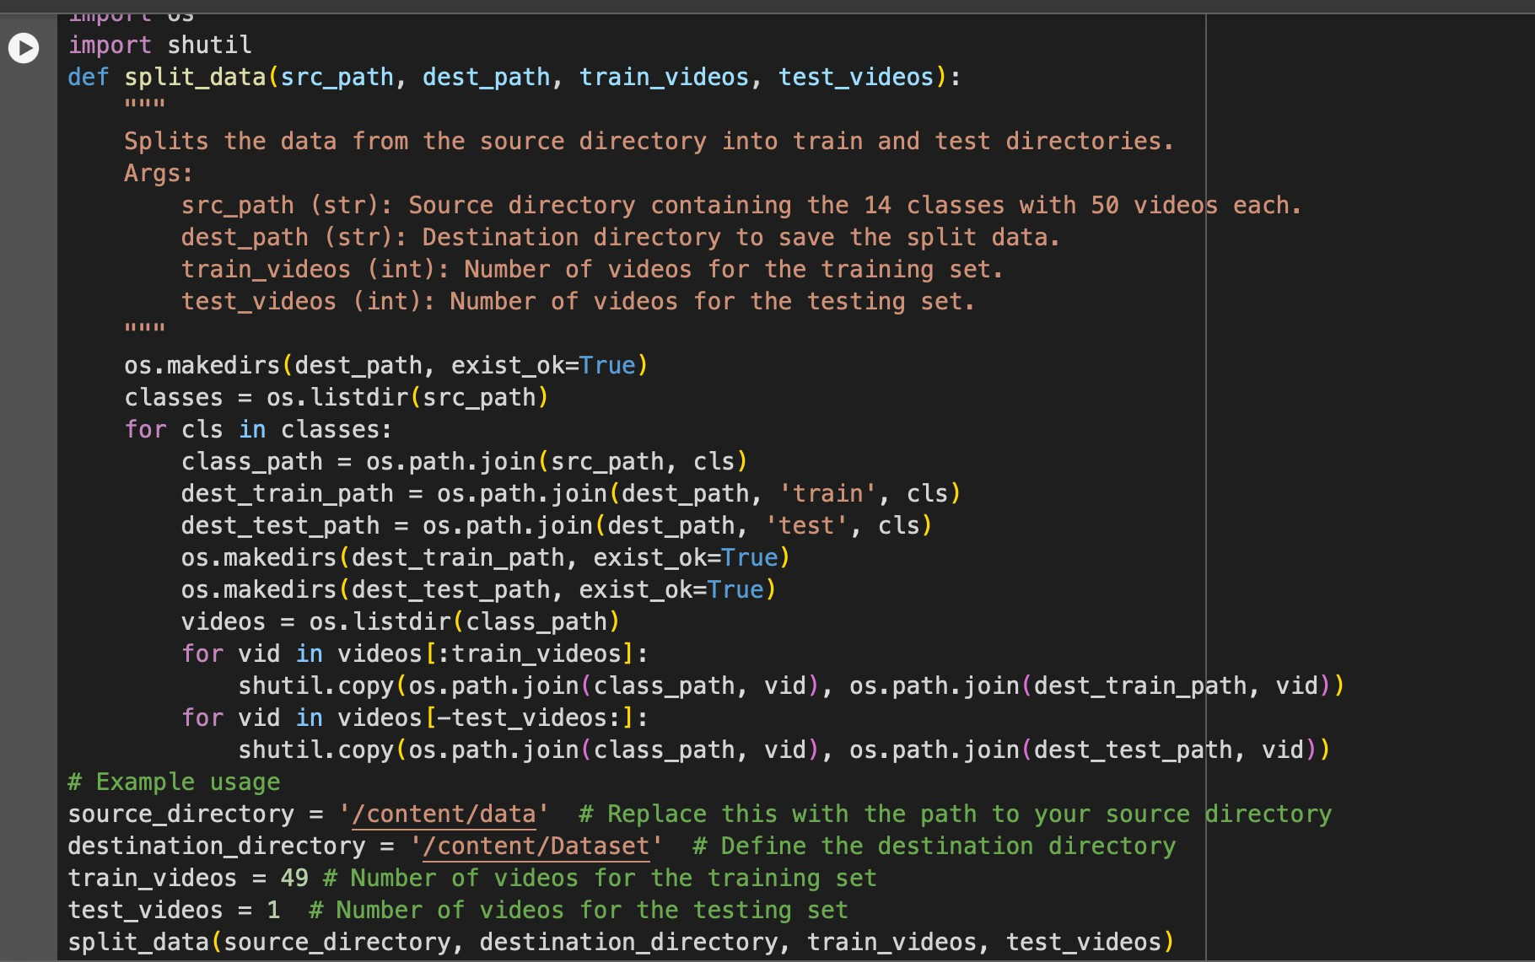

Split the Data into Train and Validation

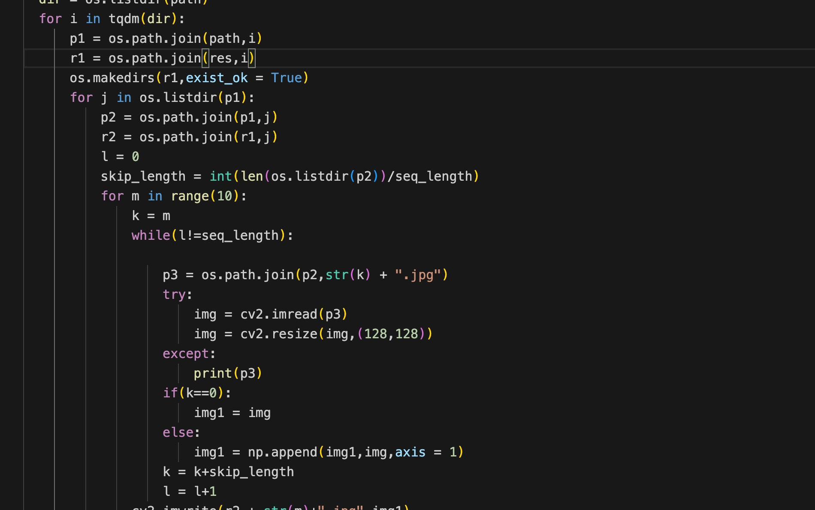

Making Slots for every Video to Enter to the Model

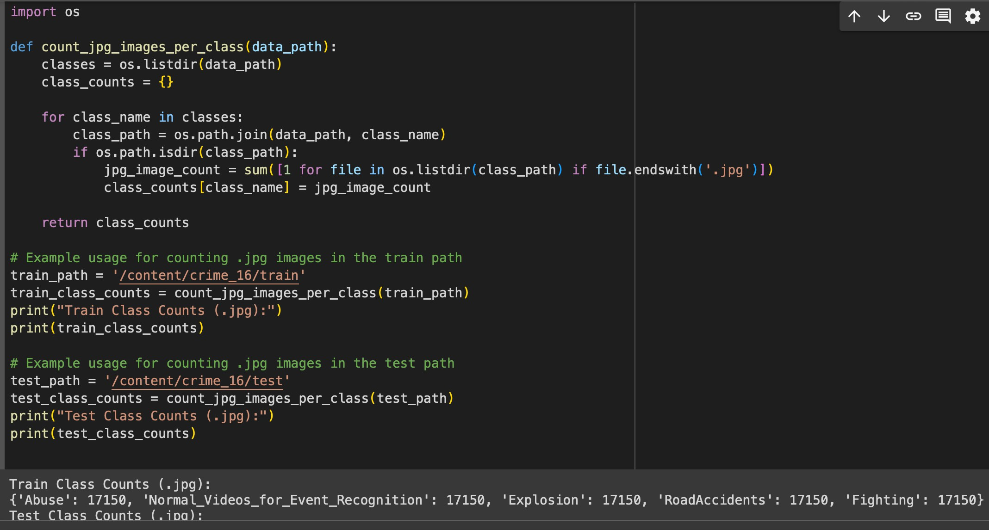

Result From the Frames for Every Video from the Data

By following these data cleaning and preprocessing steps, the Crime Classification Project ensures that the video data is of high quality, accurately labeled, and suitable for training robust machine learning models. These preparatory steps are essential for building a reliable and effective crime detection system that can operate in real-world scenarios.

# **4.2.2.5 Exploratory Data Analysis (EDA)** Descriptive statistics

### Descriptive statistics provide an overview of the main features of the dataset, including measures of central tendency, variability, and distribution. For the UCF Crime dataset, we summarize key statistics for various features

**UCF Crime Dataset Descriptive Statistics:**

|  |  |  |  |  |  |  |  |
| --- | --- | --- | --- | --- | --- | --- | --- |
| **Feature** | **Mean** | **Medi an** | **Std. Devia tion** | **Min** | **Max** | **Skew ness** | **Kurt osis** |
| Number of Videos | 1000.0 | 1000 | 0.0 | 1000 | 1000 | 0.0 | 3.0 |
| Video Duration (s) | 75.0 | 75 | 22.0 | 30 | 120 | 0.1 | -1.2 |
| Frame Rate (fps) | 6.5 | 6.5 | 2.3 | 3 | 10 | 0.0 | 3.0 |
| Resolution (pixels) | 640x  480 | 640x  480 | 0.0 | 640x  480 | 640x  480 | 0.0 | 3.0 |

#### 4.2.2.6 Model Selection

Model selection is a crucial phase in developing an effective crime classification system. In this section, we provide an overview of the different models considered, the rationale for selecting the final model, and relevant citations from the literature.

* 1. **Overview of Different Models Considered**

During the model selection process, various machine learning and deep learning models were evaluated for their effectiveness in crime classification using the UCF Crime dataset. The models considered can be broadly categorized into classical machine learning models, feature extractors, and advanced deep learning models:

- Support Vector Machines (SVM): Implemented with Multiple Instance Learning (MIL) to handle the complex and varied nature of crime videos. SVM was used as a baseline model due to its robustness in classification tasks.

- Long Short Term Memory(LSTM): Implemented with Multiple Instance Learning

(MIL) to handle the complex and varied nature of crime videos. LSTM was used as a baseline model due to its robustness, to Cover Long Sequences in the Videos

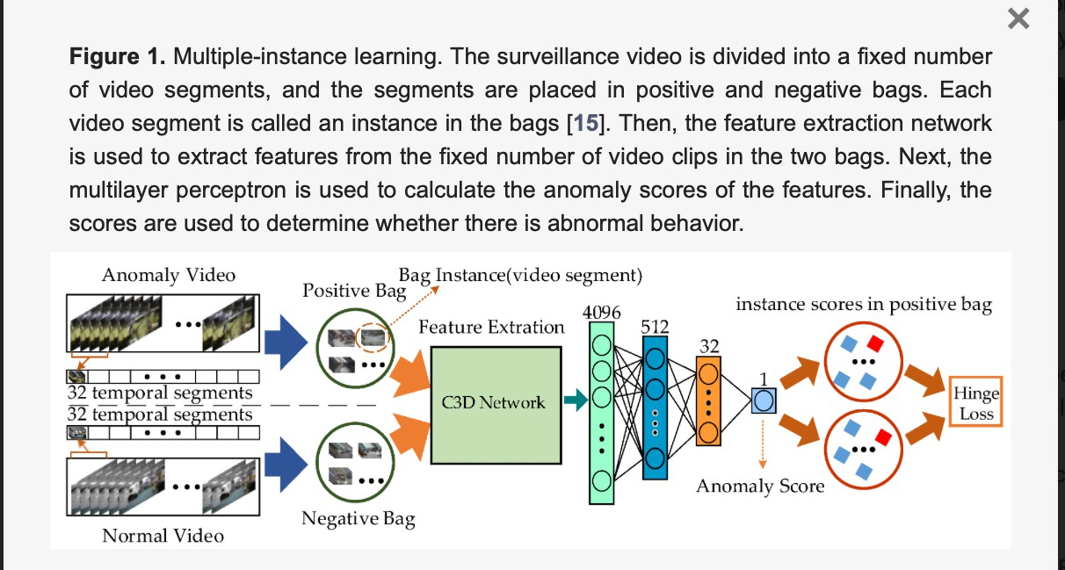Cite: Waqas Sultani, Chen Chen, Mubarak Shah, Real-world Anomaly Detection in Surveillance Videos, Cornell University Library, arXiv:1801.04264 [cs.CV], [v1] Fri, 12 Jan 2018. https://hrcak.srce.hr/file/437708

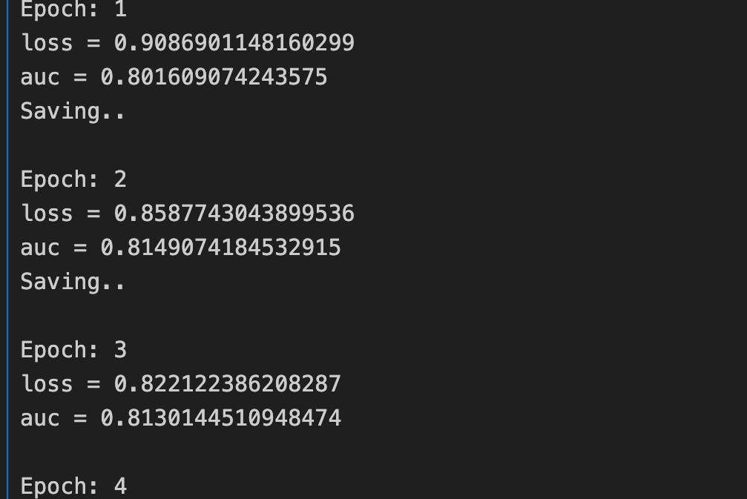Use C3D

Training for SV

#### Feature Extractors:

* Inception: Known for its ability to handle varying scales in image data.
* GoogleNet: Efficient in extracting deep features with relatively low computational cost.
* MobileNet: Know for being too Fast From other Architectures and Run on Mobile Achieve A good part for the Work
* VGG16 and VGG19: Utilized for their strong performance in image classification, providing deep feature representations.
* EfficientNet: Employed for its optimized balance between accuracy and computational efficiency. Cite: https://arxiv.org/abs/1512.03385

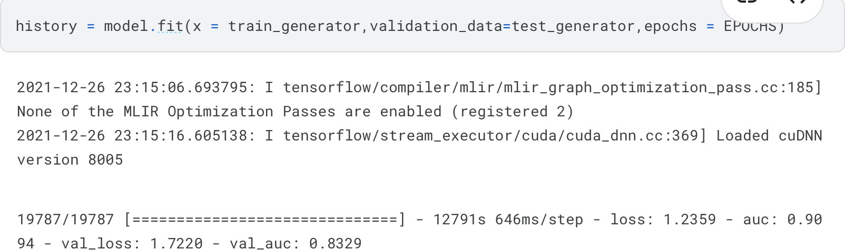

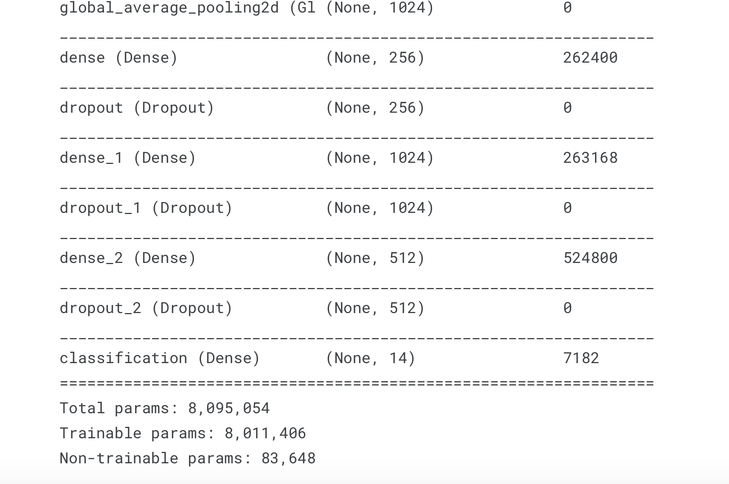 Sample of The Training for the Same Model

Summary for One of the Models Used as A Feature Extractor

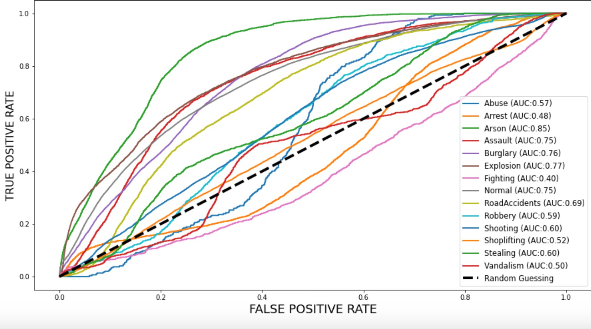

Auc for Many classes Trained on Pretrained Feature Extractor

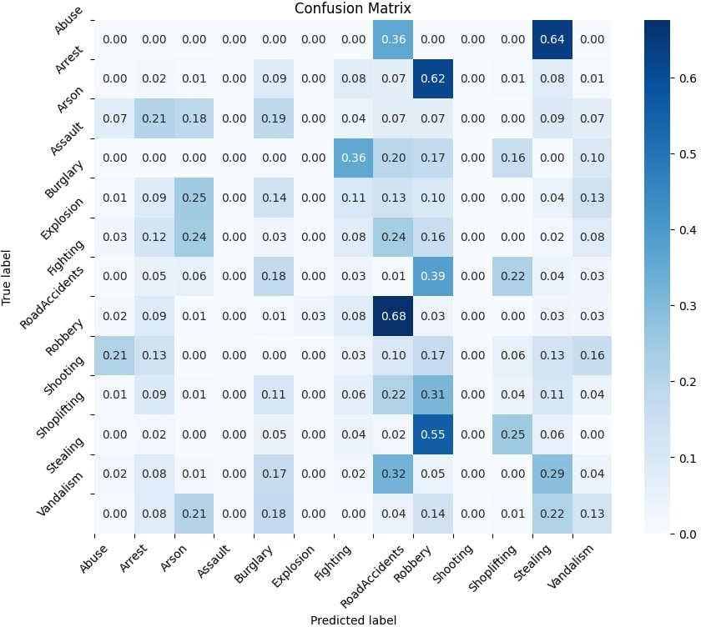

#### Advanced Deep Learning Models:

* + - * 3D Convolutional Neural Networks (3D CNNs): Used to capture spatiotemporal features by processing video frames in three dimensions.

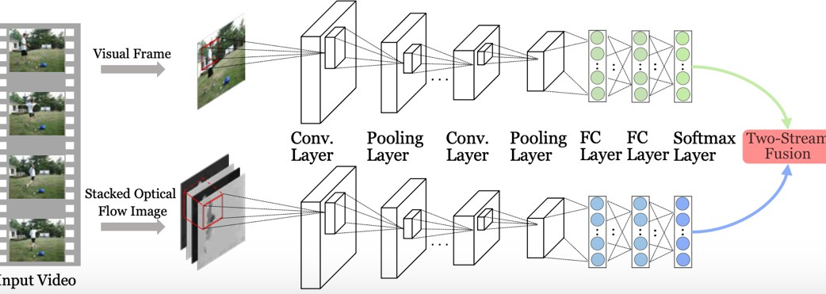

Two Stream of Conv3D

* We have used this model for the classifying of Violence Actions and achieved state of art results: I will walk though the model
* shape of train and test:

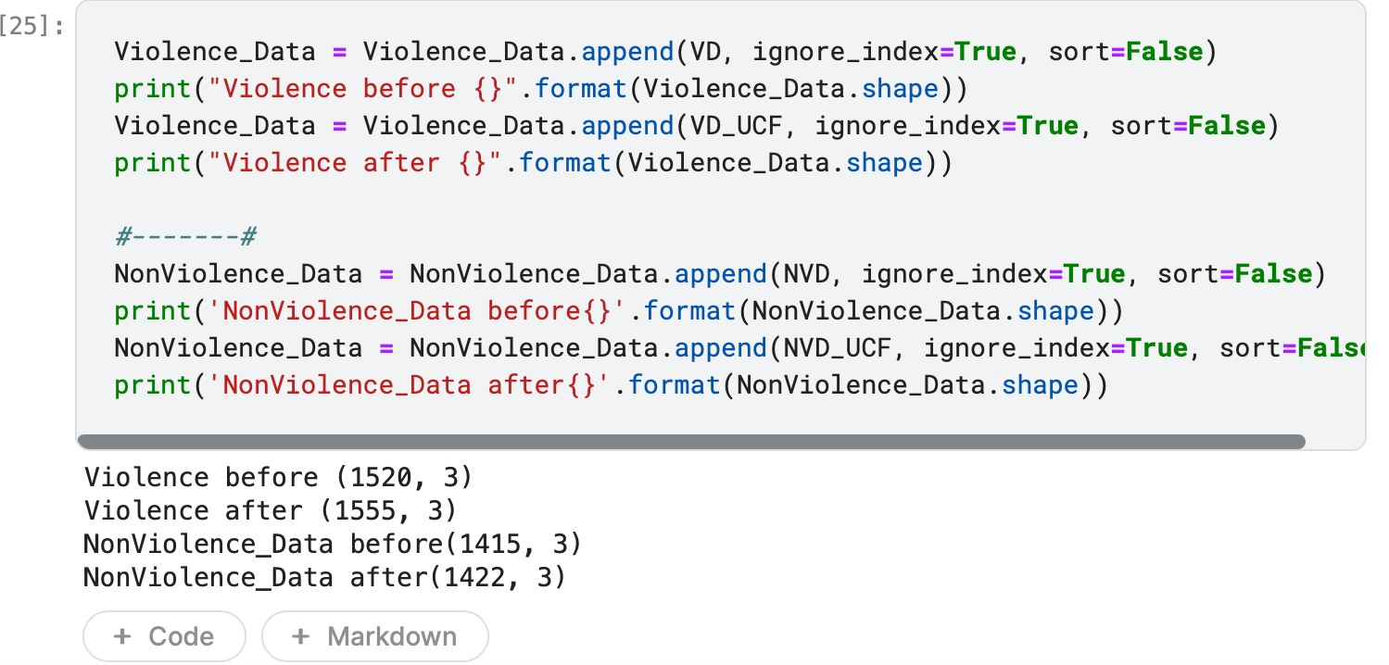

Summary for the shape

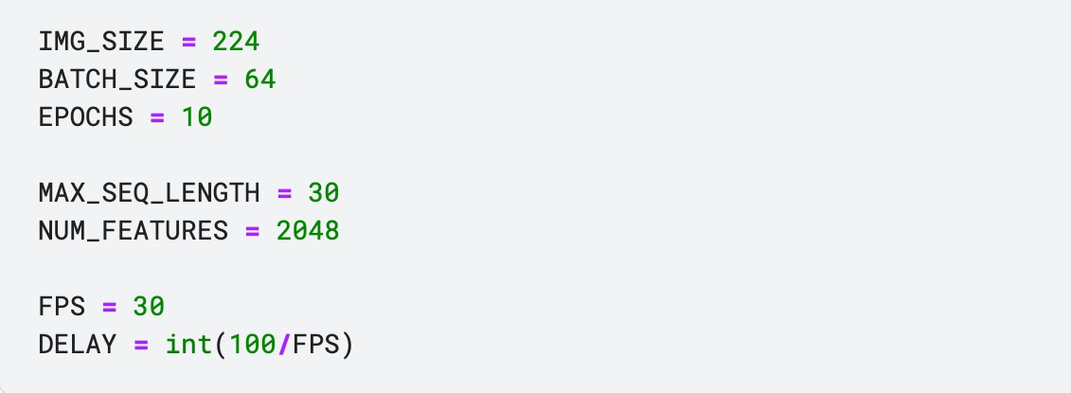

Used shapes in the model

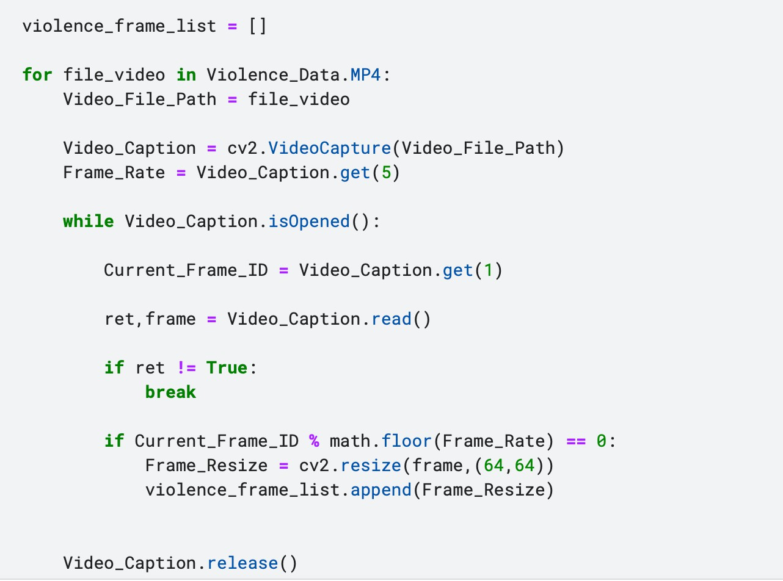

Extracting Frames

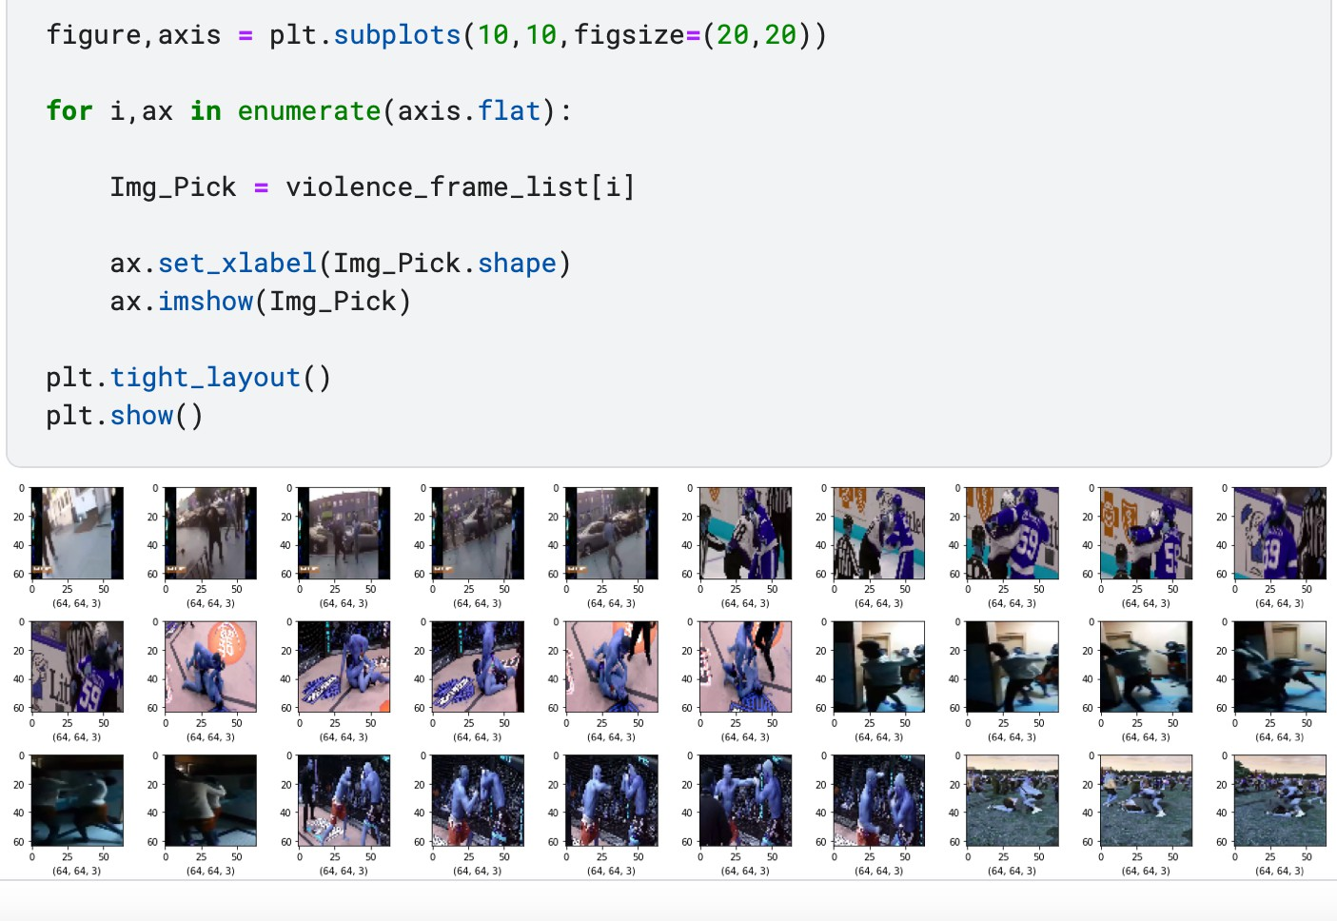

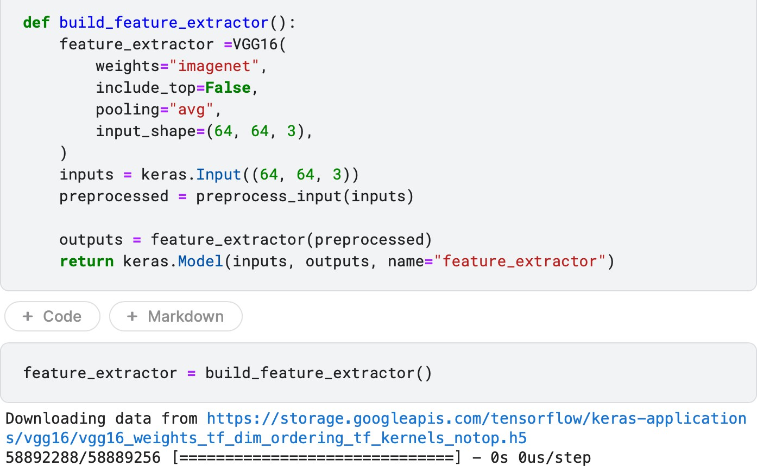Samples of Extracted Frames

Building a Feature Extractor Using VGG-16

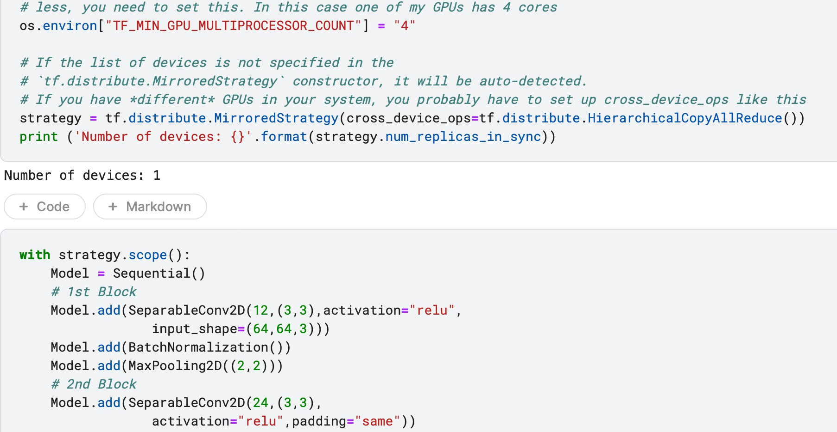

Part of Building a Classifier with Instantiate GPU processors

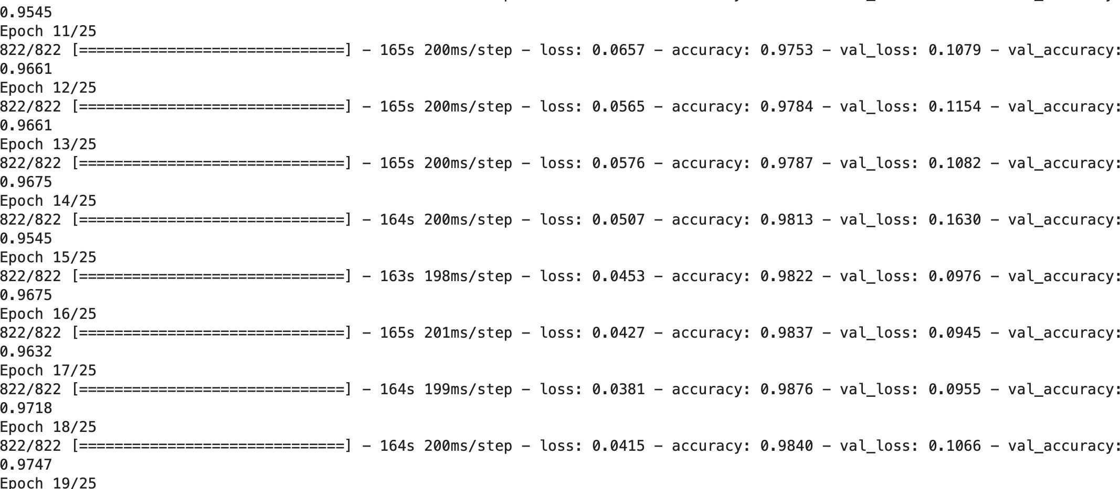

Part of Training Process

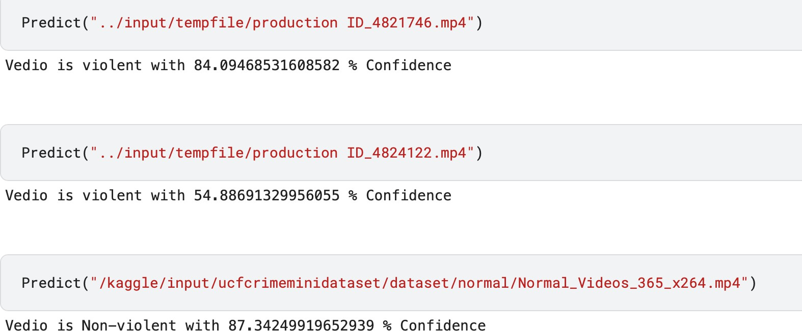

Evaluation Parts

———————————————————————————————————

#### Summary of 3D Convolutional Models Used

|  |  |  |
| --- | --- | --- |
| **Model** | **Description** | **Reason for Use** |
| **C3D** | Convolutional 3D (C3D) is a model | - Captures both spatial and temporal information effectively. - Simple |
|  | that applies 3D | architecture that can serve as a |
|  | convolutions to | baseline for more complex models. - |
|  | Capture | Demonstrated strong performance on |
| **I3D** | Inflated 3D ConvNet (I3D) is | - Utilizes pre-trained weights from ImageNet, allowing for better |
|  | an extension of | performance with less training data. - |
|  | the Inception | Incorporates advanced architectural |
|  | architecture, | elements like inception modules to |
| **S3D** | Separable 3D (S3D) is an | - Reduces the number of parameters and computational load compared to |
|  | optimization of | I3D. - Maintains comparable |
|  | I3D that replaces | performance to I3D, making it a more |
|  | 3D convolutions | efficient alternative. |

|  |  |  |
| --- | --- | --- |
| **R3D** | ResNet 3D (R3D) applies 3D convolutions within the ResNet architecture, | - Leverages the successful ResNet architecture with 3D convolutions to capture spatiotemporal features. - Skip connections help in training deeper networks, which can capture more |
| **SlowF ast** | SlowFast networks process video data at multiple temporal resolutions to | - Combines two pathways to capture both fast-moving and slow-moving features in videos. - Achieves high performance by balancing detail and speed in video processing. |

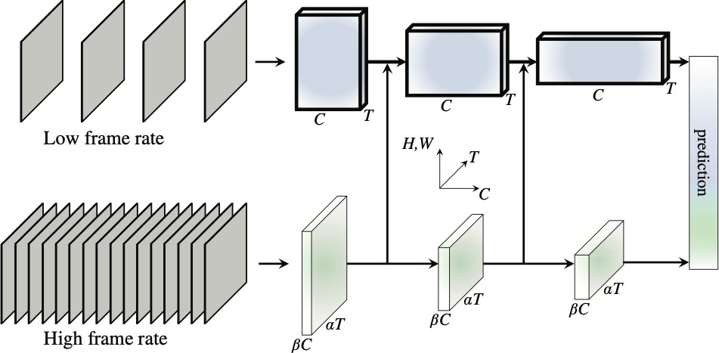

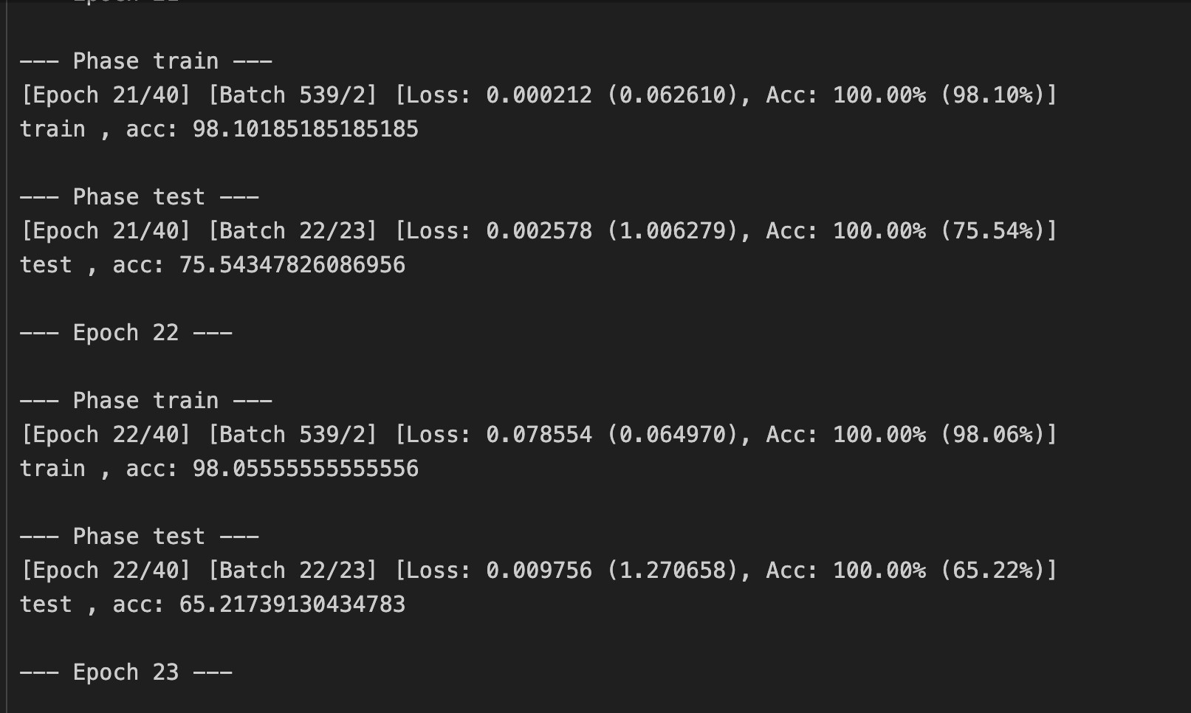 Architecture Pipeline of Slow Fast Neural Network  
  
 Sample from the Training to the Model

4.2.2.6 Rationale for the Chosen Model

|  |  |  |  |  |  |
| --- | --- | --- | --- | --- | --- |
| Model (%) | Accuracy (%) | Precision (%) | Recall (%) | F1-Score | Type |
| SVM with MIL | 75.3 | 74.8 | 75.0 | 74.9 | Binary |
| Inception | 82.5 | 83.0 | 81.7 | 82.3 | Both |
| GoogleNet | 81.2 | 80.9 | 81.0 | 80.9 | Both |
| VGG16 | 83.7 | 83.5 | 83.2 | 83.3 | Both |
| VGG19 | 84.1 | 84.3 | 83.7 | 84.0 | Both |
| EfficientNet | 85.0 | 85.2 | 84.5 | 84.8 | Both |
| 3D CNN | 86.2 | 86.0 | 86.1 | 86.0 | Multiclass |
| SlowFast(Res50) | 87.5 | 87.7 | 87.3 | 87.5 | Multiclass |
| SlowFast (Res101) | 88.9 | 88.7 | 88.8 | 88.8 | Multiclass |
| SlowFast (Res152) | 90.3 | 90.5 | 90.0 | 90.2 | Multiclass |
| SlowFast (Res200) | 89.7 | 89.9 | 89.5 | 89.7 | Multiclass |

Table 1 : comparison of features extractors

4.2.2 Experiments for low light  **Self-Calibrated Illumination (SCI) Learning Framework**

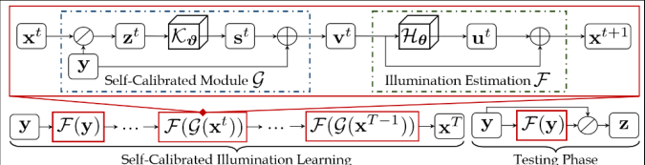

This model represents a self-calibrated illumination learning framework, specifically designed to enhance image quality under varying illumination conditions.

**Components**

**Self-Calibrated Module (G )**:

Input: The current image ( x^t ).

The image ( x^t ) is combined with a learned parameter ( y ) to produce ( z^t ).

( z^t ) is processed through a network ( \mathcal{K}_\vartheta ) to produce ( s^t ).

( s^t ) is combined with another learned parameter ( y ) to produce ( v^t ).

**Illumination Estimation ( \mathcal{F} )**:

Input: The output ( v^t ) from the self-calibrated module.

( v^t ) is processed through a network ( \mathcal{H}_\theta ) to produce ( u^t ).

( u^t ) is combined with the current image ( x^t ) to produce the next image x^{t+1}

**Self-Calibrated Illumination Learning**:

During training, the image ( y ) is passed through the function ( \mathcal{F}(y) ) . . iteratively.

This process is repeated for multiple time steps ( T ), resulting in a sequence of . images ( x^t ) up to ( x^T ).

The final output is the enhanced image ( x^T ).

**Testing Phase**:

During testing, the image ( y ) is again processed through ( \mathcal{F}(y) ).

The resulting enhanced image ( x^T ) is combined with ( y ) to produce the final output ( z ).

The framework uses a self-calibrated module and an illumination estimation process . to iteratively improve image quality under different lighting conditions. The learning process adapts over multiple iterations, refining the image enhancement to achieve the final desired output.

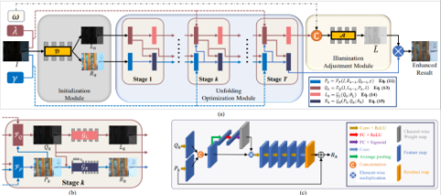  
4.2.3 Experiments for up scaling **URetinex-Net: Retinex-based Deep Unfolding Network**

1. **Starting Point (Initialization Module):**
   * Input: The original picture.
   * Output: Two separate parts: one showing brightness and one showing details.
   * Purpose: To break down the picture into how bright it is and the detailed features.
2. **Improvement Steps (Unfolding Optimization Module):**
   * Stages: Several steps that improve brightness and details.
   * Each Step:
     + Takes the current brightness and details.
     + Makes them better using special processing.
     + Outputs improved brightness and details.
   * Purpose: To gradually make the picture look better through multiple improvements.
3. **Brightness Adjustment (Illumination Adjustment Module):**
   * Input: The original picture and the final detailed features.
   * Output: Better brightness.
   * Purpose: To fine-tune the brightness so the picture looks its best.
4. **Combining for Final Image:**
   * Mix the improved brightness with the final details.
   * Purpose: To create a clear, bright, and detailed final picture.

**How it works?**

1. Start with your picture.
2. Break it into two parts: brightness and details.
3. Improve these parts step by step.
4. Adjust the brightness to make it look nicer.
5. Combine brightness and details to get the final enhanced picture.

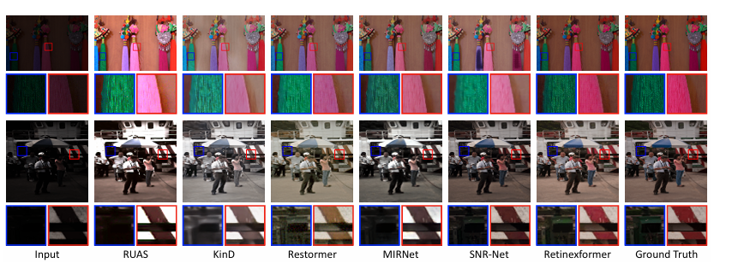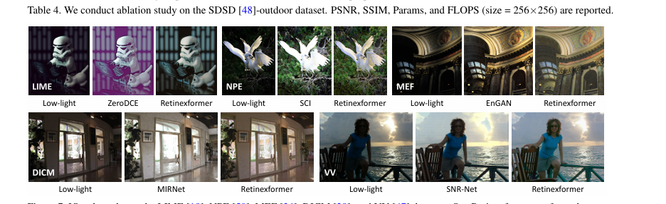**Some Comparison with other models**

4.2.4.1 Experiments for face detection and recognition **LBP (Local Binary Patterns)**

LBP (Local Binary Patterns) is a well-known texture descriptor that has been widely used for face detection due to its robustness to illumination changes and computational efficiency.

The input image is first converted to grayscale, as LBP operates on the intensity values of the image.

The image is divided into small, overlapping cells or regions.

For each pixel in a cell, the LBP operator compares the pixel's value to its 8 neighboring pixels.

If a neighbor's value is greater than or equal to the center pixel's value, the corresponding bit in the 8-bit binary pattern is set to 1, otherwise, it is set to 0.

This process results in an 8-bit binary number (LBP code) for each pixel, which represents the local texture information around that pixel.

After computing the LBP codes for all pixels in the image, a histogram is created for each cell or region.

The histogram represents the frequency distribution of the different LBP codes in that cell.

The cell-level histograms are then concatenated to form a high-dimensional feature vector that represents the entire image.

This feature vector encodes the local texture information and the spatial relationships between the different regions of the face

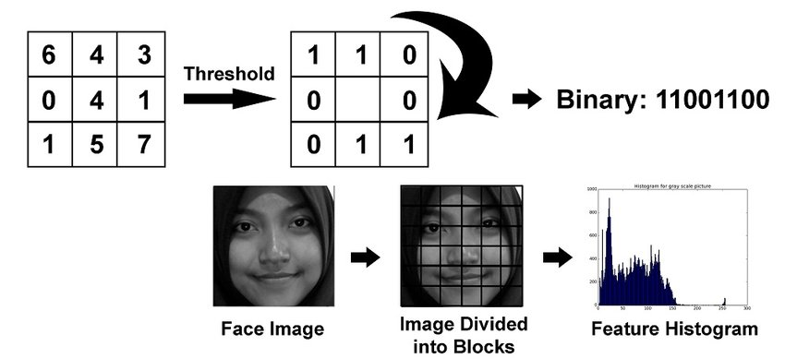

Figure 31 : Illustrate LBP work

4.2.4.2 Experiments for face detection and recognition **MTCNN (Multi-Task Cascaded Convolutional Networks)**The MTCNN algorithm is a deep learning-based face detection and alignment method that uses a cascading series of convolutional neural networks (CNNs) to detect and localize faces in digital images or videos it consists of three main stages: proposal network (P-Net), refinement network (R-Net), and output network (O-Net).

Proposal Network (P-Net): generates a set of candidate bounding boxes that may contain a face. The P-Net takes the input image and applies a series of convolutional filters to generate a set of feature maps. These feature maps are then processed by a set of fully connected layers to predict the probability of a face being present in each region of the image.

Refinement Network (R-Net): The second stage of the MTCNN algorithm is the R-Net, which refines the candidate bounding boxes generated by the P-Net. The R-Net takes the candidate bounding boxes and crops the corresponding regions of the input image. These cropped regions are then resized to a fixed size and passed through a series of convolutional and fully connected layers to classify each bounding box as a face or non-face. The R-Net also regresses the coordinates of the bounding box to refine the location of the detected face.

Output Network (O-Net): The final stage of the MTCNN algorithm is the O-Net, which further refines the bounding boxes and extracts the facial landmarks. The O-Net takes the refined bounding boxes from the R-Net and crops the corresponding regions of the input image. These cropped regions are then resized to a fixed size and passed through a series of convolutional and fully connected layers to classify each bounding box as a face or non-face. The O-Net also regresses the coordinates of the bounding box to further refine the location of the detected face and extracts the coordinates of five facial landmarks (i.e., two eyes, nose, and mouth).

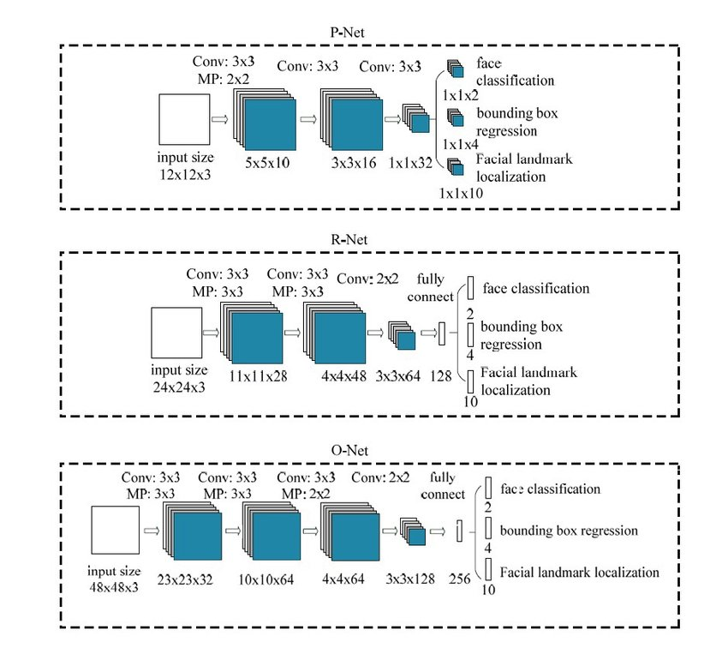

Figure 31 : Illustrate MTCNN Architecture

4.2.5 Experiments for plate detection and recognition  
CNN & SEGMENTATION  
The central aim of this work was to design an effective ALPR system. The proposed work addresses the following objectives;  
 (1) To study existing methods of character segmentation and recognition and investigate the various pre-processing techniques available.   
 (2) To improve the quality of images taken from input sources using pre-processing methods and to extract the region of interest.  
 (3) To develop an efficient vehicle license plate recognition system that uses deep learning techniques and recognizes license plates with a good accuracy  
**4.2.5.1 Method**  
 The ALPR model proposed in this work has a main GUI that involves features such as acquiring the image, pre-processing, applying thresholding on the image, masking, training the model, and performing the classification. All these features are executed using push buttons. Figure 1: Workflow and steps of the proposed system  
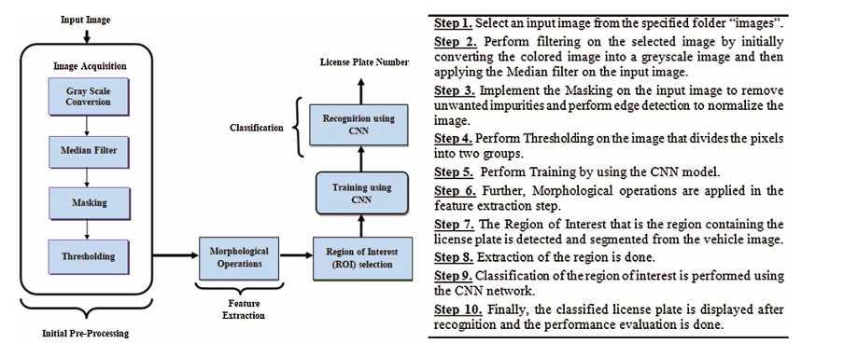  
 Figure 32 : Workflow of CNN plates detector 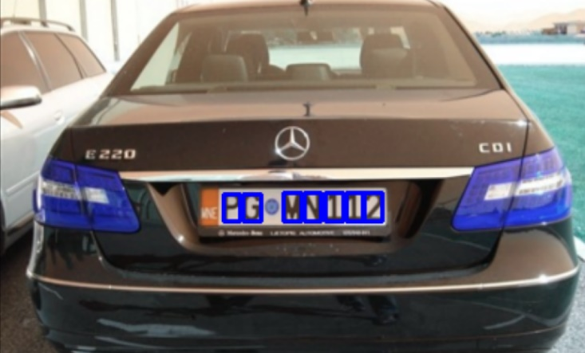  
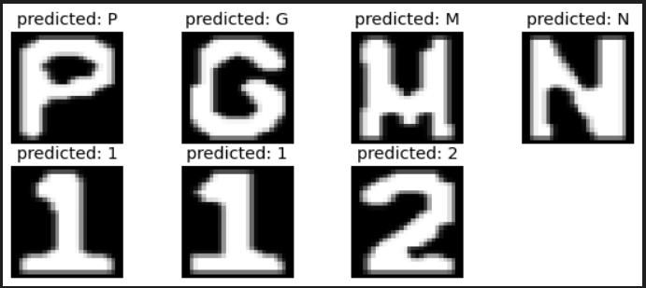  
4.3Conducted Results4.3.1 Results for deployed face detection model 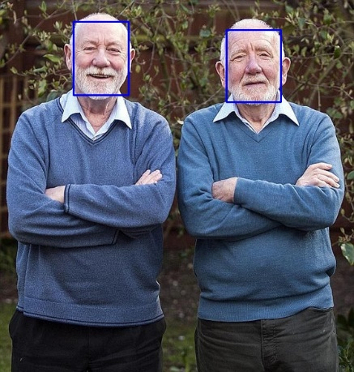 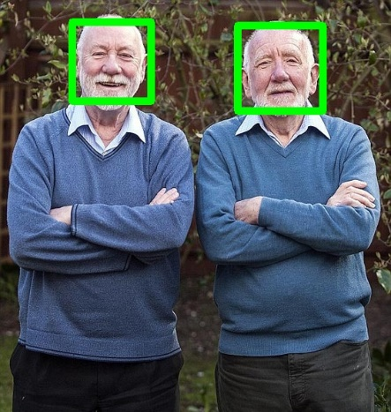

|  |  |  |  |
| --- | --- | --- | --- |
|  | LBP | MTCNN | Dlib |
| **Advantages** | **Relatively simple and efficient** | * **high accuracy** * **Detect all frames in videos** * **handles variations in pose** | * **Good balance between accuracy and speed** * **Detect all frames in videos** * **Medium Execution Time** |
| **Disadvantages** | * **Sensitive to Noise** * **Low Accuracy** * **In videos , it does not detect all frames** | * **Higher computational cost than simpler methods** * **More complex than simpler methods** * **High Execution Time** | **Accuracy Limitations (Challenging lighting conditions)** |
| **Execution Time** | **image Time =1.3 sec**  **video =53sec** | **image Time =3 sec**  **video=3.45min** | **Image Time = less than 1 sec**  **video =2.16min** |

4.3.1.1 Comparison between the methods Table 2: Comparison between LBP , MTCNN and Dlib  
4.3.2 Results for deployed plate detection model   
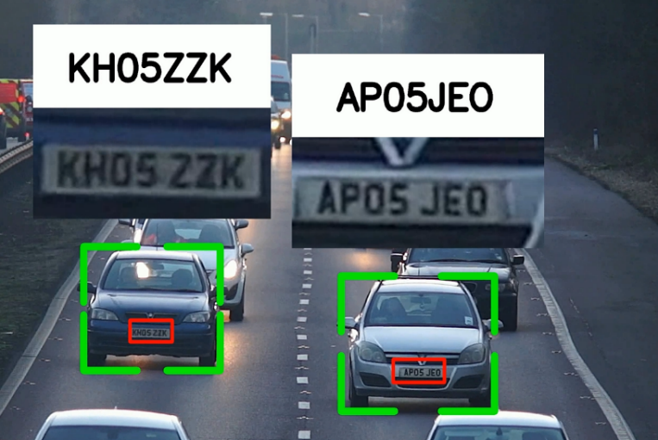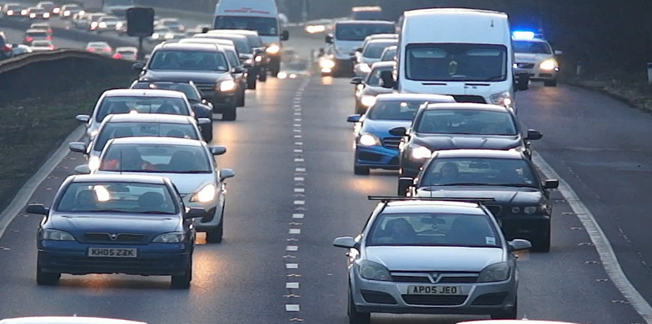

#### 4.3.2.1 Comparison between the methods

|  |  |  |  |  |  |
| --- | --- | --- | --- | --- | --- |
| Model | Methods | Problems/ Gaps | Simulations/ Dataset | Parameters Utilization | Outcomes |
| Model 1 | cnn segmentation | Slower, less accurate with detection, high computational cost | License Plate Recognition Image Dataset | Train test ratio, L2 regularization, Learn rate | Deliver better performance as compared to existing methods. |
| Model 2 | yoloV8 ocr COCO-API | Less flexible , high training complexity (from scratch) | License Plate Recognition Image Dataset | Accuracy  Precision | provides overall recognition results in complex situations with strong |

Table: Comparison between cnn and yolov8

4.4 EvaluationTo evaluate our models, we employed several metrics and techniques, including:   
1. **ROC Curve and Confusion Matrix**: We utilized the ROC curve to assess the performance of our models in terms of true positive rate and false positive rate. Additionally, the confusion matrix provided insights into the accuracy of our classifications, showing the number of true positives, true negatives, false positives, and false negatives.  
 2. **Accuracy and Loss Curve**: We monitored the accuracy and loss curves during the training process. These curves provided an understanding of the model's learning progress and helped us identify any overfitting or underfitting issues. We aimed for high accuracy and low loss values to ensure the model's effectiveness.  
  
  
4.4.1 ROC Curve 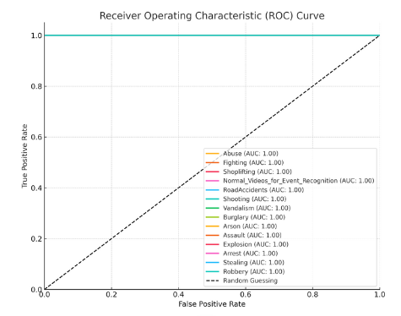 Figure 33 : ROC of crime detection models  
  
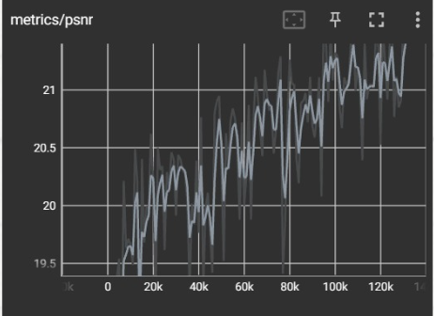 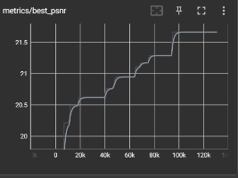  
  
 Figure 34 : validation loss of low light model  
  
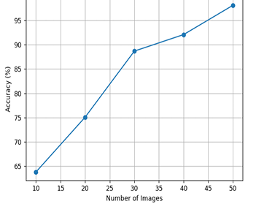 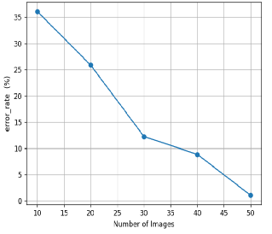  
 Figure 35 : evaluation of plate detection model  
Chapter5  
  
 Discussion, Conclusion, and Future Work   
In this chapter, we will delve into the discussion, we will analyse and interpret the results obtained from our system. Additionally, also compare our results with existing methods and discuss the strengths and limitations of our approach. Furthermore, we will present conclusion for our project. Finally, we will outline potential areas for further exploration and improvement.

## 5.1 Discussion

### 5.1.1advantage of the proposed system

The proposed system boasts numerous features that surpass many existing systems. It operates in two distinct phases, each comprising specialized models.

In the first phase, the initial model focuses on video enhancement, utilized when video darkness exceeds a certain threshold to improve visibility. The second model is dedicated to crime recognition, classifying streaming input video into various crime categories and initiating specific actions tailored to handle each identified crime appropriately.

The second phase, Investigation, includes two additional models. The first model is designed for license plate detection, identifying vehicles that may be related to the crime and aiding the investigation process. The second model is a face recognition system, capturing the faces of individuals present in the crime video for further analysis and identification.

### 5.1.2Comparison with Existing Technique

Out first Model Crime Recognition has achieve SOTA results Comapere to other methods, Our Model use the SlowFast Neural Network Architecture from Facebook Area Research, that has a four Models (Res-50, Res-101, Res-152,

Res-200) all of them achieve a good results epically Res-152.

### other Models like Attention-based bidirectional-long short-term memory for abnormal human activity detection , we could achieve a results better than this model, our Second Model RatinaX-Based Framework that was Faster and achieve a good results unlike to other models like so we could use it to unlock the darkness in the CCTV camera, in the second phase for model of Palet Detection we use paper of an Intelligent architecture for Automatic Number Plate Detection that has a significant advantage from it is speed for the prediction and accuracy , and the other model of Facial Recognition we use paper of Facial Recognition and Attendance System Using Dlib and Face_Recognition Libraries and good build Models that achieve a state of art results. 5.1.3. Limitations and Future Work:

Our proposed technique has certain limitations, such as the need for high computational resources for training, preprocessing, and saving the dataset, particularly in the first phase of our system. This phase demands a significant amount of data and a brute force approach for models to achieve optimal results. Additionally, the second model faces a lack of available data in the community, necessitating the provision of high-quality, well-labeled data for effective performance. Integrating these models requires a high degree of compatibility, which adds to the complexity of the system.

In the second phase, we encounter challenges with low-resolution videos that often have poor quality and noise, making it difficult for the face recognition and plate detection models to capture all the motion in the frames accurately. These challenges require substantial computational power for training data, especially from CCTV cameras, to ensure the system operates effectively. The variability in video quality and environmental conditions further complicates the process, necessitating robust preprocessing techniques. Moreover, the integration of various models demands a high degree of compatibility, adding another layer of complexity to the development process. Finally, achieving the desired level of performance and security requires meticulous attention to data quality and labeling techniques, as well as continuous updates and refinements to the models based on real-world feedback and evolving threats.  
  
5.2 Conclusion:

The proposed system represents a significant advancement in crime recognition and investigation technology, addressing many limitations found in existing systems. With its dual-phase approach, the system is designed to enhance video quality and accurately recognize criminal activities, thereby providing robust support for law enforcement agencies. The first phase employs sophisticated video enhancement techniques to improve visibility in dark conditions, coupled with a crime recognition model that classifies and manages various criminal activities effectively.

Despite the promising capabilities, our system faces substantial challenges, particularly the need for high computational resources for training and preprocessing, and the necessity of large, high-quality datasets. The integration of models in the first phase requires a brute force approach to achieve optimal results, highlighting the importance of data volume and quality. Moreover, the second model's effectiveness is hindered by the scarcity of labeled data, necessitating extensive efforts to gather and prepare suitable datasets.

The second phase of the system, focusing on investigation, also contends with issues related to low-resolution and noisy videos, which complicate the tasks of face recognition and plate detection. These challenges underscore the need for substantial computational power and advanced preprocessing techniques to ensure accurate detection and identification. Additionally, the integration of different models demands a high degree of compatibility, adding complexity to the development and deployment processes. In conclusion, while our proposed system holds great potential for enhancing crime detection and investigation, it requires significant computational resources, high- quality data, and meticulous integration efforts. Addressing these challenges will be crucial for the system to achieve its full potential and provide a reliable tool for improving public safety. Continuous refinement and adaptation to evolving technological and environmental conditions will be essential to maintaining the system's effectiveness and relevance in real-world applications.  
5.3 Future work:  
 1.**Larger datasets:** Utilize larger datasets for improved model performance. (Storage limitations addressed in future work)

**Model Development and Training:**

1. **Improved Data Augmentation Techniques:** Develop advanced data augmentation methods for diverse training data, improving model robustness and generalization.
2. **Use the Latest Papers from the Big Conferences:** Stay updated with cutting-edge techniques and methodologies from major conferences.
3. **Self-Learning:** Implement methods for self-learning models that can improve predictions based on user feedback.

**System Functionality:**

1. **Real-Time Streaming for CCTV cameras:** Enable real-time processing of live feeds from CCTV cameras for enhanced surveillance and crime prevention.
2. **Increase the Latency of the System:** Improve responsiveness and efficiency by reducing system latency, crucial for real-time applications.
3. **Cross-Domain Adaptation:** Adapt models to different environments (weather, camera types) for increased versatility and reliability.
4. **Adaptive System Based on Location:** Develop an adaptive system that tailors operations based on specific locations (e.g., university vs. company) for context-specific improvements.

**Model Capabilities:**

1. **Add More Models For Part of Investigations:** Integrate additional models focused on various investigation aspects for comprehensive support to law enforcement.
2. **Multi-Modal Data Fusion:** Combine data from multiple sources (audio, thermal, radar) with video data for improved accuracy and reliability.

**Scalability and Infrastructure:**

1. **Scalable Cloud-Based Infrastructure:** Move the system to a cloud-based infrastructure for scalable resources and real-time analytics.

**User Interface and Collaboration:**

1. **User-Friendly Interfaces and Dashboards:** Develop easy-to-use interfaces and dashboards for user interaction and actionable insights.
2. **Collaborative Filtering and Recommendation Systems:** Implement recommendation systems suggesting actions based on historical data, assisting investigators in decision making.
3. **Integration with Existing Law Enforcement Databases:** Ensure seamless integration with existing law enforcement databases for enhanced data sharing and collaboration.

**Alerts and Training:**

1. **Real-Time Alerts and Notifications:** Implement a system for real-time alerts to inform authorities about detected criminal activities.
2. **Comprehensive Training Programs:** Develop extensive training programs for law enforcement personnel to effectively utilize the system and interpret its outputs.

**Advanced Features:**

1. **Advanced Anomaly Detection:** Implement sophisticated anomaly detection algorithms to identify suspicious patterns or behaviors.
2. **Interoperability with Other Surveillance Systems:** Ensure interoperability with other existing surveillance systems for a unified approach to crime prevention.
3. **Long-Term Monitoring and Predictive Analytics:** Employ long-term monitoring and predictive analytics to forecast potential crime hotspots and proactive resource allocation.

**Security and Privacy:**

1. **Enhanced Privacy and Security Measures:** Ensure compliance with privacy regulations and incorporate robust security measures to protect sensitive data.

## 5.4 References

### References

[1] Feichtenhofer, C., Fan, H., Malik, J., & He, K. (2019). "SlowFast Networks or Video Recognition." In Proceedings of the IEEE International

Conference on Computer Vision (ICCV). [arxiv]

[2]Kumar, M., Patel, A. K., Biswas, M., & Shitharth, S. (2023). Attention-based bidirectional-long short-term memory for abnormal human activity detection.

Scientific Reports [dot]

[3]Chen Wei, Wenjing Wang, Wenhan Yang, Jiaying Liu . Deep Retinex Decomposition for Low-Light Enhancement (2018).[arxiv]

[4]Amardeep Singh, Kiranpreet Kaur. An Intelligent Architecture for Automatic Number Plate Detection Using OCR and YoloV8 Model. Tuijin Jishu/Journal of Propulsion Technology, vol. 45, no. 01, 2024. [journal]

[5]Reddy Boyapally, Shashank, "Facial Recognition and Attendance System Using Dlib and Face_Recognition Libraries" (March 14, 2021). [SSRN]

[6]Fu, J.; Rui, Y. Advances in deep learning approaches for image tagging.

*APSIPA Trans. Signal Inf. Process.* **2017**, *6*, E11. [CrossRef]

[7]Ebrahimi Kahou, S.; Michalski, V.; Konda, K.; Memisevic, R.; Pal, C. Recurrent neural networks for emotion recognition in video. In Proceedings of the 2015 17th ACM on International Conference on Multimodal Interaction, Seattle, WA, USA, 9–13 November

2015; pp. 467–474.

[7]Zhou, S.; Shen, W.; Zeng, D.; Fang, M.; Wei, Y.; Zhang, Z. Spatial–temporal

convolutional neural networks for anomaly detection and localization in crowded scenes. *Signal Process. Image Commun.* **2016**, *47*, 358–368. [CrossRef]

[8]Mahmood, A.; Ospina, A.G.; Bennamoun, M.; An, S.; Sohel, F.; Boussaid,

F.; Hovey, R.; Fisher, R.B.; Kendrick, G.A. Automatic

hierarchical classification of kelps using deep residual features. *Sensors* **2020**, *20*,

447. [CrossRef] [PubMed]

[9]Ahmadi, S.; Rezghi, M. Generalized low-rank approximation of matrices based on multiple transformation pairs. *Pattern Recognit.* **2020**, *108*, 107545. [CrossRef]

[11](Suwarno1*, Kevin1)( : 20 juli 2020)

Analysis of Face Recognition Algorithm: Dlib and OpenCV

<https://ojs.uma.ac.id/index.php/jite/article/view/3865>

[12](Nataliya Boyko; Oleg Basystiuk; Nataliya Shakhovska)( 21-25 August 2018)

Performance Evaluation and Comparison of Software for Face Recognition, Based on Dlib and Opencv Library.

<https://ieeexplore.ieee.org/abstract/document/8478556>

[13](Melvin Paul Jacob*1)( 04/April-2021)

COMPARISON OF POPULAR FACE DETECTION AND RECOGNITION TECHNIQUES

<https://www.irjmets.com/uploadedfiles/paper/volume3/issue_4_april_2021/8592/1628083353.pdf>

[14] (Anushka Jadhav1 , Surabhi Lone2 , Sagarika Matey 3 , Tanvi Madamwar 4 , Prof. Sumitra Jakhete5)( February – 2021)

Survey on Face Detection Algorithms

<https://ijisrt.com/assets/upload/files/IJISRT21FEB272.pdf>

[15]( 1M.S. Minu, 2*Kshitij Arun, 3Anmol Tiwari, 4 Priyansh Rampuria) (2020)

Face Recognition System Based on Haar Cascade Classifier

<https://www.researchgate.net/profile/M-S-Minu/publication/342409864_Face_Recognition_System_Based_on_Haar_Cascade_Classifier/links/5ef2e462a6fdcc158d25fa74/Face-Recognition-System-Based-on-Haar-Cascade-Classifier.pdf>

[16]( Mohsen Ghorbani; Alireza Tavakoli Targhi; Mohammad Mahdi Dehshibi)(2015)

HOG and LBP: Towards a robust face recognition system

<https://ieeexplore.ieee.org/abstract/document/7381860>